Sample Paper- 2016
Subject: Physics
Class 12th

Define impedance write its S.I. unit
- Why convex mirror is used as a rear-view mirror in vehicles?
- What is the work done in moving a charge of 10 n C between two points on an equipotential surface?
- How are side bands produced?
- On what factors dose the resistivity of conductors depend.
- Two metals A, B have work-functions 2 eV, 4 eV respectively. Which metal has a lower threshold wavelength for photoelectric effect?
- Name the logic gate shown in the diagram and give its truth table.
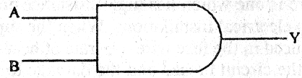
- Explain the origin of spectral lines of hydrogen using Bohr’s theory ?
- Draw a labeled ray diagram to show image formation in a compound microscope ?
Or
An astronomical telescope consists of two thin lenses set 36 cm apart and has a magnifying power 8. Calculate the focal lengths of the lenses.
- A wire of uniform cross-section and length l has a resistance of 16Ω. It is cut into four equal parts. Each part is stretched uniformly to length l and all the four stretched parts are connected in parallel. Calculate the total resistance of the combination so formed. Assume that stretching of wire does not cause any change in the density of its material.
- List any three properties of EM waves.
- If the nucleons of a nucleus are separated far apart from each other, the sum of masses of all these nucleons is larger than the mass of the nucleus. Where does this mass difference come from?Calculate the energy released if ²³⁸U nucleus emits an α-particle.
Given: Atomic mass of ²³⁸U = 238.0508 u
Atomic mass of ²³⁴Th = 234.04363 u
Atomic mass of alpha-particle = 4.00260 u And lu = 931 MeV/c²
- What is an internet system ? Describe its use in E-mail and file transfer ?
- State the essential conditions for diffraction of light to take place.
Use Huygens’ principle to explain diffraction of light due to narrow single slit and the formation of a pattern of fringes obtained on the screen. Sketch the pattern of fringes formed due to diffraction at a single slit showing variation of intensity with angle θ.
Or
What are coherent sources of light ? Why are coherent required to obtain sustained interference pattern ?
State three characteristics features which distinguish the interference pattern due to two coherently illuminated sources as compared to that observed in a diffraction pattern due to a single slit.
- Draw a schematic diagram of the experimental arrangement used by Davisson and Germer to establish the wave nature of electrons. Explain briefly how he de-Broglie relation was experimentally verified in case of electrons
- For the potentiometer circuit shown in the given figure, point X and Y represent the two terminals of an unknown emf E’. A student observed that when the jockey is moved from the end A to the end B of the potentiometer wire, the deflection in the galvanometer remains in the same direction.
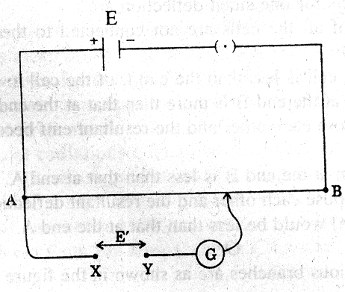
What may be the two possible faults in the circuit that could result in this observation ?
If the galvanometer deflection at the end B is (i) more, (ii) less, than that at the end A, which of the two faults, listed above, would be there in the circuit ?
Give reasons in support of your answer in each case.
- A parallel plate capacitor, each with plate are A and separation d, is charged to a potential difference V. The battery used to charge it is then disconnected. A dielectric slab of thickness d and dielectric constant K is now placed between the plates. What change, if any, will take place in
(i) charge on the plates
(ii) electric field intensity between the plates
(iii) capacitance of the capacitor. Justify your answer in each case
- Explain, with the help of a schematic diagram, the principle and working of a Light Emitting Diode. What criterion is kept in mind while choosing the semiconductor material for such a device ? Write any two advantages of Light Emitting Diode over conventional incandescent lamps.
- Draw a labeled diagram of a moving coil galvanometer. State the principle on which it works.
Deduce an expression for the torque acting on a rectangular current carrying loop kept in a uniform magnetic field. Write two factors on which the current sensitivity of a moving coil galvanometer depends.
- Draw the symbolic representation of a (i) p-n-p, (ii) n-p-n transistor. Why is the base region of transistor thin and lightly doped ? With proper circuit diagram, show the biasing of a p-n-p transistor in common base configuration. Explain the movement of charge carriers through different parts of the transistor in such a configuration and show that I_{E} = I_{C} + I_{B}.
- Define the term ‘resolving power’ of an astronomical telescope. How does it get affected on
(i) increasing the aperture of the objective lens ?
(ii) increasing the wavelength of the light used ?
Justify your answer in each case.
- When an inductor L and a resistor R in series are connected across a 12V, 50 Hz supply a current of 0.5 A flows in the circuit. The current differs in phase from applied voltage by π/3 radian. Calculate the value of R.
- Value based
- Show by a diagram the image formation of a point object by a thin double convex lens having radii of curvature R₁ and R₂. Hence derive the formula $\frac{1}{f}=(n−1)\left(\frac{1}{R_{1}}−\frac{1}{R_{2}}\right)$,
where f is the focal length and n is refractive index of material of the lens.
Or
State Huygen’s principle. Use Huygen’s construction to explain refraction of a plane wavefront at a plane surface. Draw diagrams to show the behaviour of a (i) convex lens, (ii) concave mirror when a plane wavefront falls on it.
- The given circuit diagram shows a series LCR circuit connected to a variable frequency 230 V source:
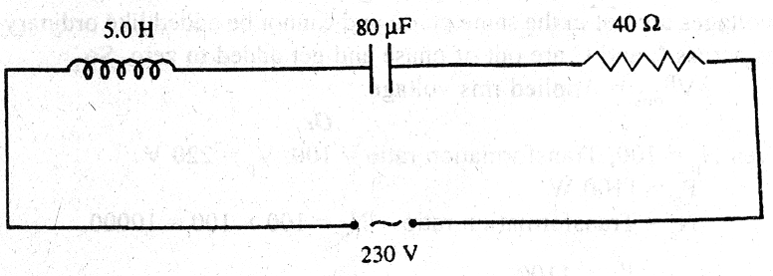
(a) Determine the source frequency which drives the circuit in resonance.
(b) Obtain the impedance of the circuit and the amplitude of current at the resonating frequency.
(c) Determine the rms potential drops across the three elements of the circuit.
(d) How do you explain the observation that the algebraic sum of the voltages across the three elements obtained in (c) is greater than the supplied voltage?
Or
The primary coil of an ideal step-up transformer has 100 turns and the transformation ratio is also100. The input voltage the power are 220 V and 1100 W respectively. Calculate:
(i) number of turns in the secondary
(ii) the current in the primary
(iii) voltage across the secondary
(iv) the current in the secondary
(v) power in the secondary
- A dielectric slab of thickness ‘t’ is kept in between the plates, each of area ‘A’, of a parallel plate capacitor separated by a distance ‘d’. Derive an expression for the capacitance of this capacitor for t << d.
Or
(a) Explain briefly how a capacitor stores energy on charging. Obtain an expression for the energy thus stored.
(b) A battery of 10 V is connected to a capacitor of 0.1 F. The battery is now removed and the capacitor is then connected to a second uncharged capacitor of same capacitance. Calculate the total energy stored in the system.

Mr. Akarshan tiwari
aakarshantiwari@gmail.com

