Sample Paper- 2016
Subject: Mathematics
Class 9th

SECTION- A
- Write the mean of perimeters of two squares having sides x & y units.
- A cuboidal block of wood is of dimensions 5m x 2m x 1m. Find the number of cubes of dimensions 1m x 1m x 1m, which can be cut from.
- The mean of 5 observations was calculated as 145, but it was later on detected that one observation was misread as 45 in place of 25. Find the correct mean of observation.
- The radii of two right circular cylinders are in the ratio 2 : 3 & their heights are in the ratio 5 : 4, then the ratio of their volumes will be in the ratio ______

SECTION- B
- ABCD is a parallelogram, E & F are the points on opposite sides AD & BC respectively such that ED= AD & BF=⅓BC. Find ∠BFD.
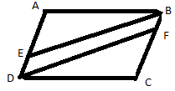
- AB is a chord equal to the radius of the circle with centre O. Find a & b.
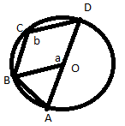
- The runs scored by two teams A & B on the first 42 balls in a cricket match are given below. Draw the frequency polygon on the same graph paper.
No. of balls | Team A | Team B
0-6 | 2 | 5
6--12 | 1 | 6
12--18 | 8 | 2
18-24 | 9 | 10
24-30 | 4 | 5
30--36 | 5 | 6
36--42 | 6 | 3
- ABCD is a parallelogram Points P & Q on BC trisect BC. Prove that ar ΔAPQ = ar ΔDPQ = 1/6 ar||gm ABCD.
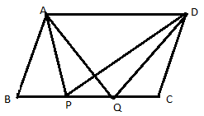
- If non-parallel sides of a trapezium are equal then prove that, “it is cyclic”
- O is a point inside rhombus ABCD such that BO = DO. Prove that AO & CO are on the same straight line.

SECTION- C
- The areas of three adjacent faces of cuboid are 15cm², 20cm² & 12cm². Find the volume of the cuboid.
- (i)A data is such that its minimum value is 86 & range is 32. Find the maximum value.
(ii) If the mean of the following distribution is 6, find the value of ‘P’.
x | 2 | 4 | 6 | 10 | P+5
f | 3 | 2 | 3 | 1 | 2

- An open box is made of wood 3 cm thick. Its external dimensions are 1.4m, 1.1m & 0.8m. Find the cost of painting the inner surface of the box @ 75 paise per 100 cm².
- (i)A & B are the only two outcomes of an event. Probability of P(A) = 0.72 Then find the probability of B?
(ii) For the data 3, 21, 25, 17, (x+3), 19, (x-4), if mean is 18, find the value of x & hence find the mode of the data.
(iii) The mean of x₁ , x₂ is 6 & mean of x₁ , x₂ , x₃ is 7, the value of x₃ is __.
- The height of cone is 30 cm & radius 6 cm. A small cone is cut off at the top of a plane || to base . The radius of cone is 3 cm. If the volume is 1/9 of the volume of the given cone, at what height above the base the section is made.
- Find (i) the total surface area of a cuboidal petrol storage tank of L=5m B=4m H=3m (ii) how much steel was actually used, if 1/16 of the steel actually used was wasted in making the tank.
- ABCD & AEFD are two parallelograms Prove that ar PEA = ar QFD.
  - 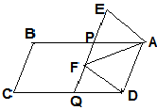
- ABCD is a rhombus , EABF is a straight line such that EA=AB=BF. When ED & FC produced meet at O. Prove that $∠\text{DOC}={\text{90}}^{0}$.

SECTION- D
- ABCD is a Δ, D is a point on AB such that AD= ¼AB & E is a point on AC such that AE= ¼AC. Prove that DE= ¼BC.
- ABCD, is a cyclic quad. AE||CD & BA is produced upto F. If $∠\text{ABC}={\text{92}}^{0},∠\text{FAE}={\text{20}}^{0} \text{find} ∠\text{BCD}$
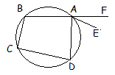
- P is a point on the side BC of a triangle ABC such that AB=AP. Through A & C, lines are drawn parallel to BC & PA, respectively, so as to intersect at D. Show that ABCD is cyclic. 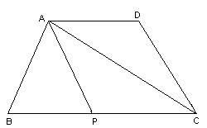
- Construct a triangle XYZ in which ∠Y = 30°, ∠Z = 90° and XY + YZ + ZX = 11 cm.
- (i) The length & breadth of a hall are in the ratio 4 : 3 & its height is 5.5 m. The cost of decorating its walls, including doors & windows @ Rs 6.60 per m² is Rs 5082 Find the length & breadth of the hall. {40, 30}.
(ii) The V is the volume of cuboid of dimensions a, b & c & S is the surface area, Prove that $\frac{1}{V}=\frac{2}{S}\left(\frac{1}{a}+\frac{1}{b}+\frac{1}{c}\right)$.
- ABCD is a parallelogram. O is any point on AC. PQ || AB & LM || AD. Prove that ar(||gm DLOP) = ar (||gm BMOQ)
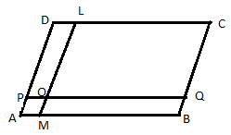
- ABCD is a parallelogram. P is the mid-point of side DC. A line through C parallel to AP meets DA produced at Q & AB at R. Prove that (i) DA=AQ (ii) CR=QR.
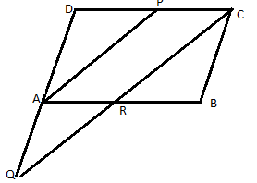
- The vol. of a sphere is 4581m³.How much should its radius be reduced so that the volume becomes $\frac{\text{4312}}{3}$m³.
- ABCD is a ||gm in which E & F are the mid-points of AB & CD respectively. If PQ is a line segment that cuts AD, EF & BC at P, M & Q respectively, prove that PM = QM.
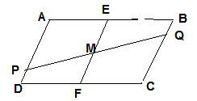
- P is a point on the side BC of a triangle ABC such that AB=AP. Through A & C, lines are drawn parallel to BC & PA, respectively, so as to intersect at D. Show that ABCD is cyclic.

For problems relating to this paper mail to

vishvas_1@ymail.com

only upto session 2015-16.

