Time allowed: 3 hours
Maximum Marks: 90
General Instructions:
a) All questions are compulsory.
b) The question paper consists of 31
c) Section A contains 4
contains 6questions of 2marks each, Section C contains 10 questions of 3marks each and
questions divided into four sections – A, B, C and D.
questions of 1
mark each which are multiple choice questions, Section B
Section D contains 11
questions of 4
marks each.
d) Use of calculator is not permitted.
Section A
1. Cards each marked with one of the numbers 6, 7, 8, …., 15are placed in a box and mixed
thoroughly. One card is drawn at random from the box. The probability of getting a card with a
number less than 10 is:
(a) 1
(b) 53
(c) 52
(d) 54
5
2. 0 units is:
The value of x for which the distance between the points A(2,−3) and B(x,5) is 1
(a) 2
(b) 4
(c) 6
(d) 8
3. The sum of first five multiples of 4 is:
(a) 30
(b) 40
(c) 50
(d) 6
4. The angle of depression and the angle of elevation from an object on the ground to an object in
the air are related as:
(a) greater than
(b) less than
(c) equal
(d) all of them
Section B
5. Find the radius of the circle whose circumference is equal to the sum of circumferences of the
two circles of diameter 30 cm and 24 cm.
6. A solid cylinder of diameter 12cm and height 15cm is melted and recast into toys with the
shape of a right circular cone mounted on a hemisphere of radius 3 cm. If the height of the toy
is 12 cm, find the number of toys so formed.
7. Water flows through a circular pipe, whose internal diameter is 2 cm, at the rate of 0.7 m per
second into a cylindrical tank, the radius of whose base is 40 cm. By how much will the level of
water in the cylindrical tank use in half an hour?
8. For what value of k, are the roots of the equation 3x2 + 2kx + 27 = 0 are real and equal?
9. Two AP’s have the same common difference. The first two terms of one of these is −3 and not
of the other is −7.Find the difference between their 4
terms.
th

10. The tangent at a point C of a circle and a diameter AB when extended intersect at P. If ∠ PCA =
100°, then find ∠ CBA.
Section C
11. If A(5,−1), B(−3,−2) and C(−1,8) are the vertices of triangle ABC, find the length of median
through A and the coordinates of centroid.
12
. If the point (x, y) is equidistant from the points (a +b,b−a) and (a−b,a+b), then prove that
bx = ay.
. A chord AB of a circle of radius 14
13
cm makes a right angle at the centre (O) of the circle. Find
the area of the minor segment.Use =
22 

7 
14. The minute hand of a clock is 21 cm long. Find the area described by the minute hand on the


22 
7 
face of the clock between 6
a.m. and 6
.05 a.m. Use =

15. Find the number of coins 1.5cm in diameter and 0.2cm thick, to be melted to form a right
circular cylinder of height 10 cm and diameter 4.5 cm.
16. Solve the quadratic equation by using quadratic formula:
2x
2
− 3 x+ 1 = 0
2 2
17
. Find the middle term of the AP 10,7,4,.......,(−62).
18
. ABCD is a quadrilateral such that ∠ D =
90a. A circle C (O, r ) touches the sides AB, BC, CD and
DA at P, Q, R and S respectively. If BC = 38 cm, CD = 25 cm and BP = 27
cm, then find r.
19. A vertical tower stands on a horizontal plane and is surmounted by a vertical flagstaff of height
5 m. From a point on the plane the angles of elevation of the bottomand top of the flagstaff of
height 5m. From a point on the plane the angles of elevation of the bottom and top of the
flagstaff are respectively 30a and 60a. Find the height of the tower.
20. Find the probability that a number selected at random from the numbers 1, 2, 3, ……., 35 is:
(i)
a prime number.
(ii)
(iii)
multiple of 7.
multiple of 3 or 5.
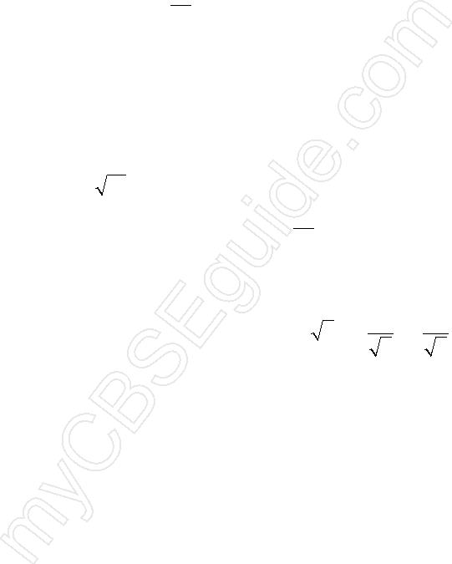
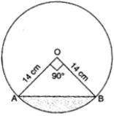
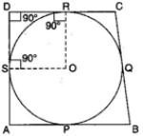

Section D
21
. Draw any quadrilateral ABCD. Construct another quadrilateral AB’C’D’ similar to the
quadrilateral ABCD with each side equal to 54 th of the corresponding side of quadrilateral
ABCD. Write the steps of construction also.
22. A tree breaks due to the storm and the broken part bends so that the top of the tree touches
the ground making an angle of 30a with the ground. The distance from the foot of the tree to
the point where the top touches the ground is 10 meters. Find the height of the tree.
23
. A box contains 19
balls bearing numbers 1
, 2
, 3
, …….., 19
. A ball is drawn at random from the
box. Find the probability that the number on the ball is:
(i) aprime number
(ii) divisible by 3 or 5
(iii) neither divisible by 5 nor by 10
(iv) an even number
 a , −2a 
. If P and Q are two points whose coordinates are at 2,2at and 
 respectively and S is
t t 
(
)
24
2
the point (a,0), then show that 1 + 1 is independent of t.
SP SQ
25. A cylindrical vessel with internal diameter 10 cm and height 10.5cm is full of water. A solid
cone of base diameter 7 cm and height 6 cm is completely immersed in water. Find the volume
of:
(i) water displaced out of the cylindrical vessel.
(ii) water left in the cylindrical vessel. Use =
22 
7 

26. From a solid cylinder whose height is 8 cm and radius 6 cm, a conical cavity of height 8 cm and
of base radius 6cm, is hollowed out. Find the volume of the remaining solid correct to two
places of decimals. Also find the total surface area of the remaining solid.(Use = 3.1416)
1
1
11
30
27
. Solve for x :
−
=
;
x ≠ −4,7
x + 4 x − 7
28. Two years ago, a man’s age was three times the square of his son’s age. Three years hence, his
age will be four times his son’s age. Find their present ages.
29. Ram and Shyam have been given to find out the number of two digit numbers in between 6 and
102
which are divisible by 6
. Ram calculated it by using AP while Shyam calculated it directly.
Read the above passage and answer the following questions:
(i) How many two digits number are there in between 6 and 102 which are divisible by 6??
(ii) What value is depicted by Ram?
30. The radius of the incircle of a triangle is 4 cm and the segments into which one side is divided
by the point of contact are 6 cm and 8 cm. Determine the other two sides of the triangle.
31. With the vertices of a triangle ABC as centre, three circles are described, each touching the
other two externally. If the sides of the triangle are 9 cm, 7 cm and 6 cm, then find the radii of
the circle.

