Sample Paper- 2016
Subject: Computer Science
Class 12th

______________________________________________________________
General Instructions:
(i)All questions are compulsory.
(ii) Programming Language: C++
_________________________________________________________________________

1(a)Find the correct identifiers out of the following, which can be used for naming Variable, Constants or Functions in a C++ program: (1)
Switch, Float, Remove, delete, 2ndName, Print-Sum, mark1

(b) Write the prototype of a function named Area, which takes two float variables L and B as parameters and return a double type value. The parameter length should have a default value 7.8. (1)
(c)Give header files for the following statements, by specifying the functions used in each header file. (2)

void main()
{ clrscr( );
int min = INT_MIN;
cout<< “Additive inverse is” <<abs(min);
}

(d) Hussain has just started working as programmer in the WORLD SOFTWARE company. In the company, he has got his first assignment to develop a small C++ module to find the smallest number out of a given set of numbers stored in a one dimensional array. Somehow he has committed a few logical mistakes while writing this code and so he is not getting the desired result from the code. Find out the mistakes and correct this C++ code so that it provides the desired result (do not add any new statement in the code). Underline each correction made: (2) int SMALLFIND(int ARR,int Size) // Statement 1
{
int SMALL=ARR[1]; //Statement 2
for (int C=2;C<Size;C++) //Statement 3
if (ARR[C]>SMALL) //Statement 4
ARR[C]=SMALL; //Statement 5
return SMALL; } //Statement 6
(e). Find the output of the following program: (Assume all the header files are included) (3)
class Class
{ int Cno,total; char section;
public:
Class(int no=1) {Cno=no;total=30;section=’A’;}

Class(Class &C)
{Cno=C.Cno+1;
total=C.total+10;section=C.section+1;}

void admission(int B=25)
{ section++;
total +=B; }

void ClassShow()
{ cout<<Cno<<”#”<<total<<’#’<<section<<endl;}
};
void main()
{ Class A, B(10);
A.ClassShow ();
B.admission(20);
B.ClassShow();
Class C(A);
C.admission();
C.ClassShow ();
}

(f). Find the output of the following program: (2)
void strcon(char s[])
{ int i,j,l;
for(i=0,l=0;s[i]!='\0';i++,l++);
for(j=0; j<l; j++)
{
if (isupper(s[j]))
s[j]=tolower(s[j])+2;
else if ( islower(s[j]))
s[j]=toupper(s[j])-2;
else
s[j]='@';
}
}
void main()
{
char *c="sun rise";
strcon(c);
cout<<"Text= "<<c<<endl;
c=c+3;
cout<<"New Text= "<<c<<endl;
c=c+5-2;
cout<<"last Text= "<<c ;
}
(g) Using the following C++ code, find out the correct possible output(s) from the suggested output options given below. Also write the highest value which can be assigned to variable G. (1)
void main( )
{ randomize( );
int G,H=5;
G = random(H)+30;
for(int i=35;i>G;i--)
cout<<i<<’$’;
cout<<i;
}
(i) 35$34$33$32$31$30$ 30
(ii) 35$34$33$32$31
(iii)30$31$32$33$34$35$36
(iv)35$34$33$32$31$30

2 (a) What is abstract class and concrete class. Illustrate with example. (2)
(b)Answer the questions (i) and (ii) after going through the following class:(2)

class Travel
{
int PlaceCode ; char Place[20];float Charges;
public:
Travel( ) //Function 1
{
PlaceCode=1; strcpy (Place,”DELHI”); Charges=1000;
}
void TravelPlan(float C) //Function 2
{
cout<<PlaceCode<<”:”<<Place<<”:”<<Charges<<endl;
}
~Travel( ) //Function 3
{
Cout<<”Travel Plan Cancelled”<<endl;
}

};
void main()
{ Travel T; //statement 1
T.TravelPlan(2500);
}//statement 2
i) Mention the function that will get invoked for statement 1 and 2 .Justify
ii) Define a parameterized constructor for the class Travel.

(c) Define a class MYFOLDER with the following specifications: (4)
Private members:
filenames- and array of string of size [10][25](to represent all the names of the file inside myfolder)
Availspace-long(to represent total number of bytes available in myfolder)
Usedspace-long(to represent total number of bytes used in myfolder)
Public members
- A constructor to initialize the data members filenames with Null and availspace and usedspace as 0.
- A function newfileentry() to allow the user to enter the values
- A function showfiles() to display all the details from myfolder
- retavailspace() that returns the value of total kilobytes available.(1 kilobyte=1024bytes)

(d) Consider the following and answer the questions given below: (4)
class University
{ int noc;
protected:
char uname[20];
public:
University();
char state[20];
void enterdata();
void displaydata();
};
class College:public University
{ int nod;
char Cname[30];
protected:
void affiliation();
public:
College();
void enroll();
void Tdisplay();};
class Department: public College
{ char Dname[25 ];int nof;
public:
Department();
void enter();
void display();};
(i) Which type of inheritance is shown in the above example?How many bytes an object of the class college requires?
(ii) Write the names of all the member functions accessible from enter() function of class Department.
(iii) Write the names of all datamembers accessible through an object of class Department.
(iv)What will be the order of execution of the constructors when an object of class Department is created?

3 .(a) Write a function in c++ which accepts a 2D array of integers, number of rows and number of columns as arguments and assign the elements which are divisible by 3 or 5 into a one dimensional array of integers. (2)
If the 2D array is $\left[\begin{matrix}\text{12} & 3 & 9 & \text{14} \\ \text{24} & \text{25} & \text{16} & \text{31} \\ \text{19} & \text{32} & \text{45} & \text{27} \\ \text{11} & 5 & \text{28} & \text{18}\end{matrix}\right]$
The resultant 1D arrays is 12, 3, 9, 24, 25, 45, 9, 5, 18

(b) An array T[-1..35][-2..15] is stored in the memory along the row with each element occupying 4 bytes. Find out the base address and address of element T[20][5], if an element T[2][2] is stored at the memory location 3000. Find the total number of elements stored in T and number of bytes allocated to T . (3)

(c) Write a function in C++ to perform insert and delete operation on a dynamically allocated Queue containing Books details as given in the following definition of node: (4)
struct bnode
{ char Aname[30]; //Author Name
char Bname[45]; // Book Name
float Price;
bnode *link ; };
(d) Write a function sort() that takes integer array and its size as parameters and arrange the array in ascending order using insertion sort. (2)

(e) Evaluate the following postfix expression using a stack and show the contents of the
stack after execution of each operation: (2)
7 , 3, 2, ^ , 14 , -2, / , - , *

4.(a).Consider a file F containing objects E of class Emp. (1)
i.write statement to position the get pointer in the beginning of the 5th record.
ii.Write statement to return the number of bytes from the beginning of the file to the
current position of the file pointer.

(b)Given a binary file Resume.dat containing records of all the following class: (3)
class Candidate
{ char C_name[20], Post_apply[20];
int Expr, Sal_Exp ;
public :
void Apply()
{ gets(C_name); gets(Post_apply);
cin>>Expr>>Sal_Exp;
}
char * Post()
{ return Post_apply; }
int Sal_Expected()
{ return Sal_Exp; }
void ShowDet()
{ cout<<C_name<<” “<<Post_apply<<” ”<<Expr<<” “<<Sal_Exp<<endl; }
};
Write a function in C++ that would read the content of Resume.dat and display the records of all those candidate who have applied for “Clerk“ with an expected salary between Rs25000 and Rs 40000.

(c)Write a function in C++ to count and display the no of two letter words in the file
“STORY.TXT”. (2 )
Example:
If the file contains:
A boy is playing there. I love to eat pizza. A plane is in the sky.
Then the output should be: 4

5. (a) Explain DDL and DML statements in SQL. (1)

(b) Define attribute and primary key in a relation data model. (1)

(c) Write SQL commands for the queries (i) to (iv) and output for (v) & (viii) based
on a table COMPANY and CUSTOMER . (6)
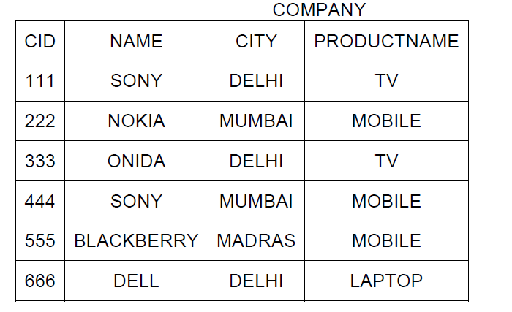
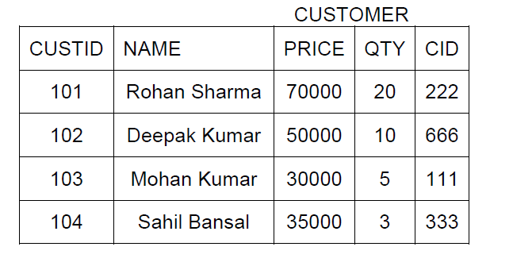

(i) To display those company name which are having prize less than 30000.
(ii) To display the name of the companies in reverse alphabetical order.
(iii) To increase the prize by 1000 for those customer whose name starts with ‘S’
(iv) To add one more column totalprice with decimal(10,2) to the table customer
(v) SELECT COUNT(*) ,CITY FROM COMPANY GROUP BY CITY;
(vi) SELECT MIN(PRICE), MAX(PRICE) FROM CUSTOMER WHERE QTY>10 ;
(vii) SELECT AVG(QTY) FROM CUSTOMER WHERE NAME LIKE “%r%;
(viii) SELECT PRODUCTNAME,CITY, PRICE FROM COMPANY,CUSTOMER
WHERE COMPANY.CID=CUSTOMER.CID AND PRODUCTNAME=”TV”;

6. a. State and verify 3rd Distributive law in Boolean Algebra?Write the complement of
it? (2)

b. Convert the following Boolean expression into its equivalent Canonical Sum of
Product Form(SOP) (1)
(X’+Y+Z’) . (X’+Y+Z) . (X’+Y’+Z) . (X’+Y’+Z’)

c.Prove algebraically ab’c+ab’c’+a’b’c=ab’+b’c (1)

d. Obtain a simplified form for a boolean expression using Kmap. (3)
F(U,V,W,Z)= ∑ (0,1,3,5,6,7,10,14,15)
e. Draw a logic circuit for the expression using NOR gates only (1)
F(x,y,z) = x’+y.z’

7. a. What is the purpose of using modem? (1)
b. What term do we use for a software/hardware device, which is used to block
unauthorized access while permitting authorized communications? This term
is also used for a device or set of devices configured to permit, deny, encrypt,
decrypt, or proxy all (in and out) computer traffic between different security
domains based upon a set of rules and other criteria. (1)
c. write two advantages for optical fibers. (1)
d. Expand CDMA and HTTP. (1)
e.Compare Email and Video Conferencing. (1)
f. Write one characteristics each for 3G and 4G mobile technologies. (1)

g. Global Village enterprises has set up its new center at Hyderabad for its office and web based activities. It has 4 blocks of buildings as shown in the diagram below: (4)
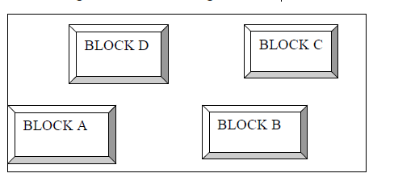

Center to center distances between various blocks
Block A to Block B 80 m
Block B to Block C 250 m
Block C to Block D 50 m
Block A to Block D 190 m
Block B to Block D 125 m
Block A to Block C 90 m

Number of Computers
Block A 25
Block B 50
Block C 150
Block D 10

i) Suggest a cable layout of connections between the blocks.
ii) Suggest the most suitable place (i.e. block) to house the server of this organization with a suitable reason.
iii) Suggest the placement of the following devices with justification
(i) Repeater (ii) Hub/Switch
iv) The organization is planning to link its International Office situated in Chennai , which wiredcommunication link , you will suggest for a very high speed connectivity?What type of networking would this connection results into?

Mrs. Deepa Ravi
kdeepa77@gmail.com

