Guess Paper – 2007
Class – X
Mathematics

Note : This paper will guide the students how to do self assessment.

- If a student is scoring 99-100 % in this paper he/she may get 100% in board exam.
- If a student is getting only 80-90% in this paper, he/she needs a thorough revision of whole syllabus. Thorough revision can be done by revising all concepts, facts and tricks. No need to do all questions which is not possible in 5 days. Attempt all important questions which are told by your teachers.
- As you are getting 5 days before your Maths paper, day 1 and day 2 revise all topics or do quick revision. Revise all formulae.
- On 3rd and 4Th day solve guess papers and do the self assessment.
- On 5th day analyze your mistakes and work accordingly. Cent percent marks are sure.
- All the best for 100%.

SECTION – A

1. Solve for x and y:
OR

2. Simplify:

3. The H.C.F. and L.C.M. of two polynomials P(x) and Q(x) are (3x+2) and (x-3)
(x³+11x² + 6x). If P(x)= x³-9x, find Q(x).
4. Using quadratic formula, solve the following quadratic equation:
(b-c) x² + (c-a) x +(a-b) = 0

OR,
The product of two consecutive multiples of 5 is 300. Find the numbers.

5. Which term of the sequence 24, 23$\frac{1}{4}$, 22$\frac{1}{2}$……… is the first negative term?
6. The present age of a father is 3 years more than three times the age of the
son. 3 Years hence, father’s age will be 10 years more than twice the age of
the son. Determine their present ages.
7. A T.V. set is available for Rs. 13,500 or Rs. 4500 cash down payment and 4
monthly instalments of Rs. 2400 each. Calculate the rate of interest charged
under the instalment scheme.

SECTION - B
8. Find graphically the vertices of the triangle whose sides have the following
equations: 2y-x=8, 5y-x=14, y-2x =1
9. A plane left 20 minutes late due to bad weather and in order to reach its
destination 1200 km away in time, it had to increase its speed by 120 km/hr.
from its usual speed. Find the usual speed of the plane.
10. A man borrows a certain sum and pays it back in two years in two equal
instalments. If compound interest is reckoned at 4% and if he pays back
annually Rs. 6760, what sum did he borrow?
11. If the diagonals of a quadrilateral divide each other proportionally, prove that
it is a trapezium.
OR
In a right angled triangle ABC, a circle with side AB as diameter is drawn to
interect the hypotenuse AC in L. Prove that the tangent to the circle at L
bisects the side BC.
12. A copper wire 4mm in diameter is evenly wound about a cylinder whose
length is 24 cm and diameter 20 cm so as to cover the whole surface. Find
the length and weight of the wire assuming the specific gravity to be 88.8
gram per cubic centimeter.
13. Construct a triangle ABC, in which A = 60⁰, BC = 5 cm, altitude AD = 4.5
cm. How many triangles are possible in this case?
14. If the points ( 3,5) , (p,2) and (7, -6) are collinear . Find the value of p.
OR
If the coordinates of the mid points of the sides of a triangle be (3,-2), (-3,1)
and (4,-3), then find the co-ordinates of its vertices.
15. Percentage of the different products of a village in a particular district are
given below. Draw a pie chart representing this information.
Items | Wheat | Pulses | Jwar | Ground  Nuts | Vegetables | Total
Percentage | 125/3 | 125/6 | 25/2 | 50/3 | 25/3 | 100

16. How many terms of the A.P. 78, 71, 64, ………. Are needed to give the sum
468? Also find the last term of this A.P>
17. Without using trigonometric table evaluate:
tan5⁰ tan10⁰ tan15⁰ tan75⁰ tan80⁰ tan85⁰
OR
Prove:
18. A bag contains identical tokens on which numbers 5 to 105 are marked. A
token is drawn randomly. What is the probability that the number on the token
is (i) an even number (ii) an odd number (iii) a multiple of 5 and 10.
19. Find the co-ordinates of the points of trisection of the line segment joining
the points A(2,1) and B(5, -8).
SECTION - C
20. A right triangle whose sides are 15cm and 20 cm is made to revolve about its
hypotenuse. Find the volume and surface area of the double cone so
formed.(use =3.14)
OR
The diameters of the top and bottom of a bucket are 2R and 2r unit. If the
bucket is h unit high and its slant height is l unit. Derive the formulas for its
volume and Curved Surface Area.
21. Mr Gopal Singh is a senior lecturer in Uttarakhand Govt. His monthly salary is
Rs. 32000. If he donates Rs. 3000 per month to Chinmaya Mission and get
50% relief. His per month deduction towards G.P.F. is 1000, he pays L.I.C.
premium as Rs. 5000 quarterly. He also invested Rs. 20000 in N.S.C. What
salary he will get in the last month if tax deduction for first 11 months is Rs.
300 per month.
INCOME TAX SLAB

Taxable income | Rate
Up to Rs. 1,00,000 | Nil
Rs. 1,00,001-1,50,000 | 10% of amount exceeding rs. 1,00,000
Rs 1,50,001-2,50,000 | Rs.5000+20% of the amount exceeding Rs.1,50,000
Exceeding Rs 2,50,000 | Rs. 25,000+30% of the amount exceeding Rs 2,50,000
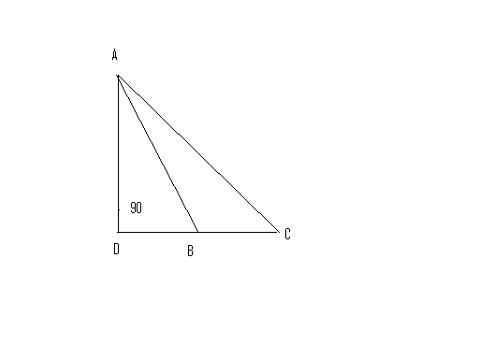
22. State and Prove Converse of Pythagoras Theorem.
In the adjacent figure ADBC,
Prove AC² = AB² + BC² + 2 BC. BD

23. Prove that if a line touches a circle and from the point of contact a chord is drawn, the angles which this chord makes with the given line are equal respectively to the angles formed in the corresponding alternate segments.
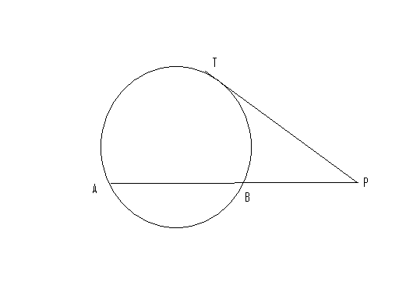
In the adjacent figure if PT is the tangent and PAB is a secant to the circle, Using this, Prove PT² = PA. PB

24. An aeroplane is flying at a constant height of 3000m. At an instant the angle
of elevation of this plane at a point is 60⁰ . After 15 seconds the angle of
elevation at the same point is 30⁰. Calculate the speed of the plane in Km per
hour.

25. If the mean of the following data is 57.6. Find the missing frequencies.
Class | 0-20 | 20-40 | 40-60 | 60-80 | 80-100 | 100-120
Frequency | 7 | f | 12 | g | 8 | 5

“You see things; and you say "Why?" But I dream things that never were; and I say "Why not?" George Bernard Shaw
You will never leave where you are, until you decide where you'd rather be.
“Your aspirations are your possibilities”. Samuel Johnson:
ALL THE BEST

Chandan Singh Ghughtyal
Chinmaya International Residential School Coimbatore T.N.
Email: chandanganga@gmail.com 09443061459, 09360461579

