Guess Paper – 2007
Class – IX
Social Science

Time: 3 hours] [Max. Marks : 80

General Instructions:
- Answers to questions carrying 2 marks should not exceed 30 words each.
- Answers to questions carrying 4 marks should not exceed 60-80 words each.
- Answers to questions carrying 6 marks should not exceed 100-125 words each.
- Maps should be securely tied in the middle of the answer book.
- Attempt all parts of a question together.

- Who were the Chinese rulers during the early 19th century? Why were they
suspicious of the foreign merchants? 2
- What are ‘reserved constituencies’? State their importance in a democracy. 2
- What are the steps to be taken in the event of a bomb scare? 2
- According to the variation in relief features, Northern Plains are divided into
four regions. Name these regions. 2
- What are the features of small scale manufacturing units in Palampur? 2
- Evergreen forests are found on the western slopes of Western Ghats. Give any
2 reasons. 2
(Or)
Which type of vegetation is found in Rajastan? Why? 2
- List out any 4 indicators of poverty. 2
- Name the largest peninsular river. Name any one tributary of this river. How
do peninsular rivers differ from Himalayan rivers? Give 2 differences. 2
- Who are the victims of chemical and industrial accidents? List any 3 effects of
these accidents? 2
- What do you understand by ‘Constitutional amendment’? Why do we need such amendments? 2

- Give reasons: 2
    - There is a decrease of rainfall from east to west in the Northern Plains.
    - The Peninsular region does not have a well–defined cold weather season.
- What is famine? Which was the most devastating famine that occurred in
India? Also mention the year in which it occured. 2
(Or)
Define the terms (i) Fair Price shops (ii) Green Revolution 2
- Suggest any 4 measures to avoid accidents on roads. 4
- Briefly explain the system of estates which was prevalent in the French society during the middle ages. 4
- What is migration? How does it affect the population of a place? Give any 2 reasons for the increase of life–expectancy from 36.7 years in 1951 to 64.6 years in 2001. 4
- Why do we need rights in a democracy? 4
(Or)
List any four functions of the Supreme Court. Why is an independent judiciary essential in a democracy? 4
- (a) What do you understand by ‘Western Disturbances’? Mention its
significance.
(b) How do monsoons act as unifying bond? 4
- Briefly discuss any 4 causes of poverty. 4
- What was Hitler’s idea of racism? Who were the sufferers of this idea in Nazi
Germany? 4
(Or)
How did the new Forest Rules affect cultivation? 4
- Why were Indian farmers reluctant to grow opium ? 4
- (a) What changes occurred in England with the coming of modern agriculture?
(b) What were ‘sumptuary laws’? 6
(Or)
(a) Why did the farmers in England grow turnip and clover during the 1600s?
(b) How did the industrialization of England lead to enclosing of farmlands? 6
- (a) Which is the most dominant type of natural vegetation in India?
Mention any 4 of its features.
(b) List out any 6 points to suggest the importance of forests in the
ecosystem? 3+3 = 6

- (a) What is food security? Explain its different dimensions.
(b) How is food security affected during a calamity or a disaster? 4+2 = 6
(Or)
Briefly describe the relevance of Right to Equality in public jobs and
social life. 6
- (a) In the given outline map of the world, locate any 4 of the following countries
(1) Germany (2) Italy
(3) USA (4) China
(5) France ½X4 = 2

24. (b) On the given outline map of India are shown two geographical features
marked 1 and 2. Identify these features with the help of the map key and
write their correct names on the line marked against each in the map.
      - A National Park
      - A west –flowing river. ½ X 2 =1
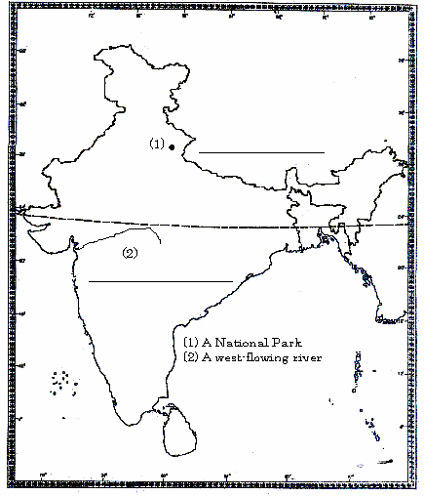

24. (c) On the given outline map of India, locate the following places:
- Kazhiranga National Park
- An area of tropical thorn forests
- Chilika lake
- Coromandel coast
- An area experiencing mango showers
- A state with high literacy rate. ½ X6=3

Prepared by:
SRIJITH.K.
Kochi, Kerala

Please Note:
This question paper includes all chapters from the following textbooks
- Geography
- Political Science
It does not include Chapter 2 in Economics textbook.
It includes only Part III from Disaster Management Textbook
The following chapters are included from History textbooks:
- Section I
  - French Revolution
  - Nazism and Rise of Hitler
- Section II
  - Forest Society and colonialism
  - Peasants and Farmers
- Section III
  - Clothing: A social history

