Guess Paper – 2007
Class – IX
Social Science

Time: 3 hours] [Max. Marks : 80

General Instructions:

- Answers to questions carrying 2 marks should not exceed 30 words each.
- Answers to questions carrying 4 marks should not exceed 60-80 words each.
- Answers to questions carrying 6 marks should not exceed 100-125 words each.
- Maps should be securely tied in the middle of the answer book.
- Attempt all parts of a question together.

- Suggest any 2 ways by which non–farming activities can be increased in a village. 2
- State any 4 arguments against democracy? 2
- In the 19th century, grain production in England grew as quickly as its population. Give 2 reasons for this increase in production. 2
- List out the factors which govern the safety of passengers in an air–craft. 2
- Compare any 4 features of east–flowing and west–flowing rivers of the Indian peninsula. 2
- (a) How do the Himalayan mountain range affect the climate of India. Suggest
any 2 points. 1
(b) Study the following table showing the temperature and rainfall of a place
Month | J | F | M | A | M | J | J | A | S | O | N | D
Temp(⁰C) | 24.5 | 25 | 26 | 26 | 27 | 36 | 37 | 33 | 29 | 30 | 24 | 24
Rain(cms) | 0.5 | 0.5 | 0.9 | 1.1 | 2.0 | 2.0 | 1.1 | 1.5 | 1.0 | 0.5 | 0.4 | 0.4

    - Calculate the annual rainfall.
    - What is the annual range of temperature? ½+½=1
- Right to Constitutional remedies is called the heart and soul of our
Constitution. Why? 2
- What are bioreserves? Give one example each from northern and southern
India. 2
Or
How does relief affect the distribution of flora and fauna of the country? 2
- What are the main features of the National Rural Employment Guarantee
Act 2005? 2
- List out any 4 causes of fire. 2
- Name any 2 hill ranges in North Eastern India. Give reason as to why
earthquakes are common in the Himalayan region. 2
- Define the terms: (a) MSP (b) Issue Price 2
Or
What commodities are available from Fair Price Shops? Name the three types
of ration cards. 2
- What led to the Great Economic Depression in USA in the 1930s? How did the
depression affect the middle classes? 4
- How did the two World wars bring about a change in women’s clothing? 4
- (a) What do you mean by ‘break’ in monsoons? Explain the reason behind it.
(b) Give reasons:
    - The delta region of the eastern coast is frequently struck by cyclones.
    - The Coromandel Coast receives rainfall during winter 2+2=4
- Clearly explain the significance of the Constitution of 1791 in French history 4
Or
Why did the people of Bastar revolt against the British? How was the rebellion suppressed? 4
- (a) Study the following pie–chart and answer the questions below:

i. How much is the dependent population of India in percentage? 1
ii. What are the implications of a large dependent population? 1
(b) What are the significant features of National Population Policy 2000? 2
- Write a short note on Buffer stocks. 4
- What is an epidemic? List the risk reduction measures against spread of
epidemics. 4
- Mention any 4 challenges to free and fair elections. 4
Or
How is the President elected? What are his powers? 4
- How and why did the cultivators and peasants raise protests against the British government against Opium cultivation? 6
Or
What was the situation of the poor people in England during the Enclosure
Movement? Explain briefly.
- In mountainous areas, the decrease in temperature and increase in altitude leads to corresponding change in natural vegetation. Justify the statement with reference to the Himalayan region. Also name any 4 animals found in this
region. 5+1= 6
- Briefly explain the three specific evils declared illegal under the Right against Exploitation by the Constitution. 6
Or
What are the advantages of PDS? What are the problems related to the
functioning of ration shops? 6
- (a) In the given outline map of the world, name and locate the following places:
      - The triangular trade route of tea and opium.
      - Region where maximum enclosure of common land took place in England.
      - The country where women wore flowing gown sweeping the ground during the 19th century.
      - Any one Axis power during the Second World War. ½ X 4 = 2
24. (b) On the given outline map of India are shown two geographical features
marked 1 and 2. Identify these features with the help of the map key and
write their correct names on the line marked against each in the map.
- A bird sanctuary
- A mountain range ½ X 2 = 1
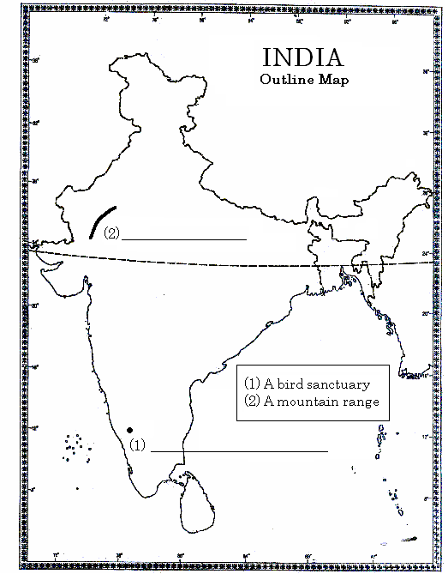

24. (c) On the given outline map of India, locate the following places:
- An area of mangrove forests
- Pulicat lake
- An area affected by Kal Baisakhi
- Bandipur wildlife sanctuary
- Chota Nagpur Plateau
- An eastern state with very high density of population. ½ x 6=3

Prepared by:
SRIJITH.K.
Kochi, Kerala

Please Note:
This question paper includes all chapters from the following textbooks
- Geography
- Political Science
It does not include Chapter 2 in Economics textbook.
It includes only Part III from Disaster Management Textbook
The following chapters are included from History textbooks:
- Section I
  - French Revolution
  - Nazism and Rise of Hitler
- Section II
  - Forest Society and colonialism
  - Peasants and Farmers
- Section III
  - Clothing: A social history

