Guess Paper – 2007
Class – IX
Social Science

Time: 3 hours] [Max. Marks : 80

General Instructions:

- Answers to questions carrying 2 marks should not exceed 30 words each.
- Answers to questions carrying 4 marks should not exceed 60-80 words each.
- Answers to questions carrying 6 marks should not exceed 100-125 words each.
- Maps should be securely tied in the middle of the answer book.
- Attempt all parts of a question together.

- What is scientific forestry? How were forests classified according to the
Forest Act? 1 + 1 = 2
- Poverty reduction is expected to make better progress in the coming years.
Give 4 reasons. ½ x 4 = 2
- Which is the standard meridian of India? Why is the time along this meridian
taken as the standard time of the country? 1 + 1 = 2
OR
Write a brief note on the formation of Himalayas. 2
- What is Universal Adult Franchise? Why is it important in a democracy? 2
- Give reasons: 2
  - River Godavari is known as ‘Dakshin Ganga’.
  - River Ganga develops large meanders
- State any 4 causes of fire. 2

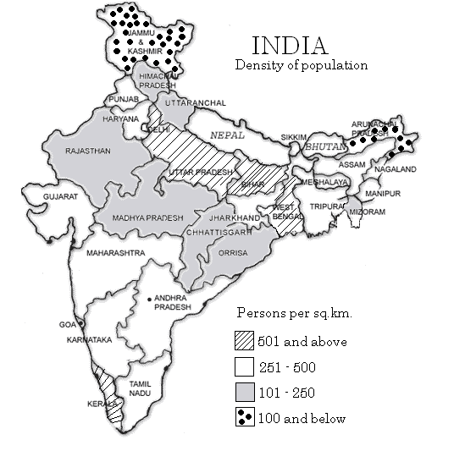
- Study the following map and answer the questions

  - Name two states having population density less than 100 persons/sq.km
  - Give 2 reasons for the low density in these states. 1 + 1 = 2

- Which are the two types of physical capital? Explain. 2
OR
Why is dairying considered a non–farming activity in Palampur 2
- Give an account of the weather conditions during the season of Retreating
Monsoons. 2
- List out the causes for occurrence of an epidemic. 2
- What is seasonal hunger? Mention its cause in rural and urban areas. 1+1=2
- Explain the terms: (a) Writ (b) Political executive 1 X 2 = 2
- Compare the reasons for the formation of enclosures in England during the 16th
and the late 18th centuries. 4
- (a)Distinguish between eastern coastal plain and western coastal plain.
(b) Mention any 4 features of the Indian desert. 2+2=4
- (a) What were the problems faced by pastoralists and peasants during the colonial rule in India?

(b) How did the British earn profit in Opium trade at the expense of Indian
farmers? 2+2=4
- Which period in France is known as the ‘Reign of Terror’? Why? 4
OR
Briefly explain the racial utopia that was existing in Nazi Germany. 4
- (a) Mention the powers of the Prime Minister. How has the coalition politics
imposed restriction on the powers of the Prime Minister?
(b) Which are the people who are more prone to food insecurity? 3+1= 4
- Mention any 4 steps adopted by the Government of India to protect the diverse
flora and fauna of the country? 4
- State four steps to be taken to reduce chemical and industrial accidents. 4
- List out any 4 functions of the Election Commission. 4
OR
How did hats and shoes, a part of clothing, create misunderstanding and
conflicts among the Indians and the British? 4
- Explain briefly the open field system that was prevalent in England during the 16th century. 6
OR
How did Indians react to the Western style of clothing which came into India in
the 19th century? Describe. 6
- Explain the major components of population growth. Write a brief note on the
age structure of population. 3 + 3 = 6
- Write a note on the role of cooperatives in providing food and related items. 6
OR
Which are the three qualities a right should possess? Explain briefly. 6
- (a) In the given outline map of the world, name and locate the following places:
    - Country from which tea was imported to England
    - Country where Great Economic Depression started
    - Country which attacked Pearl Harbour during World War II
    - Country in which suffrage movement started ½ X 4 = 2
24. (b) On the given outline map of India are shown two geographical features
marked 1 and 2. Identify these features with the help of the map key.
      - A state with high density of population
      - Place which receives highest rainfall ½ X 2 =1
24. (c) On the given outline map of India, locate the following places:
- River Indus
- An area of tropical rainforests
- Highest peak in South India
- A wildlife sanctuary in Jammu and Kashmir
- An area experiencing Western Disturbances
- A state with very low density of population. ½ x 6 = 3

