Guess Paper – 2007
Class – X
Mathematics

Time allowed: 3 hours Maximum Marks: 80

- Please check that this question paper contains 4 printed pages.
- Code number given on the right hand side of the question paper should be written on the title page of the answer-book by the candidates
- Please check that this question paper contains 25 questions.
- Please write down the serial number of the question before attempting it.

GENERAL INSTRUCTIONS: -

- All questions are compulsory.
- This question paper consists of 25 questions divided into three sections: - A, B and C. Section A contains 7 questions of 2 Marks each. Section B is of 12 questions of 3 Marks each and section C is of 6 questions of 5 marks each.
- There is no overall choice. However an internal choice has been provided in two questions of 2 Marks each, two questions of 3 Marks each and two questions of 5 marks each.
- In questions on constructions, the drawing should be neat and exactly as per the given measurements.
- Use of calculator is not permitted.

SECTION – A

Question numbers 1 to 7 carry 2 Marks each.
$\text{If P }=\frac{x+2}{x^{3}−1}−\frac{1}{x^{2}−1}\text{ , Q }=\frac{2x^{2}−3x+1}{x^{3}+1}\text{ and R }=\frac{4x^{2}−1}{x^{4}+x^{2}+1}$
Q.1

,find the multiplicative inverse of (P x Q) ÷ R in lowest terms.

Q.2 Solve the following system of equations: -
3 (a +3b) = 11 ab, 3 (2a + b) = 7 ab.
OR
$\frac{5}{x+y}−\frac{2}{x−y}=−1\text{, }\frac{\text{15}}{x+y}+\frac{7}{x−y}=\text{10}$ Solve the following system of equations: -

Q.3 The G.C.D. of two polynomials is x + 3 and their L.C.M. is x³ – 7x + 6. If one of the polynomial is x² + 2x – 3, find the other.
OR
Find the G.C.D. and L.C.M. of 4x⁴ + 16, 2x² + 4x + 4 and 2x³ – 4x – 8.

Q.4 Find the sum of all three digit numbers each of which leave the remainder 3 when divided by 7.

Q.5 A man borrows Rs.25220 which he undertakes to pay back with compound interest at the rate of 5% per annum in three equal annual instalments. Find the amount of each instalment.

Q.6 In Δ ABC, ∠C is acute, AD is perpendicular to BC. Prove that AB² = AC² + BC² – 2.BC.DC.

Q.7 A pair of dice is thrown once, find the probability of getting a number multiple of 2 on one dice and a multiple of 3 on the other.

SECTION – B

Question numbers 8 to 19 carry 3 marks each.

Q.8 Solve the following system of linear equations graphically.
3x + y – 12 = 0
x – 3y + 6 = 0
Also find the coordinates of the points where the lines meet the x – axis.

Q.9 If two pipes function simultaneously, the reservoir will be filled in 12 hours. One pipe fills the reservoir in 10 hours faster than the other. How many hours does each pipe take to fill the reservoir working alone.
OR
$x^{2}−2(a+2)x+(a+1)(a+3)=0$ Solve the following quadratic equation for $x$:

Also verify it by factorization method.

Q.10 In the given figure, PT is a tangent and PAB is a secant to the circle. If bisector of ∠ATB, meets AB at M. Prove that Δ MPT is isosceles.

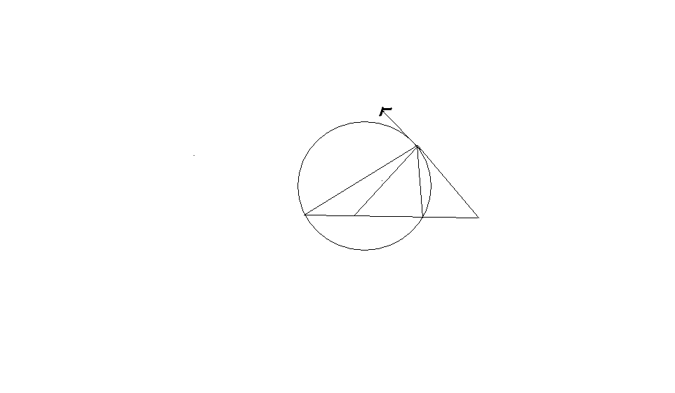
B
M
A
P
T
Q.11 Show that (sin θ + cosec θ)² + (cos θ + sec θ)² = 7 + tan² θ + cot² θ.
OR
Without using the trigonometric tables, evaluate the following: -
$2\left(\frac{{\text{cos}}^{2}{\text{20}}^{0}+{\text{cos}}^{2}{\text{70}}^{0}}{{\text{sin}}^{2}{\text{25}}^{0}+{\text{sin}}^{2}{\text{65}}^{0}}\right)−\text{tan}{\text{45}}^{0}+\text{tan}{\text{13}}^{0}\text{tan}{\text{23}}^{0}\text{tan}{\text{30}}^{0}\text{tan}{\text{67}}^{0}\text{tan}{\text{77}}^{0}$

Q.12 A cone is divided into two parts by drawing a plane through the mid point of its axis, parallel to the base. Compare the volumes of the two parts.

Q.13 What type of quadrilateral is formed by the points (3, 2), (0, 5), (- 3, 2) and (0, - 1), give reason in support of your answer.

Q.14 Construct a triangle ABC in which BC = 6 cm ∠A = 60⁰ and median AD through A is 5 cm long. Write the steps of construction. How many such triangles can be constructed? Also find length of the altitude through A.

Q.15 Which term of the sequence
20, 19 ¼ , 18 ½ …………… is the first negative term.

Q.16 An article is sold for Rs. 30000 cash or Rs.17500 as cash down payment and instalment of Rs. 1600 per month for eight months. Determine the rate of interest charged under the instalment plan.

Q.17 Books
Miscellaneous
15⁰ 140⁰

Entertainment 75⁰ 130⁰

Canteen

The above pie chart represents the spending of money by a student on various items. Find the expenditure on each item and the percentage expenditure on each item, If total expenditure is Rs.720.

Q.18 Find the centre of the circle passing through the points ( - 3, - 1), ( - 1, 3) and (6, 2), also find radius of the circle.

Q.19 Find ‘a’ and ‘b’ so that the polynomials
p (x) = (x + 2) (x² + 6x + 5) (x² + 2x + a) and
q (x) = (x + 4) (x² + 8x +15) (x² + 7x + b) may
have (x + 1) (x + 5) (x + 3) as their H.C.F.

SECTION – C

Question numbers 20 to 25 carry 5 marks each.

Q.20 Prove that in a right triangle, the square of the hypotenuse is equal to the sum of the squares of the other two sides.
Using the above theorem, prove that sum of the squares of the sides of a rhombus is equal to the sum of the squares of its diagonals.
OR
Prove that “The ratio of areas of two similar triangles is equal to the ratio of squares of their corresponding sides”.
Using the above, prove the following
Prove that the area of the equilateral triangle described on the side of a square is half the area of the equilateral triangle described on its diagonal.

Q.21 If PAB is a secant to a circle intersecting the circle at A and B and PT is a tangent segment then
PA. PB = PT². Prove it.
Using the above result prove that p is the mid point of AB, where AB is common tangent of two circles intersecting at M and N and PMN is the common chord. A P B

M

N

OR
Prove that “The angle subtended by an arc at the centre is double the angle subtended by it at any point on the remaining part of the circle”. Using the above, Prove the following if O is the centre of the circle, chords AQ and BP are intersecting at C such that ∠ACB = y, ∠AOB = z, ∠ARB = x. then show that x + y = z.
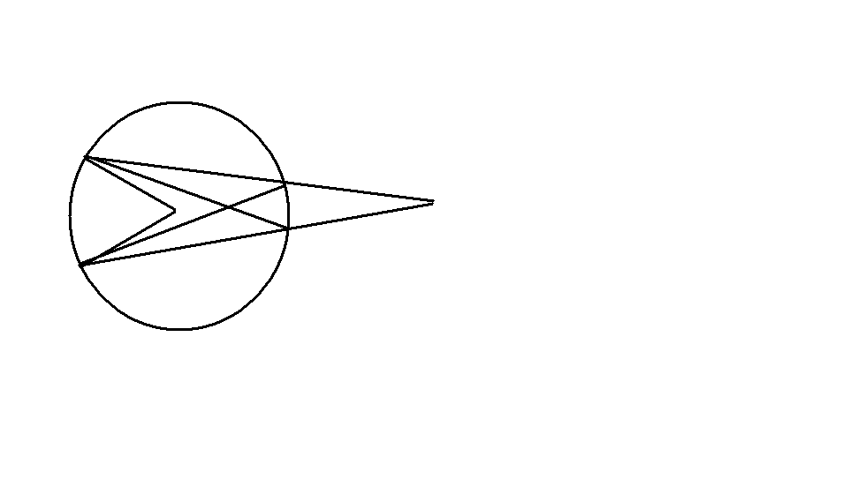
A
B
O
C
P
Q
R

Q.22 The internal radii of the ends of a bucket, full of milk and of internal height 16 cm are 14 cm and 7 cm. If this milk is poured into a cylindrical vessel fitted with a hemispherical end, the vessel is completely filled. Find the internal diameter of the vessel, if height of the cylindrical part is equal to diameter of the vessel.

Q.23 An aeroplane flying horizontally at a height of 2500 m above the ground is observed at an elevation of 60⁰, and after 15 seconds, the elevation is observed to be 30⁰. Find the speed of the aeroplane in km / hr.

Q.24 Find the mean of the following data by any two methods.

Marks | Below 20 | Below 40 | Below 60 | Below 80 | Below 100
Number of Students | 15 | 31 | 55 | 70 | 80

Q.25 Virendra gets a salary of Rs.90000 per month. He contributes Rs.4000 per month towards Provident fund, pays Rs.2000 per month as LIC premium. He also purchases NSC’s worth Rs.50000. He also invests Rs.20000 in Infrastructure bonds. He contributes Rs.15000 to PM’s national relief Fund and donates Rs.10000 to the college where he studied, getting a relief of 100% and 50% on the donations respectively. If Rs.15000 in the tax deducted each month from his salary for 11 months, find the tax deducted from his salary in the last month of the year.
Use the following for calculating income tax.

- Rebate for savings: 100% exemption for savings up to a maximum of Rs.100000
- Rate of income tax
Slab Income Tax
(i) Up to Rs.100000 No tax
(ii) From Rs.100001 to Rs. 150000 10% of the amount exceeding Rs.100000
(iii) From Rs. 150001 to Rs. 250000 Rs.5000 + 20% of the amount exceeding
Rs.150000.
(iv) From Rs.250001 and above Rs.25000+30% of the amount exceeding
Rs.250000
- Education cess 2% of the income tax
- Surcharge 10% of the net income tax if gross
income is more than Rs.100000

~~00~~

FORTUNE SUPPORTS BRAVE

BEST OF LUCK FOR YOUR EXAMINATIONS

BY,
SANDIP KUMAR DAS
DELHI PUBLIC SCHOOL, DAMANJODI
ORISSA
MOBILE NO.09437792384

