Sample Paper – 2007
Subject – Informatics Practices
Class - XII

Note
1. This question paper is divided into sections
2. Section – A consists 30 marks.
3. Section – B and Section – C are of 20 marks each
4. Answer the questions after carefully reading the text.

SECTION - A

1. Answer the following questions :
(a) What is Program Testing? [2]
(b) Explain Personal Management System. [2]
(c) Explain Two-tier system. [2]
(d) What is Data Mining ? [2]
(e) What is Metadata ? [2]

2. Answer the following questions :
(a) What is a Properties Window ? [2]
(b) What is a Flowchart ? [2]
(c) What is Class Modules ? [2]
(d) Explain Parent & Child Form. [2]
(e) What is Bound Control ? [2]

Q3 Answer the following questions
(a) What do you mean by TCL. [2]
(b) What is a Function in SQL ? [2]
(c) What is a Bind Variable ? [2]
(d) What is a Cursor ? [2]
(e) What is TCP/IP ? [2]

SECTION B

Q4 Read the following case study and answer the questions that follows
Mr. Vijay has designed a VB form to gather the data regarding the ranks and prize amounts won by different teams in am annual sports meet.
He has used different controls for storing the sports name, rank and the prizeamount respectively. Now he wishes to make the following changes to the application he designed.

Object | Object Name | Description
Form  Label  Text Box  Check Box  Command Button | FrmSports  Lblname  Lblparticapated  Lblrank  Lblprize  TxtTeamname  Txtrnkbasket  Txtrnkfootball  Txtrnkvolley  Txtprzhockey  Txtprzbasket  Txtprzfootball  Txtprzvolley  Txtprzhockey  Chkbasket  Chkfootball  Chkvolleyball  Chkhockey  Cmdcalculateprize  Cmdclear | The main Form Object  To enter Team name  To enter rank  To enter rank  To enter rank  To enter rank  To enter prize  To enter prize  To enter prize  To enter prize  To calculate the prize.  To clear the text box and check box

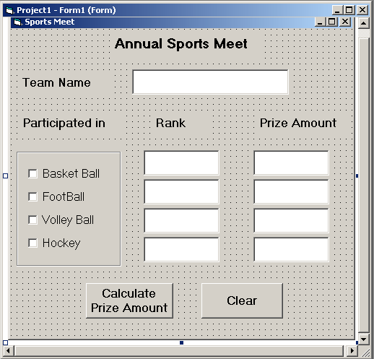

- The team Name should be displayed in upper case and the text box for rank should be enabled only if the corresponding check box is checked. [3]
- The text box for prize amount should be enabled only if the corresponding check box is checked [2]
- The contents of the text box prize amount should be a non-negative number. [2]
- When the user clicks the command button Calculate Prize Amount, the total prize amount should be displayed in a message box. [2]
- When the user clicks the clear button, the form should be restored to the default state. [1]

Q5 Answer the following questions:-
- Find the errors from the following code segment and rewrite the corrected code
underlining the correction made : [2]
Private Static Function Square(number As Long) As Long
Dim number As Long, temp As Long
Temp=number^2
Function Square=temp
End Function
(b) Give output of the following statements : - [2]
Private sub cmdDisplay_Click()
Dim counter As Integer
Counter=1
While counter<=10
Print Iif(Counter Mod 2, “$$$”, “????????”)
Counter=counter+1
Wend
End sub
(c) Change the following code using While…Wend loops without effecting the output : [2]
X=1
For J=0 to 20 step 2
If (J Mod 2)=1 then
Print X
Else
Print X-3
End If
Next j
(d) Write a Visual Basic function that takes two string arguments representing a first name
and a last name, concatenates the two strings to form a new string representing the full
name and return the concatenated string. [4]

SECTION C

Q6 Read the question given below and answer accordingly :
(a) Find the output of the following code in Pl/SQL : [2]
DECLARE
X CHAR(7):=’WELCOME’;
i NUMBER;
BEGIN
FOR i IN 1..7
LOOP
DBMS_OUTPUT.PUT_LINE(SUBSTR(x,I,I));
END LOOP;
END;

- Find the errors from the following PL/SQL code and rewrite the corrected code underlining
the correction made :
DECLARE
N AS NUMBER :=1;
WHILE N<10
PW=POWER(N,2);
DBMS_OUTPUT.PUT_LINE(PW);
N:=N+1;
END LOOP;
(c) Differentiate between Actual and Formal Parameters. [2]
- Write a PL/SQL function called PALINDROME which will accept an argument of NUMBER
type and returns the 1 if palindrome otherwise 0. [4]

Q6 Answer the questions based on the table Transaction given below :

Table : Transaction
Column Name | Data Type | Size | Constraint
Invoice Number  ItemCode  TransactionDate  TransactionMode  TransactionUnits  Rate | NUMBER  NUMBER  DATE  VARCHAR2  NUMBER  NUMBER | 10  10  -  10  5  7,2 | PRIMARY KEY  NOT NULL  NOT NULL

(a) Write the SQL command to create the table Transaction including the constraints. [2]
(b) Write the SQL command to display the details of all the Transaction done between1st Feb
2006 to 30th Aug 2006. [2]
(c) Write a PL/SQL code to increase the rate by 10 % for all the Transaction done after 1st Jan
- [3]
(d) Write a Pl/SQL block to create a trigger to display a Welcome message before each insert operation on the table. [3]

========***========

