M M-80 Time- 3Hrs

General Instructions
- All questions are compulsory
ii) The question paper consists of 25 questions divided into three sections A, B,
and C Section
- Section A contains 7 questions of 2 marks each,
Section B is of 12 questions of 3 marks each,
Section C is of 6 questions of 5 marks each.

SECTION A

Q1. Use Euclid's division lemma to show that the square of any positive integer is either of the form 3m or 3m + 1 for some integer m.

Q2. Divide 3x² - x³-3x+5 by x-1-x², and verify the division algorithm

Q3. Solve the following system of equations:
2x – y = 11
5x + 4y = 1

Q4. Solve the quadratic equation 6x² + x -15 = 0

Q5. The common difference of an AP is –2. Find its sum, if its first term is 100 and the last term is –10.

Q6. In the given figure $∠$A = $∠$B and AD = BE. Prove that DE || AB.

OR

If the area of two triangles are equal, prove that they are congruent.

Q 7. A chord of a circle of radius 12 cm subtends an angle of 120° at the centre. Find the area of the corresponding segment of the circle.
(Use π = 3.14 and $\sqrt{3}$ =1.73)

OR

A bag contains 3 red and 2 blue marbles. A marble is drawn at random. What is the probability of drawing a blue marble.

SECTION B
(Please email to educonfident@gmail.com)

Q8. Consider the numbers 4^{n}, where n is a natural number. Check whether there is any value of n for which.4^{n} ends with the digit zero.

Q9. Check whether the first polynomial is a factor of the second polynomial by dividing second polynomial by the first polynomial:

(i) t²-3, 2t⁴ + 3t³-2t²- 9t -12
(ii) x² + 3x + 1, 3x⁴ + 5x³ - 7x² + 2x +2

Q10. If A and B are (1,4) and (5,2) respectively, find the coordinate of P when AP/PB=3/4.

Q11. Find the value of cos¹²θ + 3cos¹⁰θ + 3cos⁸θ + cos⁶θ + 2cos⁴θ + 2cos²θ - 2,
if sinθ + sin²θ = 1.

Q.12. Draw a triangle with sides 3 cm, 4 cm and 5 cm. Draw its incircle.
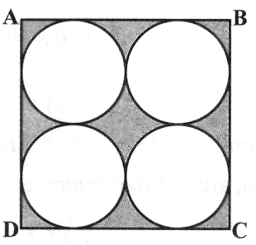
Q13. Find the area of the shaded region in figure, ABCD is a square of side 14 cm.

Q14. Prove that the points (-2, -1), (1, 0), (4, 3) and (1, 2) are the vertices of a parallelogram. Is it a rectangle ?
Q15. In a ΔABC, P and Q are points on sides AB and AC respectively such that PQ II BC. If AP = 4cm, PB = 6 cm and PQ = 3 cm, determine BC.

Q16. If the surface area of a sphere is 616cm², find its volume.

Q17. Find the angle of elevation of the sun (Sun’s altitude) when the length of shadow of a vertical pole is equal to its height.

Q18. In the following frequency distribution, the frequency of the class –interval (40-50) is missing. It is known that the mean of the distribution is 52. Find the missing frequency.

Wages | 10-20 | 20-30 | 30-40 | 40-50 | 50-60 | 60-70 | 70-80
No of workers | 5 | 3 | 4 | - | 2 | 6 | 13

Q19. What is the probability that an ordinary year has 53 Sundays.

SECTION C
(Please email to educonfident@gmail.com)

Q20. Prove that the ratio of the areas of two similar triangles is equal to the ratio of the squares of any two corresponding sides. Using this theorem, find the area of ΔABC if AB = 10 cm and area of Δ PQR= 12 cm², PQ = 11cm.
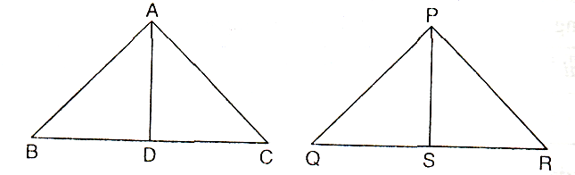

Q21. A solid cone, with height and base radius of 28 cm each, is cut along a plane parallel to its base so that the bottom and top radii of the remaining part are in the ratio 1 : 4. Find its volume. Also find the cost of painting its outer surface @ Re 0.70 per sq.cm.

OR
A wooden toy is conical at the top, cylindrical in the middle and hemispherical at the bottom (see figure). If the height and radius of the cylindrical portion are both equal to 21 cm and the total height of the toy is 70 cm, find the cost of painting it @ Re 0.70 per sq.cm and the amount of wood used to make it.

Q22. The diagonals of a cyclic quadrilateral are at right angles. Prove that the perpendicular from the point of their intersection on any side when produced backward bisects the opposite side.

Q23. Prove that any line parallel to parallel sides of a trapezium divides the non- parallel sides proportionally (i.e. in the same ratio)

Q24. At the foot of a mountain, the elevation of its summit is 45⁰. After ascending 1000m towards the mountain up a slope of 30⁰ inclination, the elevation is found to be 60⁰. Find the height of the mountain.

Q25. The following table gives weekly wages in rupees of workers in a certain commercial organization. The frequency of class 49-52 is missing. It is known that the mean frequency distribution is 47.2. Find the missing frequency.

Weekly Wages (Rs.) | 40-43 | 43-46 | 46-49 | 49-52 | 52-55
Number of workers | 31 | 58 | 60 | ? | 27

