Sample Paper – 2008
Class – XII
Subject – informatics Practices

Marks:70
Time : 3 hrs
- Answer the following:- (2*5)
  - Differentiate between public and private variables & discuss their scope visibility.
  - Expand the abbreviation ODBC. What does ODBC mean
  - What are intrinsic controls? Name any two
  - What do you understand by the term Record Source of an ADO data control?
  - Write a function in VB to toggle(invert) the case of each character of a string i.e characters in uppercase should be converted to lowercase and vice versa
- Explain in short:- (2*5)
  - Differentiate between pre-tested and post –tested loop .Give two example of each.
  - What is module? What are the different types of modules that can be created in VB ? Define all of them.
  - Find the errors from the following code segment and rewrite the corrected code underlining the correction made : 2
X=90
Do while x<=100
If x mod 6 =0
Print x-9
Else
Print x
X=x*3.4 + 45.98
Loop while x<=100
d. Rewrite the following code segment using For … Next instead of Do ..until: 2
Dim total as integer
Dim n as integer
Dim I as integer
N= val (text1.text)
Do until i< = n
Total =total +i
I=i+1
End do
e. Give the output of the follwing statements:
    - INSTR(LTRIM(“ INFORMATICS”), “ma”)
    - INT(40-20*4/3+5)

3. Read the following case study and answer the questions that follows
Mr. Vijay has designed a VB form to gather the data regarding the ranks and prize amounts won by different teams in am annual sports meet.
He has used different controls for storing the sports name, rank and the prizeamount respectively. Now he wishes to make the following changes to the application he designed.
Object | Object Name | Description
Form  Label  Text Box  Check Box  Command Button | FrmSports  Lblname  Lblparticapated  Lblrank  Lblprize  TxtTeamname  Txtrnkbasket  Txtrnkfootball  Txtrnkvolley  Txtprzhockey  Txtprzbasket  Txtprzfootball  Txtprzvolley  Txtprzhockey  Chkbasket  Chkfootball  Chkvolleyball  Chkhockey  Cmdcalculateprize  Cmdclear | The main Form Object  To enter Team name  To enter rank  To enter rank  To enter rank  To enter rank  To enter prize  To enter prize  To enter prize  To enter prize  To calculate the prize.  To clear the text box and check box

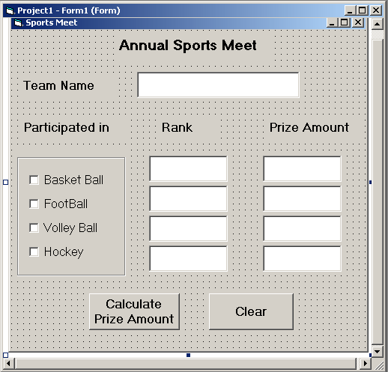

- The team Name should be displayed in upper case and the text box for rank should be enabled only if the corresponding check box is checked. [3]
- The text box for prize amount should be enabled only if the corresponding check box is checked [2]
- The contents of the text box prize amount should be a non-negative number. [2]
- When the user clicks the command button Calculate Prize Amount, the total prize amount should be displayed in a message box. [2]
- When the user clicks the clear button, the form should be restored to the default state. [1]
4. . Read the following case study and answer the questions that follow:
Mr. Vidyarthi works in Blossoms Public School as a programmer. He is required to develop a student record. The school offers two different streams, medical and non-medical, with different grading criteria. The school also offers incentive to the NCC cadets in the form of a 3% increment in percentage for all the NCC cadets. The grading criteria for the two streams are given below:
Stream | Percentage | Grade
Medical | >=80  60-80  <60 | A  B  C
Non Medical | >=75  50-75  <50 | A  B  C
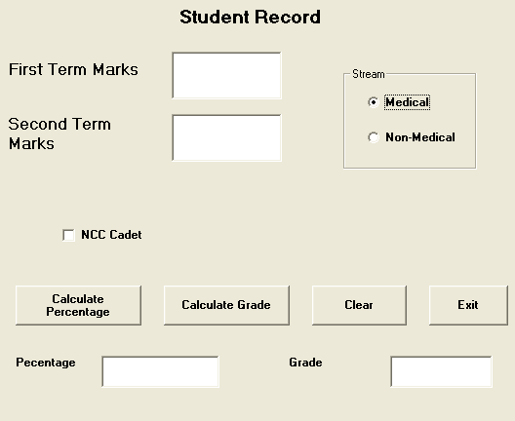
Object Type | Object Name | Description
Form | FrmStudRec | The Main Form object
Text  Box | TxtFirstTerm  TxtSecondTerm  TxtPercentage  TxtGrade | To enter first term marks  To enter second term marks  To display the percentage of the student  To display the grade of the student
Check Box | ChkCadet | To be Checked if student is an NCC Cadet
Option  Button | OptMedical  OptNonmedical | To provide Stream  Information
Command  Button | CmdCalcPer  CmdCalcGrade  CmdClear  CmdExit | To calculate the percentage  To calculate the grade  To clear the entered values  To close the application

(a) Write the commands to disable the textboxes txtPercentage and txtGrade. 1
(b) Write the code for cmdClear Command Button to clear all the textboxes and the checkbox. 1
(c) Write the code for cmdCalcPer to calculate the percentage after finding the total marks of first term and second term (assuming that both marks are out of 100). Also ensure that NCC cadets get an increment of 3% in their percentages. 4
(d) Write the code for cmdCalcGrade to calculate the grade depending on the stream selected according to the criteria given above. 4
5.
a. Design an application that lets the user enter a line of text and a word to be searched for. It then reports how many times the word has occurred in the line of text 4
b. Rewrite the following code segment using select case instead of if else : 3
Dim sal as integer
If sal >=10000 then
Msgbox (“ new year bonus is 2000”)
Elseif sal>=12000 and sal <=15000 then
Msgbox (“ new year bonus is 5000”)
Elseif sal= 20000 then
Msgbox (“ new year bonus is 7000”)
Else
Msgbox (“ Bonus not applicable”)
End if
c. Convert the following without using an for loop:- (3)
For i=3 to 1 step-1
if x=1 then
Print “One”
elseif x=2 then
Print “Two”
elseif x=3 then
Print “Three”
Endif
Next
6. a. Convert the following into a for loop:- (3)
i=99
Do while (i<=33)
Print i+10
i=i-3
loop
b. Difference between

a.SDI and MDI 2
b. Pass ByVal and Pass ByRef 2
c. What are the recordset types? Explain in brief 3
7
- Differentiate between DAO and ADODC? 2
- Differentiate between ADODC and ADODB project reference in detail? 4
- What are the lock Types? Explain? 2
- What is connection object ? Give example and purpose2

