Sample Paper- 2008
Class - XII
Subject - Physics

Time : Three Hours Max. Marks: 70

General Instructions

(a) All questions are compulsory.
(b) There are 30 questions in total. Questions 1 to 8 carry one mark each, questions 9 to 18 carry two marks each, questions 19 to 27 carry three marks each and questions 28 to 30 carry five marks each.
(c) There is no overall choice. However, an internal choice has been provided in one question of two marks, one question of three marks and all three questions of five marks each. You have to attempt only one of the given choices in such questions.
(d) Use of calculators is not permitted.
(e) You may use the following physical constants wherever necessary:

c = 3 x 10⁸ms⁻¹
h = 6.6 x 10⁻³⁴Js
e = 1.6 x 10⁻¹⁹C
μ₀= 4 π x 10⁻⁷ TmA⁻¹

Boltzmann constant k = 1.38 x 10²³ JK⁻¹
Avogadro’s number NA = 6.023 x 10²³/mole
Mass of neutron m_{n} = 1.6 x 10⁻²⁷kg

- State two properties of the material of the wire used for suspension of the coil in a moving coil Galvanometer.
- Why does the acceleration of a magnet falling through a long solenoid decrease?
- How does electric resistance differ from reactance?
- What evidence is there to show that sound is not electromagnetic wave?
- Vehicles moving in foggy weather use yellow color headlights. Why?
- Draw the graph showing the distribution of kinetic energy of electrons emitted during beta decay.
- What is the phase relation between input signal and output signal in the case of transistor amplifier in a) common emitter configuration b) common base configuration?

- The signals A and B are used as two inputs of NOR gate. Sketch the output wave form. Draw its logic symbol.
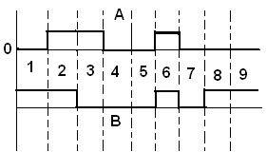

- Two point charges q_{A} = +3µC and q_{B}= -3µC are located 20 cm apart in vacuum.
  - Find the electric field at the mid point of the line (AB) joining the two charges.
  - If a negative test charge of magnitude 1.5x10⁻⁹ C is placed at the centre, find the force experienced by the test charge.
- When a battery of e.m.f E and internal resistance r is connected to a resistance R, a current I flows through it. Derive a relation between E, I, r and R.
- Draw a graph to show the variation of stopping with frequency of radiations incident on a metal plate. How can the value of Plank’s constant be determined from this garpah?
- The following circuit shows the use of potentiometer to measure the internal resistance of a cell.
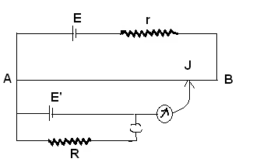

- State four properties of electromagnetic waves.

- How do optical fibers transmit light without significant absorption? Mention one practical application of optical fibres.
Or
What is the effect of increasing the diameter of the objective of a telescope on its i) magnifying power and ii) resolving power.

- Monochromatic light incident on a metal surface emits electron with kinetic energies from 0 to 2.6 eV. What is the least energy of incident photon if the tightly bound electron needs 4.2 eV to be removed?
- Foe a given impact parameter b, does the angle of deflection increases or decrease with increase in energy?
- Why do we use short waves for long distance radio broad cast?
- Derive an expression for the potential and kinetic energy of an electron in any orbit of a hydrogen atom, according to Bohr’s atomic model. How does P.E change with increasing n?
- Mention the frequency at which T.V signals are transferred. Derive an expression for the range up to which signals transmitted by a T.V tower can be received.
Or
Give point of difference between conductor, semiconductor and insulator on the basis of energy band theory.
- A slit of width ‘d’ is illuminated by light of wavelength 6500 A⁰. For what values of ‘d’ will the i) first minimum fall at an angle of diffraction of 30⁰ ii) First maximum fall at an angle of diffraction of 30⁰.
- Explain the principle, construction and working of a Van de Graff generator.
- Fig shows , how the reactance of an inductor varies with frequency
- Calculate the value of the inductance of the inductor using the information given in the graph.
ii) If the inductor is connected in series to a resistor of 8 ohm, find what would be the
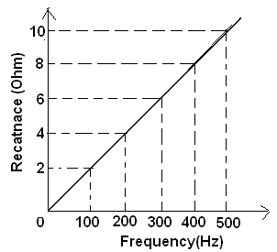
impedance at 300 Hz.

- Draw a ray diagram to show an image id formed by a compound microscope. On what factors will depend i) its resolving power, and ii) its magnifying power?
- Prove that an ideal inductor does not dissipate power in an a.c circuit.
Or

- Half life of a certain radioactive material against α –decay is 138 days. After what lapse of time the undecayed fraction of the material will be 6.25 %.
- State Gauss’ theorem. Express it mathematically. Apply this theorem to obtain an expression for electric field due to straight wire carrying a positive charge.
- What is the principle of a potentiometer? How can it be used for comparing emf’s of two primary cells? Why cannot we use a voltmeter for the same purpose?
- a) Draw the energy band diagram of an n-type semiconductor. How does the forbidden
energy gap of an intrinsic semiconductor vary with increase in temperature?
b) A transistor is connected in common-emitter configuration in which collector supply is
8V and the voltage across. The 800 Ω resisitor in the collector circuit is 0.5 V. If α = 0.96, determine the a) collector emitter voltage b) base current.
Or
Explain with the help of a labeled circuit diagram the use of a transistor as an oscillator.
- Derive the lens-maker’s formula in case of a double convex lens. State the assumptions made and convention of signs used.
Or
State the condition under which the phenomenon of diffraction of light takes place. Derive an expression for the width of the central maximum due to diffraction of light at a single slit.
- Give principle, construction and working of moving coil galvanometer.
Or
Explain the phenomenon of total internal reflection. State two conditions that must be satisfied for total internal reflection to takes place. Derive the relation between the critical angle and the refractive index of the medium. Draw ray diagrams to show a right angled isosceles prism can be used to i) deviate ray through 180⁰, and ii) to invert it.

viswamvinish@yahoo.co.in

