Sample Paper -2008
Class - XII
Subject - Physics

(NCERT PART 2)
Based on the new pattern for CBSE board examination 2008

Time allowed : 3 hours Maximum Marks : 70

General Instructions :
- All questions are compulsory.
- This paper includes questions from chapters nine to fifteen only
- Question numbers 1 to 8 are very short answer type questions, carrying one mark each.
- Question numbers 9 to 18 are short answer type questions , carrying two marks each.
- Question numbers 19 to 27 are also short answer type questions, carrying three marks each.
- Question numbers 28 to 30 are long answer type questions, carrying five marks each.
- Use of calculators is not permitted. However, you may use log tables, if necessary.

Q.1> Define “bandwidth” of a signal

Q.2> In a series of radioactive disintegration of ^{Z}X_{A} , first an alpha particle and then a beta particle is emitted. What is the atomic and mass number of the new nucleus formed by this disintegration.

Q.3> Mention one advantage of reflecting type telescope

Q.4> With that purpose was famous Davisson-Germer experiment with electrons performed?

Q.5> What should be the length of the dipole antenna for a carrier wave of frequency 3 × 10⁸Hz ?

Q.6> Why is heavy water used as a moderator in a nuclear reactor?

Q.7> What is the name given to that part of electromagnetic spectrum which is used for taking photographs of earth under foggy conditions from great heights?

Q.8> Draw the symbol of the universal logic gate.

Q.9> What is the frequency of the output if 50Hz input is applied to a (a) H.W. rectifier (b) F.W. Rectifier

Q.10> Give reasons for
- The sky appears blue
- Sun appears reddish at sunset and sunrise

Q.11> Draw energy band diagrams of p type and n type semiconductors

Q.12> State the two drawbacks of Bohr’s theory.

Q.13> Draw a labeled block diagram for a communication system

Q.14> An equi-concave lens of radius 10cm is made of a material having refractive index 1.5. Find the focal length of this lens when it is kept in water ( refractive index ⁴/₃ )

Q.15> An electron, an alpha particle and a proton have the same kinetic energy. Which of these will have the largest De’Broglie wavelength

Q.16> The two slits in YDSE are separated by 0.03mm and the screen is kept 1.5m away. The 4th bright fringe is at a distance of 1cm from the central maxima. Calculate the wavelength of light used.

Q.17> An astronomical telescope consist of 2 thin lenses 36cm apart and has a magnifying power of 8. Calculate the focal length of the lenses.

Q.18> Find the wavelength of the first and the last spectral line of balmer series.

OR

An electron makes a transition from 4th shell to the 1st shell. Find the wavelength of light emitted. To which spectral series does this transition belong?

Q.19> Draw the binding energy curve. What are the 2 main inferences of this curve?

Q.20> Show that the decay rate 'R' of a sample of a radionuclide is related to the number of radioactive nuclei 'N' at the same instant by the expression R =  λN.
(b) The half-life of ²³⁸U₉₂ against -decay is 1.5 × 10¹⁷ s. What is the activity of a sample of U²³⁸ having 25 × 10²⁰ atoms?

Q.21> Calculate the De’Broglie wavelength of (a) an electron in hydrogen atom moving with 0.01 times the speed of light and (b) a ball of radius 1cm and mass 0.3 kg moving with a speed of 5m/s. Hence show that the wave nature of matter is important at the atomic level but is not really relevant at the macroscopic level.

Q.22> Explain briefly, with the help of circuit diagram, how V—I characteristics of a p-n junction diode are obtained in (i) forward bias, and (ii) reverse bias. Draw the shape of the curves obtained.

OR

Distinguish between metals, insulators and semiconductors on the basis of their energy bands. Draw a graph showing the variation of resistivity of conductors and semiconductors with temp.

Q.23> Draw a circuit diagram for use of npn transistor as an amplifier in common emitter configuration. The input resistance of a transistor is 1000ohm. On changing its base current by 10microampere, the collector current increases by 2 m A. If a load resistance of 5K ohm is used in the circuit, calculate:
- The current gain
- Voltage gain of the amplifier

Q.24> Define the term modulation. Name three different types of modulation used for a message signal using a sinusoidal continuous carrier wave. Explain the meaning of any one of these.

Q.25> State and derive Snell’s law using wave theory.

Q.26> A material has a work function of 1.5 eV. Light of wavelength 310nm is incident on it. Find
- Kinetic energy of the emitted photo-electron
- Threshold wavelength
- Stopping potential

Q.27> State Bohr’s postulate for the ‘permitted orbits’ for the electron in a hydrogen atom. Use this postulate to prove that the circumference of the nth permitted orbit for the electron can ‘contain’ exactly n wavelengths of the De’Broglie wavelength associated with the electron in that orbit.

Q.28> What is binding energy. How is it related to mass defect?
The nucleus of an atom of ²³⁵Y₉₂, initially at rest, decays by emitting an alpha-particle as per the equation ²³⁵Y₉₂ → ²³¹X₉₀ + ⁴He₂ + Energy

It is given that the binding energies per nucleon of the parent and the daughter nuclei are 7.8 MeV and 7.835 MeV respectively and that of alpha-particle is 7.07MeV/nucleon. Assuming the daughter nucleus to be formed in the unexcited state and neglecting its share in the energy of the reaction, calculate the speed of the emitted alpha-particle. Take mass of alpha-particle to be 6.68 x 10-27 kg.

Q.29> Derive the relation b/w distance of object, image and radius of curvature of a convex spherical surface when refraction takes place from rarer medium to a denser medium and image produced is real. State assumptions and conventions of sign used.

OR

Using suitable ray diagrams, explain the following defects and their corrections
- Short sightedness
- Far sightedness
- presbyopia
- 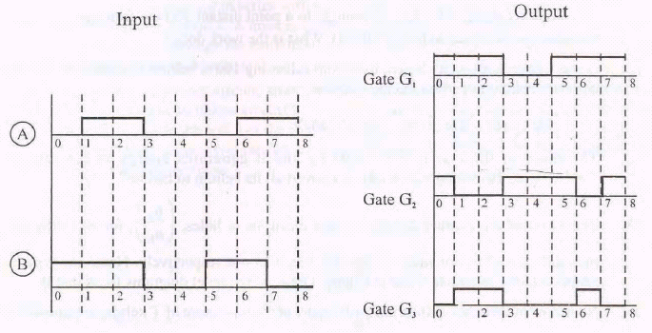astigmatism

Q.30> Two signals A and B as shown are used one by one as the two inputs of the three gates G1, G2 and G3. The outputs obtained from the three gates are as shown. Identify each of the three gates
Which of them is called the universal gate. Explain using a figure, how a combination of suitable number of this gate can be used to get the other 2 gates.

----< For solutions, write to >----

Abhishek Gupta
Dept. of Physics
I.I.T. - Delhi

Email: physics_css@yahoo.com

