Sample Paper – 2008
Class – X
Subject -Mathematics

Time:1 hour 15 minutes Max .Marks :35

Instructions
i) All questions are compulsory.
ii) The question paper is divided in to three sections A, B and C
iii) Section A consists of 4 questions of 1mark each
iv) Section B consists of 2 questions of 2 marks each
v) Section C consists of 5 questions of 3 marks each
vi) Section D consists of 2 questions of 6 marks each
vii) Use of calculator is not allowed.

Section - A

1. Following is the graph of the polynomial y = p(x).Find the zeros of p(x).

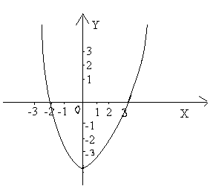

2 .If sin 3θ =1 then what is the value of tan θ?

3. If A+B = 90° and sin A = ⅔ then what is cosB?

4 .If length of arc of a circle of radius 5 cm is 8.2cm, find the area of the corresponding sector.

Section B

5. Prove that 3-2√2 is irrational.

6. Prove that the lengths of the tangents drawn from an external point to a circle are equal.
Section C
7.A train travels 360 km at a uniform speed .If the speed had been 5 km ∕h more, it would have taken 1 hour less for the same journey. Find the speed of the train.

8.A spiral is made up of successive semi circles, with centres alternately at A and B , starting with centre A ,of radii0.5cm,1.0cm,1.5cm,2.0cm,-----as shown in the following figure. What is the total length of such a spiral made up of 13 consecutive semi circles?
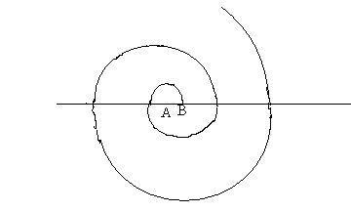

9. Find the point on the x-axis which is equidistant from (-2,5) and (2,-3). 10. The angles of elevations of the top of a tower from two points P and Q at distances of a and b respectively ,from the base and in the same straight line with it are complementary. Prove that the height of the tower is √ab.
11.Draw a pair of tangents to a circle of radius 5 cm which are inclined to each other at an angle of 60°.
Section D
12.A person can row 8 km upstream and 24 km downstream in 4 hours. He can row 12 km downstream and 12 km upstream in 4 hours .Find the speed of the person in still water and the speed of the current.
13. State and prove the converse of Pythagoras theorem. Using this prove the following:

In ∆PQR,QM ┴PR and PR²-PQ² =QR². Prove that QM² =PM*MR.

Best of luck

