Sample Paper – 2008
Class – X
Subject -Mathematics
Trigonometry (Assignment)
Prove the following identities:
- 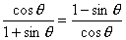
- 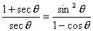
- 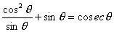
- 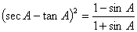
- 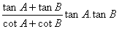
- 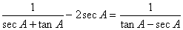
- 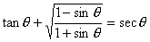
- 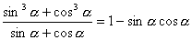
- 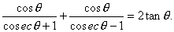
- 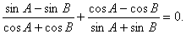
- 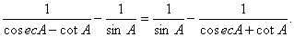
- 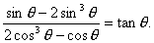
- 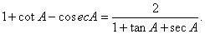
- 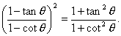
- If and show that <
- If prove that
- If prove that
- If prove that
- If 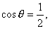find the value of 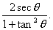
- If 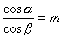and 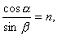show that
- If prove that
- If prove that
- Simplify:
- Evaluate:
- Evaluate: 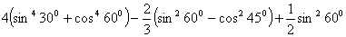
- Evaluate: 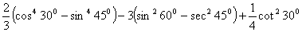
- 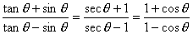
- 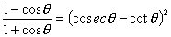
- 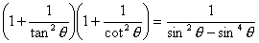
- 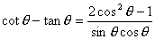
- 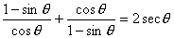
- 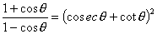
- . 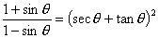
- 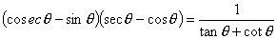
- 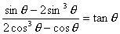
- 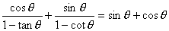
- 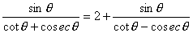
- 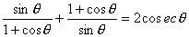
- 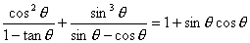
- 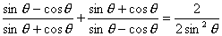
- 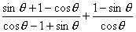
- 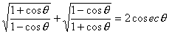
- 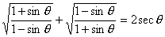
- 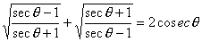
- 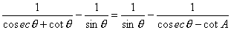
- 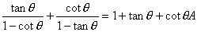
- 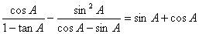
- 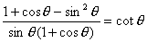
- 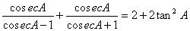
- If determine
- If Show taht
- If Show that
- If Show that
- If find the value of 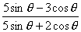
- If find the value of 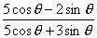
- If 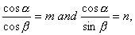show that
- prove that
- If 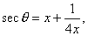prove that 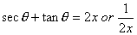
- If and prove that
- If prove that
- 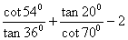
- 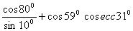
- 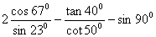
- 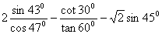
- 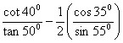
- tan 35⁰ tan 40⁰ tan 45⁰ tan 50⁰ tan 55⁰
- tan 7⁰ tan 23⁰ tan 60⁰ tan 67⁰ tan 83⁰
- tan 5⁰ tan 25⁰ tan 30⁰ tan 65⁰ tan 85⁰
- 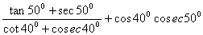
- 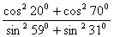
- 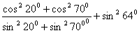
- 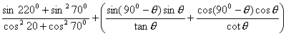
- 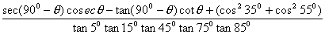
- Express sin 81⁰ + tan 71⁰ in terms of trigonometric ratios of angles between 0⁰ and 45⁰.
- Express cos 75⁰ + cot 75⁰ in terms of trigonometric ratios of angles between 0⁰ and 45⁰.
- If where are acute angles, find the value of
- . If A and B are acute angles and sin A = cos B, Prove that A + B = 90⁰.
- . If A, B, C are the interior angles of a triangle ABC, show that show that 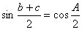
- 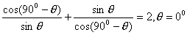
- 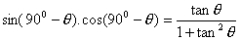
Er. VIKRANT AGGARWAL
(Lecturer, Ludhiana College of engineering & technology,
Lecturer – mathematics. institute of chartered accountant of India.)
ANANYA INSTITUTE
2502, HIG FLATS, PHASE-II, DUGRI, URBAN ESTATE, LUDHIANA M-9915089502

