Guess Paper – 2008
Class: - X
Subject - Mathematics
Maximum Marks: 80 Time: 3 hours
General Instructions:
- All questions are compulsory.
- This question paper consists of 30 questions divided into four Sections A, B, C and D. Section-A consist of 10 questions of 01 marks each, Section -B consists of 5 questions of 02 marks each, Section - C consist of 10 questions 03 marks each and Section – D consist of 5 questions 06 marks each.
- All questions in section – A are to be answered in one ward, one sentence or as per the exact requirement of the question.
- There is no overall choice. However, internal choice has been provided in one question of Section- B, three questions of Section-C and two questions of Section-D. You have to attempt only one of the alternatives in all such questions.
- In question of construction, drawings should be neat and exactly as per the given measurements.
- Use of calculator is not permitted.

SECTION A
- Which term of the AP : 21, 18, 15, ..... is –81?
- A system of simultaneous linear equation is said to be consistent, if it has __________ solution.
- Quadric equation has _________ solutions.
- The area of a circle inscribe in a equilateral triangle is 154sqcm. Find the perimeter of the triangle.
- Fill in the blank:
- A solid sphere of radius 6cm is melted and recast into small spherical balls each of diameter 0.6cm. Find the number of balls thus obtained.
(A) 2
(B) 3
(C) 4
(D) none
7. If three or more parallel lines are intersected by transversals, the intercepts made by them on the transversals are

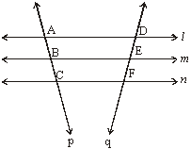

(A) 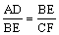
(B) 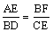
(C) 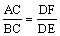
(D) 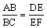
- A point P is 13 cm from the centre of the circle. The length of the tangent drawn from P to the circle is 12 cm. Find the radius of the circle.
- In a simultaneous throw of a pair of dice, find the probability of getting 8 as sum.
- If A (3, 1), B(2, 6) and C(–5. 7) are the midpoints of the sides of PQR, the area of the triangle is -------------
SECTION B

- If one of roots of x² + ax + 4 = 0 is twice the other root, then find the value of ‘a’?
- Find all the zeroes of , if you know that two of its zeroes are .
- Which term of the AP 24, 21, 18, 15, .... is the first negative term?
- How many two-digit numbers are divisible by 5?
- A boat goes 30km upstream and 44km downstream is 10hrs. In 13 hrs it go 40km upstream and 55 km downstream. Determine the speed of the stream and that of boat in still water.
SECTION C
- In the fig. ABC is a rt. , rt. angled at B. AD and CE are the two medians drawn from A and C respectively. If AC = 5 cm. and AD 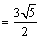cm. Then CE

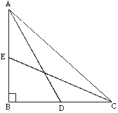
- A(–1, 2), B(4, 1) and C(7, 6) are three vertices of the parallelogram ABCD. The coordinates of fourth vertex is.
- If the distance between points (p, –7),(9, –7) is 15 units, then p is______
- If then find m² – n²?
- Evaluate : 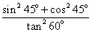
- Prove that 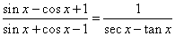
- Find the mode of the following distribution table.
V. 0-10 10-20 20-30 30-40 40-50 50-60 60-70 70-80
F: 5 8 7 12 28 20 10 10
- Four equal circles, each of radius 7cm touch each other as shown in figure. Find the area included between them.
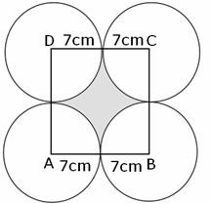
- Construct an isosceles triangle whose base is 8 cm and altitude 4 cm. Then construct another triangle whose sides are times the corresponding sides of the isosceles triangle.
- If 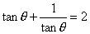, find the value of 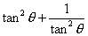.
SECTION D
- A hollow cone is cut by a plane parallel to the base and the upper portion is removed. If the curved surface of the remainder is 8/9 of the curved surface of the whole cone. Find the ratio of the line-segment in which the cone’s altitude is divided by the plane.
- The angles of elevation of the top of a tower from two points at distances and metres from the base and in the same straight line with it are complementary, prove that the height of the tower is metres.
- The coefficient of x in the quadratic equation x² + px + q = 0 was taken as 17 in the place of 13 and its roots were found to be –2 and –15. The roots of the original equation are?
- In fig. ABC is a right-angled at B such that BC=6 cm and AB=8 cm. Find the radius of its incircle.
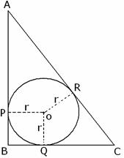
- prove the Pythagoras theorem. Using it In the figure ABC is obtuse. Then AC² = (A) AB² + BC² – 2BC. BD
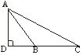

SHAURYA VEEDYA PEETH
BIKANER
SANJAY BATRA
09929181531

