Sample Paper - 2008
Class – X
Subject - Mathematics

Time allowed: 3 hrs M.Marks: 80

General Instructions:
- All questions are compulsory.
- This question paper consists of 30 questions divided into four Sections A, B, C and D. Section-A consist of 10 questions of 01 marks each, Section -B consists of 5 questions of 02 marks each,
Section - C consist of 10 questions 03 marks each and Section – D consist of 5 questions 06 marks each.
- There is no overall choice. However, internal choice has been provided in one question of Section- B, three questions of Section-C and two questions of Section-D. You have to attempt only one of the alternatives in all such questions.
- All questions in section – A are to be answered in one word, one sentence or as per the exact requirement of the question.
- In question of construction, drawings should be neat and exactly as per the given measurements.
- Use of calculator is not permitted.

SECTION – A

  - Use Euclid’s division algorithm to find HCF of 420 and 130
  - In the given figure the graph of a polynomial p(x) is given. Find the zeroes of the polynomial.


  - For what value of k will the following pair of linear equation have no solution?
3x+y=1
(2k-1)x+(k-1)y=2k+1
  - If A, B C are interior angles of a Δ ABC, then show that $\text{sin}\frac{B+C}{2}=\text{cos}\frac{A}{2}$
  - If sin (A-B) =$\frac{1}{2}$, cos (A+B) =$\frac{1}{2}$, $0°$⁰, A>B, find A and B.
  - If the perimeter and the area of a circle and numerically equal then what is the radius of the circle.
  - If tangent PA and PB from a point P to a circle with centre O are inclined to each other at angle 80⁰ then what is the value of$∠\text{POA}$?
  - Express sinA in term of cotA.
  - Savita and Hamida are friends, what is the probability that both will have the same birthdays in a non-leap year.
  - What is the value of the median of the data given in the following figure.
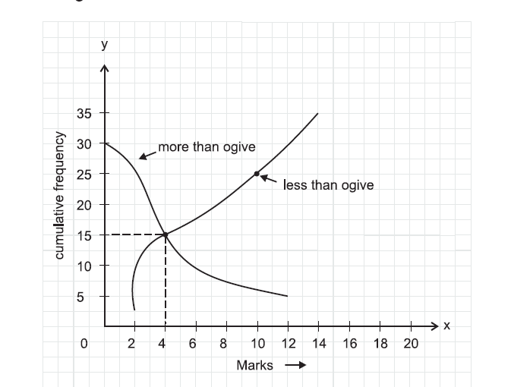

Section B
  - Find the sum of first 51 terms of an AP whose second and third terms are 14 and 18 respectively.
  - One card is drawn from a well shuffled deck of 52 cards calculate the probability that the card will
- not be an ace
- be an ace

  - Find the solution of the pair of equations $\begin{aligned}\frac{4}{x}+3y=\text{14} \\ \frac{3}{x}−4y=\text{23}\end{aligned}$
  - If the point A(6,1), B(8,2),C(9,4) and D(p,3) are vertices of a parallelogram, taken in order, find the value of p.
  - Find a quadratic polynomial, the sum and product of whose zeroes are -3 and 2 respectively.
OR
What are quotients and remainder, when x³-3x²+5x-3 is divided by x²-2.

Section C

  - A train travels 360km at a uniform speed. if the speed had been 5km/h more, It would have taken 1 hour less for the same journey. Find the speed of the train.
  - Show that $\sqrt{2}$ is an irrational number.
  - Find the roots of the quadratic equation 3x²-2$\sqrt{6}$x+2=0
  - Draw a circle of radius 3cm. Take two points P and Q on one of its extended diameter each at a distance of 7cm from its centre. Draw tangents to the circle from these two points P and Q.

  - Prove that $(\text{cos}\text{ecA}−\text{sin}A)(\text{sec}A−\text{cos}A)=\frac{1}{\text{tan}A+\text{cot}A}$

OR
Evaluate
- $\frac{{\text{sin}}^{2}\text{63}\text{°+}{\text{sin}}^{2}\text{27}°}{{\text{cos}}^{2}\text{17}\text{°+}{\text{cos}}^{2}\text{73}°}$

- $$\text{tan}\text{48}°\text{tan}\text{23}°\text{tan}\text{42}°\text{tan}\text{67}°$$

  - If the areas of two similar triangles are equal, prove that they are congruent.
OR
PQ is a chord of length 8cm of circle of a radius 5cm. The tangents at P and Q intersects at point T. find the length of TP and TQ

  - Find a relation between x and y such that the point (x,y) is equidistant from points (7,1) and (3,5).

  - Find the area of the triangle formed by joining the midpoints of the sides of a triangle whose vertices are (0,-1),(2,1) and (0,3).
  - ABC and AMP are two right angled triangles right angled at B and M respectively. prove that
A
P
B
C
M

- $Δ\text{ABC}$ ∼ΔAMP
- CA×MP=PA×BC

  - Find the area of the segment AYB shown in figure, If radius of the circle is 21cm and $∠\text{AOB}=\text{120}°$ (use π=$\frac{\text{22}}{7}$)
Y
B
A
O
120
21cm
21cm

OR

Find the area of the shaded region whose ABCD is a square of side 10cm and semicircles are drawn with each side of the square as diameter (use π=3.14)

A
B
D
C

Section D
  - In a triangle, if square of one side is equal to the sum of the squares of other two sides, then angle opposite the first side is a right angle.using the converse of above theorem determines the length of an altitude of an equilateral triangle of side 2a.

  - Given the linear equation 2x+3y-8=0, write another linear equation in two variable such that the geometrical representation of the pair so formed is intersecting lines. and solve that equation so obtained with given equation graphically.

  - The angles of depression of the top and bottom of an 8m tall building from the top of multi-storeyed building are 30° and 45° respectively. Find the height of the multi-storeyed building and distance between the two buildings.

  - A metallic right circular cone 20cm height and whose vertical angle is 60° is cut into two part at the middle of its height by a plane parallel to its base. if the frustum so obtained is drawn into a wire of diameter $\frac{1}{\text{16}}$ cm, find the length of the wire.

OR
A solid iron pole consists of cylinder of height 220cm and base diameter 24cm, which is surmounted by another cylinder of height 60cm and radius 8cm. find the mass of the pole, given that 1cm³ of iron has approximately 8g mass. (Use π=3.14)

  - The median of the following data is 525. find the values of x and y, if the total
frequency is 100.

Class interval | frequency
0-100 | 2
100-200 | 5
200-300 | x
300-400 | 12
400-500 | 17
500-600 | 20
600-700 | y
700-800 | 9
800-900 | 7
900-1000 | 4

OR

Consider the following distribution and find mean using step deviation method.
Class interval | frequency
50-52 | 15
53-55 | 110
56-58 | 135
59-61 | 115
62-64 | 25

