SAMPLE QUESTION I - 2008
Class - X
Subject - Mathematics

Time:3hrs Set - 1 Max.Marks:80

General Instructions
- All questions compulsory
- The question paper consist of thirty questions divided in to 4 sections A,B,C and D. Section A comprises of ten questions of 1 marks each ,Section B comprises of five questions of 2 marks each, Section C comprises of ten questions of 3 marks each and section D comprises of five questions of 6 marks each
- All questions in section A are to be answered in one word , one sentence or as per the exact requirement of the question
- there is no overall choice .However internal choice has been provided in one question of 2 marks each ,three question of three marks each and two questions of 6 marks each .You have to attempt only one of the alternatives in all such questions.
- In question on construction ,drawings should be neat and exactly as per the given measurements
- Use of calculators is not permitted .However you may ask for mathematical tables

SECTION A
1. $5×7×\text{13}×\text{17}+\text{17}$ is a composite number because ………………………
2. Are the system of linear equations x + 2y = 5, 3 x + 12y =10 consistent? Give reason.
3. If $α$,$β$,$γ$ are zeros of the cubic polynomial ${\text{ax}}^{3}+{\text{bx}}^{2}+\text{cx}+d$ then $\text{αβ}+\text{βγ}+\text{γδ}$ =……
4. The common difference of an A.P. is 4 then the value of t₆₀-t₅₅ is:
5. The mean of 30 numbers is 18. If 5 is added to every number, then the new
mean is:
6. One card is drawn from a well-shuffled deck of 52 cards. Calculate the probability that the cards will not be an ace.
7. Given tanA = ¾ , find sinA cosA.
8. Two cubes each of 10 cm edge are joined end to end. The surface area of the
resulting cuboid is: P
9. M and N are points on the sides PQ and PR
respectively of Δ PQR. State whether PQ//QR. M N
PM = 4cm, MQ = 4.5cm, PN = 4cm, NR = 4.5cm
P
T
Q
O
Q R
10. Two tangents TP and TQ are drawn to circle with
centre O from an external point T, and
∠PTQ = 60⁰, find ∠OPQ.

SECTION B

11. m and n are zeros of ${\text{ax}}^{2}−5x+c$ . Find the values a and c if $m+n=m\text{.}n=\text{10}$
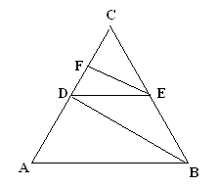
12. In the figure ,AB parallel to DE and BD parallel to EF , is ${\text{CD}}^{2}=\text{CF}×\text{CA}$ justify your answer

13. Without using trigonometric table find the value of
$\frac{\text{Sin}{\text{50}}^{0}}{\text{Cos}{\text{40}}^{0}}+\frac{\text{Co}\text{sec}{\text{40}}^{0}}{\text{Sec}{\text{50}}^{0}}−4\text{Cos}{\text{50}}^{0}×\text{Co}\text{sec}{\text{40}}^{0}$
14. Determine the ratio in which the point $(−6,a)$ divides the join of $A(−3,−1)$ and $B(−8,9)$ also find the value of a
15. In a single throw of two dice , find the probability of getting
i) Two heads ii) At least one heads

SECTION C
16. Find the HCF of 426 and 576 using Euclid’s division algorithm
17. Draw the graph of $x−y+1=0$ and $3x+2y−\text{12}=0$ and show that there is a unique solution .Calculate the area bounded by these lines and x-axis
18. On dividing $x^{3}−3x^{2}+x+2$ by a polynomial$g(x)$, the quotient and remainder were $x−2$ and $−2x+4,$ respectively. Find$g(x)$.
19. A polygon has 10 sides .The lengths of the sides starting with the smallest form an AP .If the perimeter of the polygon is 420 Cm and the length of the longest side is twice that of the shortest side .Find the first term and the common difference of the AP .
20. Prove that the opposite sides of a quadrilateral circumscribing a circle subtend supplementary angles at the centre of the circle.
21. Draw a triangle ABC with side $\text{BC}=6\text{cm}$ , $∠B={\text{30}}^{0},∠A={\text{120}}^{0}$ then construct a triangle whose sides are $\frac{4}{3}$ times the corresponding sides of $Δ\text{ABC}$.
22. Prove that $(\text{sin}A+\text{cos}\text{ecA})^{2}+(\text{cos}A+\text{sec}A)^{2}=7+{\text{tan}}^{2}A+{\text{cot}}^{2}A$
OR
Prove that $\frac{\text{cos}A−\text{sin}A+1}{\text{cos}A+\text{sin}A−1}=\text{cos}\text{ecA}+\text{cot}A$ , Using the identity $\text{cos}{\text{ec}}^{2}A=1+{\text{cot}}^{2}A$
23. Observe the graph and state whether the quadrilateral ABCD is a parallelogram .Justify your answer .
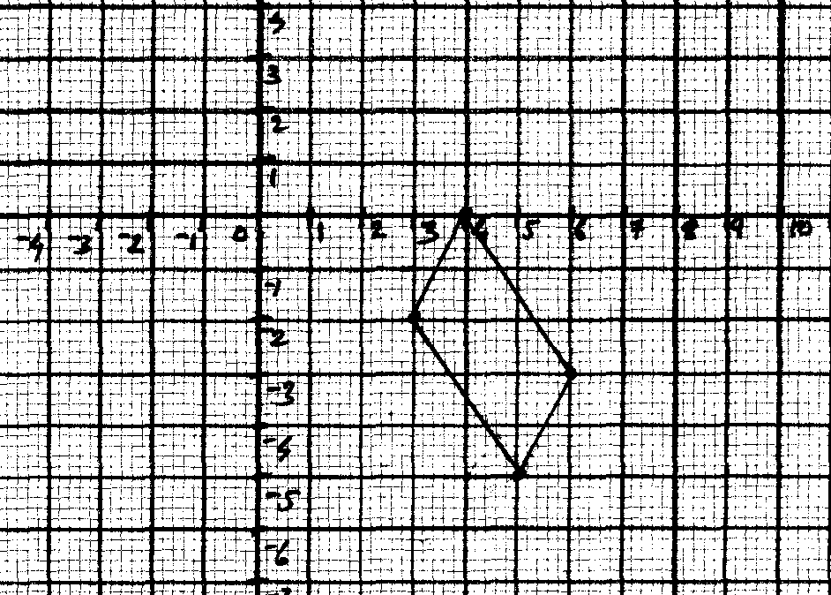

24. Find the area of the triangle formed by joining the mid points of the sides of the sides of triangle whose vertices are $(4,−7),(−8,7),(\text{10},\text{13})$
25. A regular hexagon is circumscribed by a circle of radius 14 cm. Find the area of the shaded region use $\sqrt{3}=1\text{.}7,π=\frac{\text{22}}{7}$
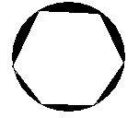

SECTION D
26. A train covers a distance of 90 Km at uniform speed .Had the speed been 15 Km /hr more. It would have taken 30 minutes less for the journey find the original speed of the train
OR
A party of tourists booked a room in a hotel for Rs 1200 , three of the members failed to pay as a result others had to pay Rs 20 more (each) . How many tourists were there in the party?
27. Prove that in a right triangle , the square of the hypotenuse is equal to the sum of the squares of the other two sides. Using the above solve the following
L and M are the mid points of AB and BC respectively of $Δ\text{ABC}$, right angled at B prove that $4{\text{LC}}^{2}={\text{AB}}^{2}+4{\text{BC}}^{2}$
28. The angle of elevation of a jet plane from a point A on the ground is ${\text{60}}^{0}$ .After a flight of 15 seconds , the angle of elevation changes to ${\text{30}}^{0}$ .If the jet plane is flying at a constant height of $\text{1500}\sqrt{3}m$ , find the speed of the jet plane.
29. A building is in the form of a cylinder surmounted by a hemispherical vaulted dome ,the building contains 17.7 m³ of air and its internal diameter is equal to the height of the cylindrical part find the height of the building (use $π=\frac{\text{22}}{7}$).
30. If the mean of the following frequency distribution is 53, find the value of ‘f₁ and f₂’
Class: 0 – 20 20 – 40 40 – 60 60 – 80 80 – 100 total
Frequency: 15 f₁ 21 f₂ 17 100

