SAMPLE QUESTION PAPER
CLASS XII (2024-25)
INFORMATICS PRACTICES (065)
TIME : 03 HOURS M. M. : 70

General Instructions :
1. This question paper contains five sections, Section A to E.
2. All questions are compulsory.
3. Section A has 18 questions carrying 01 mark each.
4. Section B has 07 Very Short Answer type questions carrying 02 marks each.
5. Section C has 05 Short Answer type questions carrying 03 marks each.
6. Section D has 02 questions carrying 04 marks each.
7. Section E has 03 questions carrying 05 marks each.
8. All programming questions are to be answered using Python Language only.

SECTION A

- From the followings statements which is/are not correct? (1)
(i) Switch and Hub are network devices and both are used to connect multiple devices
(ii) Gateway connects two similar networks
(iii) Modem is a network device used for converting protocols
(iv) Repeater is used to strengthen weak signals in a network
Find the correct answer :
- (i) and (iii)
- (i) , (iii) and (iv)
- (ii) , (iii) and (iv)
- (ii) and (iii)
- AADYA SINGHANIA of AGCS, Purulia abides by some rules, regulations, manners and shows (1)
good behavior while working online. Her acts are collectively known as _________________.
(a) Computer Etiquettes
(b) Secured Etiquettes
(c) Digital Etiquettes
(d) Net Etiquettes
- State True or False : (1)
(i) Plagiarism is known as Academic Theft.
(ii) Intellectual Property Rights safeguards your investments made in share market.
Choose the correct option :
(a) (i) True (ii) False
(b) (i) False (ii) True
(c) (i) True (ii) True
(d) (i) False (ii) False

- GORAV DUDHERIA wants to write equivalent command of the following MySQL command. (1)
Suggest him the correct one.
Select ALL Book_Name From Library;
- Select * Book_Name From Library;
- Select Book_Name(*) From Library;
- Select Book_Name From Library;
- None of these
- What will be displayed after the execution of the following command? (1)
Select TName From Teacher Where TName Like '%D%';
- All names of the teachers which contains D in the end.
- All names of the teachers which contains D in the middle.
- All names of the teachers which contains D in the start.
- All names of the teachers which contains D anywhere.
- Which of the followings is a unique data trace of a user's activities, actions, communications or (1)
transactions in the world of internet.
(a) Internet Footprint
(b) Digital Footprint
(c) Digital Record
(d) Browser History
- Identify the type of charts given below : (1)
(i) (ii)
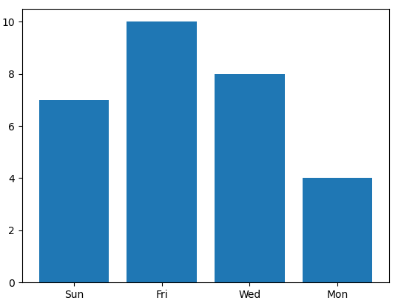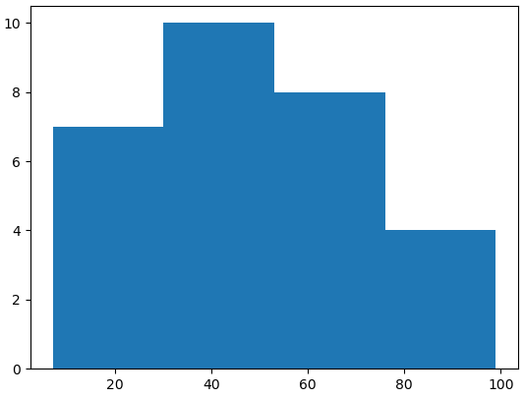
(a) (i) Histogram (ii) Bar Chart
(b) (i) Bar Chart (ii) Histogram
(c) (i) Bar Chart (ii) Bar Chart
(d) (i) Histogram (ii) Histogram
- Which of the following statements show the correct use of DISTINCT clause? (1)
- Select DISTINCT Name From Student;
- Select Name DISTINCT From Student;
- Select DISTINCT (Name) From Student;
- Select Name = DISTINCT From Student;
Choose the correct option :
- (ii) , (iii) , (iv)
- (i) , (iii)
- (i) , (ii) , (iv)
- (ii) , (iii)

- What will be the output of the given MySQL command? (1)
SELECT MOD(73.2 , 6) + ROUND(7326.6237 , -2);
(a) 7312.2
(b) 7362.0
(c) 7301.2
(d) 7401.2
- Given an import statement in Python. Find the equivalent statement for the same. (1)
import matplotlib.pyplot as plt
(a) from matplotlib import pyplot
(b) from matplotlib import pyplot as plt
(c) import pyplot from matplotlib as plt
(d) import pyplot as plt from matplotlib
- What will be the Degree and Cardinality of the given MySQL table? (1)
Id | Name | Address | Job
E206 | RAJOSHEE MUKHERJEE | Kolkata | Doctor
E387 | SHREYA BHAGAT | Mumbai | Teacher
E422 | ANGANA PALIT | Purulia | Scientist
E641 | PRACHI TULSYAN | Indore | Designer
E714 | RONIT SINGH | Ambala | Professor
(a) Degree = 4, Cardinality = 6
(b) Degree = 4, Cardinality = 5
(c) Degree = 5, Cardinality = 4
(d) Degree = 6, Cardinality = 4
- HARSHITA JAISWAL has created the following Series object named 'Series' : (1)
0 567.0
1 194.0
2 NaN
3 206.0
dtype: float64
What will be the output of following statement?
print(series.shape , series.size)
(a) 4 (4,)
(b) 3 (4,)
(c) (4,) 4
(d) (3,) 4
- Out of the following statements related to E-waste management which is/are correct? (1)
(i) E-waste can be sold back to its manufacturer
(ii) E-waste can be dumped to the waste dumping grounds
(iii) E-waste can be given to certified E-waste recycler
(iv) E-waste can be donated to NGOs
Select the appropriate option from the followings:
- (i) , (ii) and (iv)
- (ii) , (iii) and (iv)
- (i) , (iii) and (iv)
- (i) , (ii) and (iii)
- SRISHTI DHARAMSIKA needs your help to find out the correct statement from the followings : (1)
(a) A Primary Key is one of the Alternate Key
(b) A Foreign Key is one of the Primary Key
(c) A Primary Key is one of the Candidate Key
(d) A Candidate Key is one of the Foreign Key
- Name the device which is used for connecting multiple networks over different protocols. (1)
(a) Bridge
(b) Switch
(c) Router
(d) Gateway
- Which of the following software does not comes under FOSS? (1)
(a) Ubuntu
(b) OpenOffice
(c) MS Windows
(d) Python
- Answer the question based on the Assertion A and Reason R given. (1)
Assertion : Web Servers store and secure website data and serve the end user requests.
Reason : Web Servers are computers with small memory and limited storage space.
(a) Both A and R are true and R is the correct explanation of A
(b) Both A and R are true but R is not the correct explanation of A
(c) A is true but R is false
(d) A is false but R is true
- Answer the question based on the Assertion A and Reason R given. (1)
Assertion : A bar chart in Python requires values for both x and y axis whereas a histogram
requires values for only y axis.
Reason : In Python a bar chart plots categorical data whereas a histogram plots quantitative data.
(a) Both A and R are true and R is the correct explanation of A
(b) Both A and R are true but R is not the correct explanation of A
(c) A is true but R is false
(d) A is false but R is true

SECTION B

- NANDINI MOHTA of The Assembly of God Church School, Purulia is confused about the (2)
given address : http://www.abc.com/main/doc/index.htm
Identify the address and mention its parts.
OR
Name the network devices used for the given purposes :
- To convert digital signals to analog and vice versa.
- To regenerate the data and voice signals over a network.
- ADITYA CHOURASIA has created a DataFrame 'df'. Now he wants to remove the column 'Age' (2)
from it and for that he has written the following command :
df = df.drop('Age')
But he is getting error message. Rectify and rewrite the command to help him.
- Which of the following command(s) will raise error and why? Also rectify the code(s). (2)
- UPDATE Emp SET Comm = NULL WHERE Comm = 500;
- UPDATE Emp SET Comm = 500 WHERE Comm = NULL;
- A Python DataFrame named 'DFrame' exists as shown below : (2)
Fruits Price
0 Orange 70
1 Guava 45
2 Apple 90
Based on the above DataFrame answer the following questions :
- Write a statement to modify the values of the column Price to : [60 , 40 , 75].
- Write a statement to modify the fruit name from Guava to Banana.
- AASTHA KEDIA is not sure about the differences between a Freeware and an Open Source (2)
Software in terms of their cost and customizability. Help her to understand the facts by
writing the differences.
- Answer the questions given below : (2)
- Why is the following code producing error? In order to make it correct write only one
missing statement.
import matplotlib.pyplot as pl
import numpy as np
set1 = np.arange(6 , 19 , 3)
set2 = np.arange(10 , 60 , 10)
pl.plot(set1 , set2)
pl.show( )
- Find out the error(s) in the code given below and rewrite the corrected code underlining
the corrections made.
import Pandas as pd
LOD = [{'a' : 10 , 'b' : 20} , {'a' : 6 , 'b' : 32 , 'c' : 22}]
DF = pd.Dataframe(data = LOD , rows = ['Row1' , 'Row2'] , columns = ['a' , 'b' , 'x' , 'y'])
print(DF)
- ABHIRUP ROY of BSS School, Purulia has created the following 'BSS' table in MySQL : (2)
Roll | Name | Stream
11 | BHAVESH CHURIWALA | Sc
17 | ABHINAV JALAN | Com
22 | ADRIJA PAYIN | Sc
26 | SANNIDHI JALAN | Com
31 | MAHI JAIN | Com
42 | DISHA TEWARY | Com
Write down the output of the following commands :
- SELECT LENGTH(MAX(Name)) FROM BSS;
- SELECT MAX(LENGTH(Name)) FROM BSS;

SECTION C

- Write MySQL commands for the followings : (3)
(a) To change the first name from Suraj to Chand in the FName column in 'Student' table.
(b) To delete the rows with marks below 33 in the 'Exam' table.
(c) To show all the details from the 'EMP' table for those employees whose Ename and Job
columns contain equal number of characters.
OR
What will be the output of the following MySQL commands?
- SELECT MID("Bharat Ratna Award" , LENGTH("Java") , 3);
- SELECT MOD(14 * 9 , POW(2 , 3));
- SELECT MOD(MONTH("2022-12-18") * 7 , 25);
- Observe the DataFrame named 'School' and the Bar chart as shown below. Write code to (3)
create the given DataFrame and to plot the given chart using the DataFrame.
Class Sections Students
C1 VIII 3 143
C2 IX 4 199
C3 X 4 205
C4 XI 3 226
C5 XII 3 199
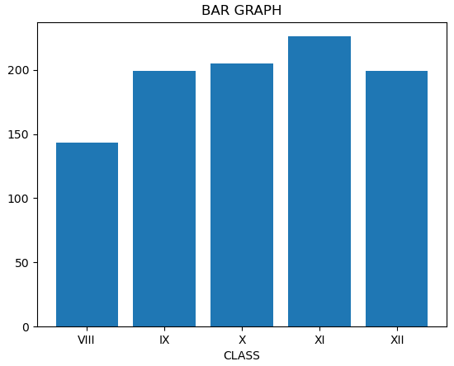
- JAHNAVI AGARWAL has created a table 'Payment' with the following data : (3)
ID | NAME | SALARY | BONUS | DATEOFJOIN
E05 | MUSKAN FOGLA | 64000 | NULL | 2021-09-30
E04 | ANNANYA AGARWAL | 80000 | 4000.00 | 2007-11-31
E03 | MUSKAN SARAWGI | 72000 | NULL | 2020-09-18
E02 | RAHEE HANSDA | 95000 | 4750.00 | 2008-03-16
E06 | SHYAM PANCHARIA | 69000 | 3450.00 | 2009-07-25
E07 | SHREYA SINGH | 55000 | NULL | 2018-10-30
Based on the above table, write SQL statements for the followings :
(a) Display the names and name of the month from date of joining of those employees who
have joined after 2010.
(b) Display the name, salary and joining date of those employees whose bonus is unknown.
(c) Display first three characters from the name whose name contains more than 12 characters.
- VINAYAK SARAWGI does not understand Plagiarism. Help him to understand it by defining (3) Plagiarism. Also write any two ways to avoid Plagiarism.
OR
What is the difference between Copyright and Licensing?
- Observe the following DataFrame named 'df' and answer the given questions. (3)
Single Double
a 3 6
b 5 10
c 4 8
d 6 12
- Write code to change the values of the 3rd row to [7 , 14].
- Write code to add a new column named Triple having triplicate values of the column Single.
- Write code to change the column labels from ['Single' , 'Double' , 'Triple'] to ['C1' , 'C2' , 'C3'].

SECTION D

- Consider the following tables 'EVENT' and 'PARTICIPANT'. Write commands for questions (4)
(a) to (c) and output for question (d).
Table : EVENT
ECode | EName | NoofParticipants | PrizeMoney | ScheduleDate
104 | Shot Put | 12 | 8000 | 2024-03-23
105 | High Jump | 10 | 12000 | 2024-01-12
106 | Relay 100x4 | 16 | 10000 | 2024-02-14
108 | Long Jump | 12 | 9000 | 2024-03-01
109 | Discuss Throw | 10 | 15000 | 2024-02-19

Table : PARTICIPANT
PCode | PName | ECode
1 | SOURAV LODHA | 104
2 | PLABAN GUPTA | 108
3 | BHUMI SHUKLA | 104
4 | ANISH BUDHIA | 106
5 | CHAHAT PRASAD | 109

(a) Write MySQL command to display the name of all events, their schedule date and corresponding
participant names.
(b) Write a MySQL statement to list event codes, prize money and number of participants of those
events which are scheduled in the month of February.
(c) Write MySQL query to show the event name, prize money and player's code for those records
where the number of participants are more than 11.
(d) SELECT EName, PrizeMoney, PCode FROM Event, Participant
WHERE Event.ECode = Participant.ECode AND PName LIKE '%N%';
- Given below a Python code. Observe the code and answer the questions that follow. (4)
import pandas as pd
L = [ [55 , 44] , [100 , 900 , 400] , [67 , 70] , [414 , 185] ]
dframe1 = pd.DataFrame(L)
print(dframe1)
(a) How many rows and columns will be there in the DataFrame?
(b) Write statement to count the number of rows of the DataFrame.
(c) Write statement to change the value from 70 to 75 in the given DataFrame.
OR
(Option for part (c) only)
Show the DataFrame which will be created after the execution of the given code.

SECTION E

- NAVANSHU JALAN and ROUNAK AGARWAL, both are very much interested in cricket. They (5)
have created the following 'ODI' table showing the batting records of Indian players in
One Day International cricket matches. Write SQL commands for (a) to (c) and give output
for (d) and (e) on the basis of the table ODI given below :
Table : ODI
PName | Matches | Innings | Notouts | Runs | Highest | Average | Hundreds | Fifties
Rohit Sharma | 262 | 254 | 36 | 10709 | 264 | 49.12 | 31 | 55
Subhaman Gill | 44 | 44 | 7 | 2271 | 208 | 61.37 | 6 | 13
K L Rahul | 75 | 70 | 14 | 2820 | 112 | 50.35 | 7 | 18
R Ashwin | 116 | 63 | NULL | 707 | 65 | 16.44 | 0 | 1
Virat Kohli | 292 | 280 | 44 | 13848 | 183 | 58.67 | 50 | 72
Shreyas Iyer | 59 | 54 | 6 | 2383 | 128 | 49.64 | 5 | 18

- To show all the details of the players having scored hundreds and not played matches
less than 100.
- To display player's name, matches played, runs scored of those players who have remained
not out and scored more than 5000 runs.
- To count the number of players who have scored more hundreds than their not outs.
- SELECT PName, Innings, Notouts, Innings – Notouts "Total Outs" FROM ODI
WHERE Runs BETWEEN 2820 AND 14000;
- SELECT PName, Runs, Average FROM ODI WHERE Fifties > (SELECT MAX(Hundreds) FROM ODI);
OR
Consider the string "The AGCS Purulia". Write MySQL statements to implement the followings :
(a) To display the first six characters from the given string.
(b) To count the number of characters in the given string.
(c) To display the substring starting from index 4 and ending at index 8.
(d) To display the starting index for the substring "AG".
(e) To change the case of the given string to upper case.
- PRACHI KATARUKA owns a company named 'PRACHI Enterprises' situated in Mumbai. The (5) company has four departments in its campus as shown below :

Dep1
Dep3

Dep2
Dep4

Center to center distance between various departments :
Dep3 TO Dep1 | 50 M
Dep1 TO Dep2 | 60 M
Dep2 TO Dep4 | 25 M
Dep4 TO Dep3 | 170 M
Dep3 TO Dep2 | 125 M
Dep1 TO Dep4 | 90 M

Number of computers in each department :
Dep1 | 20
Dep2 | 15
Dep3 | 60
Dep4 | 25

Computers in each department are networked but departments are not networked. The company
has now decided to connect the departments also.
- Suggest the most appropriate topology for the connections between the departments and
draw the cable lay-out for the network of various departments.
- The company wants internet accessibility in all the departments. The suitable and cost-effective
technology for that would be :
- Suggest the most appropriate location of the server, to get the best connectivity for the network.
- Which device will you suggest for connecting all the computers within each of the departments?
- The company is planning to link its company of Mumbai with its head office situated in
New Delhi. Suggest an economical way to connect them and also mention the type of network
that will be formed in this case.
- Observe the DataFrame 'AGCS' given below and write the answers of the questions that follow. (5)
Name Stream Roll
0 VIDHI SARAWGI Science 27
1 SNEHA JAISWAL Commerce 13
2 GITIKA JAIN Commerce 21
3 ISSIKA NAG Humanities 25
4 SAMPA MAHATO Science 22

(a) Write the code to modify the column labels to Col1, Col2 and Col3.
(b) Write the command that will change the name from ISSIKA NAG to SAMUEL PRODHAN.
(c) What will be the command to create a Series object named 'S1' which will contain all the values
from the Name column of the DataFrame 'AGCS'?
(d) Write code to create a DataFrame named 'Commerce' having only those rows whose stream is
Commerce.
(e) Write code to create a Series named 'S2' having all the values from the Name column of only
those rows whose stream is Science.
OR
Given below a Pandas Series named 'Series1'. Observe it and answer the question that follows.
VI 45
VII 60
VIII 52
IX 49
X 54
(a) Write code to add a new row with label as XI and value as 76.
(b) Write statement to remove the row labelled as VIII.
(c) Write command to change the row label from IX to 9.
(d) Find the output of the given code :
for x in Series1.index :
if Series1[x] < 50 :
print(x , Series1[x] + 5)
(e) Using Series1, write a command that will create the following Series :
45 VI
60 VII
52 VIII
49 IX
54 X

Sample Paper submitted by :

NAME : MR. RAJESH KUMAR SINGH
ADDRESS : NEW COLONY, NIMTAR, MISSION ROAD,
POST + DIST – PURULIA, WEST BENGAL,
PIN – 723101.
E-MAIL : rajeshsinghprl1@gmail.com
MOB : 7001849705

