Sample Paper – 2008
Class – X
Subject - Mathematics

1 | A point P is 13 cm from the centre of the circle. The length of the tangent drawn from P to the circle is 12 cm. Find the radius of the circle. | 5 cm
2 | In figure if AB=AC, prove that BE=EC.  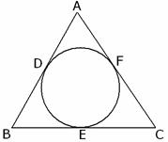
3 | In fig. AQ and AR are tangents from A to the circle with centre O. P is a point on the circle. Prove that AB+BP=AC+CP  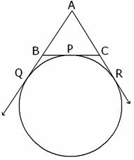
4 | In fig. ABC is a right-angled at B such that BC=6 cm and AB=8 cm. Find the radius of its incircle.  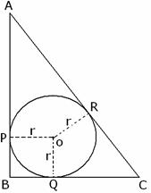
5 | Two concentric circles have radii 5 cm and 3 cm . Find the length of the chord of the larger circle which touches the smaller circle.
6 | Prove that the segment joining the points of contact of two parallel tangents passes through the centre.
7 | If all the sides of a parallelogram touch a circle, show that the parallelogram is a rhombus.
8 | A circle is touching the side BC of at P and touching AB and AC produced at Q and R respectively. Prove that 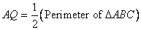

BRCM PUBLIC SCHOOL,BAHAL
PRACTICE SET - 3
Circles

9 | Two tangents TP and TQ are drawn to a circle with centre O from an external point T. Prove that
10 | A triangle ABC is drawn to circumscribe a circle of radius 4 cm such that the segments BD and DC into which BC is divided by the point of contact D are of lengths 8 cm an 6 cm respectively. Find the sides AB and AC.  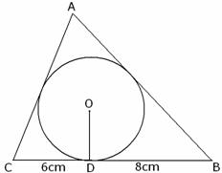
11 | Prove that, the tangent at any point of a circle is perpendicular to the radius through point of contact.
12 | Prove that, the length of tangents drawn from external point to circle is equal.
13. | The in circle of ABC Touches the sides BC, CA and AB at D, E and F respectively. Show that AF + BD + CE = AE + BF + CD =
14. | Prove that the tangents at the extremities of any chord make equal angles with the chord.
15. | A circle is inscribed in a ABC having sides 8 cm, 10 cm and 12 cm as shown in the figure. Find AD, BE and CF | AD=7 cm  BE = 5 cm  CF = 3 cm
16. | Show that tangent lines at the end points of a diameter of a circle are parallel.
17. | If AQ, AR, BC are tangents. And AQ = 5 cm, Find the perimeter of ABC.
18. | A circle touches the sides of a quadrilateral ABCD at P, Q, R, S respectively. Show that the angles subtended at the center by a pair of opposite sides are supplementary.

Hridyanand
HOD Mathematics
BRCM Public School,
Vidyagram
Bahal
District Bhiwani
Haryana-127028
Email: hrd_anand@rediffmail.com
Hrd_anand@yahoo.com
hridyanand@gmail.com
Mobile No. 9991512009, 9416312921

