Sample Paper – 2008
Class – XII
Subject - Physics
Time: Three Hours Max. Marks: 70
General Instructions
(a) All questions are compulsory.
(b) There are 30 questions in total. Questions 1 to 8 carry one mark each, questions 9 to 18 carry two marks each, questions 19 to 27 carry three marks each and questions 28 to 30 carry five marks each.
(c) There is no overall choice. However, an internal choice has been provided in one question of two marks, one question of three marks and all three questions of five marks each. You have to attempt only one of the given choices in such questions.
(d) Use of calculators is not permitted.
(e) You may use the following physical constants wherever necessary:

c = 3 x 10⁸ms-1
h = 6.6 x 10⁻³⁴Js
e = 1.6 x 10⁻¹⁹C
μ₀= 4 π x 10⁻⁷ TmA⁻¹

Boltzmann constant k = 1.38 x 10²³ JK⁻¹
Avogadro’s number NA = 6.023 x 10²³/mole
Mass of neutron m_{n} = 1.6 x 10⁻²⁷kg
1 MeV = 1.602x10⁻¹³ J

- What is the advantage of radial magnetic field in a moving coil galvanometer?
- What is the power factor of LCR circuit at resonance?
- Draw a graph showing the variation of intensity of polarized light transmitted by an analyzer?
- How does the force between two point charges change if dielectric constant of medium in which they are kept increases.
- The output of a two input NAND gate id fed as input to a NOT gate. Write down the truth table for the final output of the combination.
- Name the electromagnetic radiation used by any device for viewing objects through haze and fog.
- A metal surface is shined by a light of certain frequency and intensity I above the threshold frequency. The intensity is reduced to (I/4). What is the maximum kinetic energy of the photo electrons?
- Name the gate obtained from the combination of gates as shown.
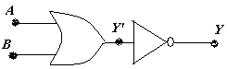

- Derive an expression for the potential at a point along the axial line of a short electric dipole.
- Derive relation showing that resisitivity of a material is inversely proportional to the number density as well as relaxation time.
- What is the maximum value of current when inductance of 2 H is connected to 150 V, 50 cycles supply?

- How an oscillator produces an output signal without any external input signal? How is that only one frequency of oscillation is obtained?
- A current of 2A is obtained when a resistance 5 Ω is connected across a cell and a current of 3 A is obtained when a resistance of 3 Ω is connected. Calculate internal resistance and emf of cells.
- A cyclotron cannot accelerate negatively charged particles. Why?
- What are eddy currents? How are they reduced in the core of a transformer?
- Infra red waves are sometimes referred to as heat waves. Why? Write any two applications of IR radiation.
- Define modulation index.Why modulation index is kept 1?
- Draw a labelled diagram showing the formation of image in a reflecting telescope.
- A beam of light with red, green and blue colours falls on a right angled prism as shown. The refractive indices of material of the prism for red, green and blue are 1.38, 1.45 and 1.47. Which colour will emerge from the prism?
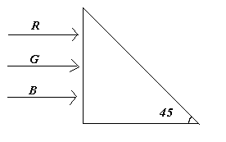

- Draw a schematic arrangement diagram for Geiger-Marsden experiment. What is the ratio of α-particles scattered through 60⁰ and 120⁰. State the formula used.
- A series LCR circuit with L= 0.2 H, C=480 nF, R =23 Ω is connected to a 230V variable frequency supply.
a) What is the source frequency for which current amplitude is a maximum? Obtain the maximum value.
b) What is the source frequency for which average power absorbed by the circuit is a maximum? Obtain the value of maximum power.
- Write the three frequencies contained in the amplitude modulated signal. How is the modulating signal recovered from the AM waveform?
- Draw a labelled diagram of a Cassegrain reflecting telescope. What is the main problem faced by a observer while using a reflecting telescope and how has it been resolved?
- Define the term half life period and decay constant of a radioactive substance. Write their SI unit. Establish a relation between them.
- Explain various series spectral lines of spectrum of hydrogen atom and draw energy level diagram. What are the limitations of Bohr’s theory?
- What is meant by positive feed back? Explain how oscillations are produced using the principle of positive feedback in a transistor circuit.
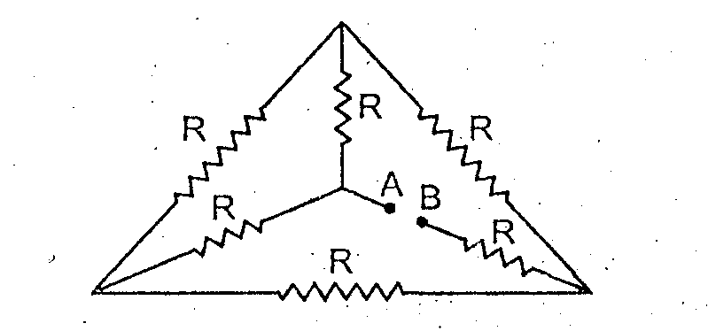
- What is the effective resistance between A and B in the figure?

- In young’s double slit experiment with red light, state the effect of the following on the fringes:
a) The separation between the slits is decreased.
b) The screen is moved closer to the slits.
c) The source slit is moved closer to the slits.
d) Green light is used in place of red light.
e) The source slit is made wider.
f) One of the double slit is covered.
OR
Draw a curve showing the variation of intensity in the interference pattern obtained in Young’s double slit experiment? State and explain the conditions of sustained interference.
- Derive a mathematical expression for the force on a unit length acting on each of the two straight parallel metallic conductors carrying current in the same direction and kept near each other. Illustrate in the diagram why two such conductors carrying current in opposite directions repel each other?
OR
Obtain an expression for the magnetic moment of an electron in a circular orbit of radius r and moving with speed v. State the rule to find its direction. How does this magnetic moment change when the:
a) Frequency of revolution is doubled b) Orbital radius is halved.
- Draw a labelled diagram of Van de Graff generator. State its principle of working. How is the leakage of charge minimized from the generator?
OR
Derive an expression for the energy stored in a parallel plate capacitor, with air as the medium between the plates. A parallel plate capacitor of capacitance 100 μF is charged to 200 V. After disconnecting it form the battery, using an insulated handle, the distance between the plates, and
i) Potential difference between the plates, and
ii) energy stored in the capacitor, after the separation between the plates has been increased.

For solutions contact viswamvinish@yahoo.co.in

