Guess Paper – 2008
Class – X
Subject – Mathematics

Section A
1. A wire is in the form of a circle of radius 7 cm. It is rebent into a square form. Find the length of the side of the square.
2. Write down two events which have probability 1.
3. The lengths of the tangents drawn to a circle from a point outside the circle are always equal. Is it true?
4. If triangles ABC and DEF are similar, area of ABC = 9 cm², area of DEF = 25 cm² and DE = 6 cm, find the length of AB.
5. For an acute angle A, value of sin A lies between 0 and 1. Is it true?
6. How many terms are there in the AP 8, 12, 16 ………. 96?
7. The diameter of a garden roller is 1.4 m and it is 2 m long. How much area will it cover in 5 revolutions?
8. Both the ogives (less than and more than) for a data intersect at P (30, 15). Find the median for the data.
9. Without performing the actual division, state whether 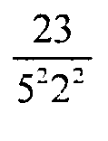will represent a terminating decimal or a non-terminating repeating decimal.
10. If 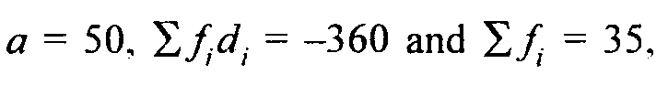 then find the mean.
Section B
11. In a lottery there are 10 prizes and 25 blanks. What is the probability of getting a prize?
12. Find x so that the line segment with end points A (x, y) and B (3. 0) is divided at (2, 1) in the ratio 3 : 1.
OR
Find the relation between x and y such that the point (x, y) may lie on the line joining the points (3, 4) and (- 5, - 6).
13. If 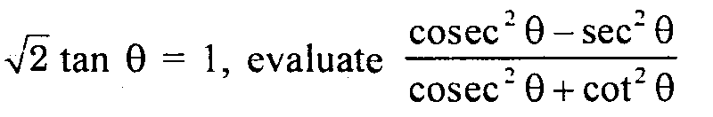
14. Find the distance between the points : R(a + b, a - b) and S(a - b, - a - b)
15. A bag contains 5 red balls. 8 white balls. 4 green balls and 7 black balls. If one ball is drawn at random, find the probability’ that it is black.
Section C
16. Determine graphically the vertices of a triangle, the equations of whose sides are
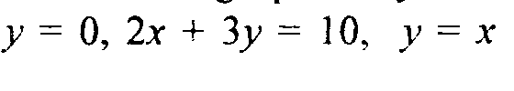
OR
Solve for x and y
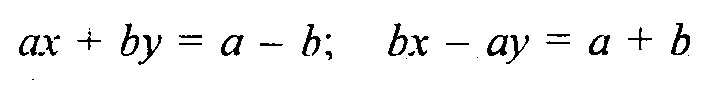
17. One fourth of a herd of camels were seen in the forest. Twice the square root of the herd gone to mountain and the remaining 15 camels were seen on the bank of a river. Find the total number of camels.
18. The second and third terms of an AP are 2 and 22 respectively. Find the sum of its first 30 terms.

19. Prove that 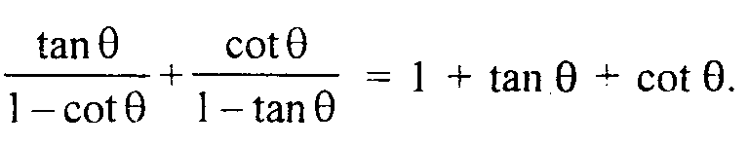

20. Points (1. 2), (3, - 4) and (5, - 6) lie on the circumference of a circle. Find the coordinates of its centre.
OR
Using the formula of area of a triangle, show that the points (4, 3). (5. 1) and (1. 9) are collinear.
21. Three consecutive vertices of a parallelogram ABCD are A (1, 2), 13 (1, 0) and C (4, 0). Find the fourth vertex.
22. In what ratio is the line segment joining points P (4, 3) and Q (2,- 6) divided by the x-axis? Also, find the coordinates of the point of intersection.
OR
Find the circumcentre of the triangle whose vertices are (0, - 3), (7, 0) and (4, 7).
23. The perimeter of a sector of a circle with central angle 90° is 25 cm. Find the area of the minor segment of the circle.
24 In the given figure, DE // BC and CD // EF. Prove that
AD² =AB x AF
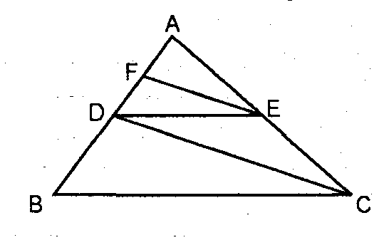
25. Find the area of the sector of a circle with radius 4 cm and of angle 30. Also find the area of the corresponding major sector.
Section D
26. A circular grassy plot of land, 42 m in diameter, has a path 3.5 m wide running round it on the outside. Find the cost of gravelling the path at Rs 4 per square meter.
27. A vertical tower is surmounted by a flagstaff of height h metres. At a point on the ground, the angles of elevation of the bottom and top of the flagstaff are 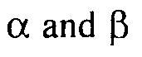 respectively. Prove
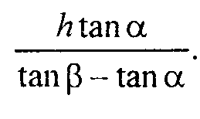
28. If a line is drawn parallel to one side of a triangle, prove that the other two sides are divided in the same ratio.
Use the above to prove the following
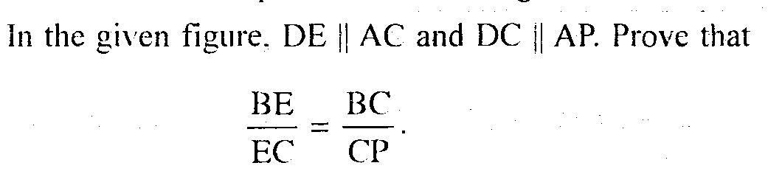
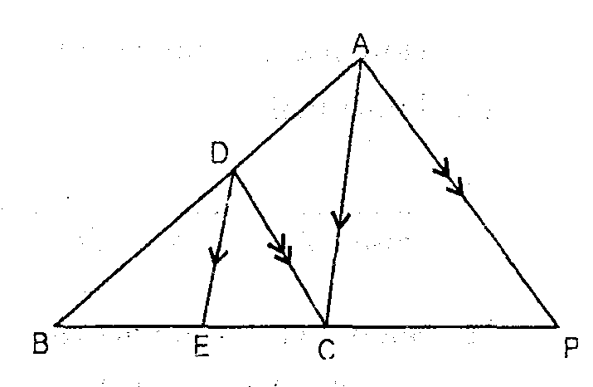
29. A circus tent is cylindrical upto a height of 6 m and conical above it. If its diameter is 1 05 in and the slant height of the conical portion is 50 m, find the total area of canvas required to built it.
OR
The height of a cone is 42 cm. A small cone is cut off at the top by a plane parallel to the base. If its volume is 1/27 of the volume of the given cone, at what height above the base.
30. The mean of the following distribution is 18 and the sum of all frequencies is 64. Compute the missing frequencies f₁ and f₂.
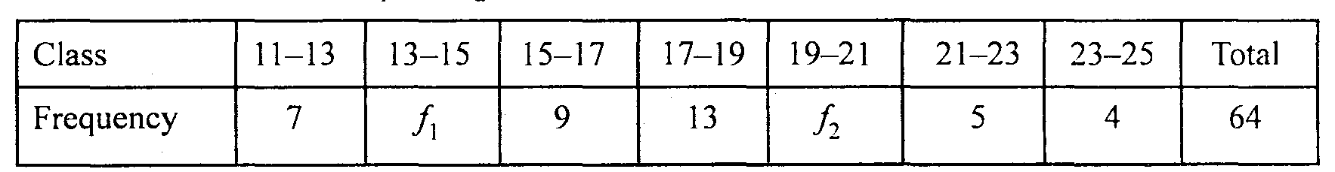

OR
Draw a less than type ogive for the following data and estimate the median from it.

