Sample Paper – 2008
Class – X
Subject – Mathematics

Time:3hrs Max.Marks:80
General Instructions
All questions compulsory
- The question paper consist of thirty questions divided in to 4 sections A,B,C and D. Section A comprises of ten questions of 1 marks each ,Section B comprises of five questions of 2 marks each, Section C comprises of ten questions of 3 marks each and section D comprises of five questions of 6 marks each
- All questions in section A are to be answered in one word , one sentence or as per the exact requirement of the question
- there is no overall choice .However internal choice has been provided in one question of 2 marks each ,three question of three marks each and two questions of 6 marks each .You have to attempt only one of the alternatives in all such questions.
- In question on construction ,drawings should be neat and exactly as per the given measurements
- Use of calculators is not permitted .However you may ask for mathematical tables

SECTION A

- Write a quadratic equation whose roots are 3+√3 and 3-√3.
- Write the prime factors of 49.
- If tanB = ¾, and A+B = 90°, then find the value of cotA.
- Find the zeroes of the quadratic polynomial x² – 2x + 1.
- A cylinder, a cone and a hemi-sphere have equal base and same height. What is the ratio of their volumes?
- Give an example of polynomial p(x), g(x), q(x) and r(x), satisfying
P(x) = g(x).q(x) + r(x), deg r(x) = 0
- A die is thrown once. What is the probability of getting an even prime number?
- Find the 20th term of the sequence -2, 0, 2, 4 ------------.
- Find the perimeter of the sector whose base radius is 14 cm and central angle is 120°.
- For what value of ‘k’ the following pair of linear equations has infinitely many solutions?
10x + 5y – (k-5) = 0 and 20x + 10y – k = 0.
SECTION B
- Find the value of k for which the system of equations has infinite number of solutions
$\begin{aligned}4x+y=3 \\ 8x+2y=5k\end{aligned}$
- Without using trigonometric table find the value of
$\frac{\text{Sin}{\text{50}}^{0}}{\text{Cos}{\text{40}}^{0}}+\frac{\text{Co}\text{sec}{\text{40}}^{0}}{\text{Sec}{\text{50}}^{0}}−4\text{Cos}{\text{50}}^{0}×\text{Co}\text{sec}{\text{40}}^{0}$
- Determine the ratio in which the point $(−6,a)$ divides the join of $A(−3,−1)$ and $B(−8,9)$ also find the value of a

- In the figure ,AB parallel to DE and BD parallel to EF , is ${\text{CD}}^{2}=\text{CF}×\text{CA}$ justify your answer

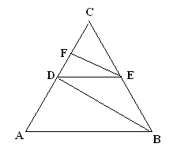

- In a single throw of two dice , find the probability of getting
i) Two heads ii) At least one heads

SECTION C

16 Solve for x and y : 47 x + 31 y = 63, 31 x + 47 y = 5.
17. If the sum of first 14 terms of an A.P. is 1050 and its first term is 10, find the 20th term.
OR
Prove that no number of the type $4k+2$ be perfect square
- Draw the graph of $x−y+1=0$ and $3x+2y−\text{12}=0$ and show that there is a unique solution .Calculate the area bounded by these lines and x-axis
- A polygon has 10 sides .The lengths of the sides starting with the smallest form an AP .If the perimeter of the polygon is 420 Cm and the length of the longest side is twice that of the shortest side .Find the first term and the common difference of the AP
- Prove that $(\text{sin}A+\text{cos}\text{ecA})^{2}+(\text{cos}A+\text{sec}A)^{2}=7+{\text{tan}}^{2}A+{\text{cot}}^{2}A$
OR
Prove that $\frac{\text{cos}A−\text{sin}A+1}{\text{cos}A+\text{sin}A−1}=\text{cos}\text{ecA}+\text{cot}A$ , Using the identity $\text{cos}{\text{ec}}^{2}A=1+{\text{cot}}^{2}A$

- Observe the graph and state whether the quadrilateral ABCD is a parallelogram .Justify your answer .
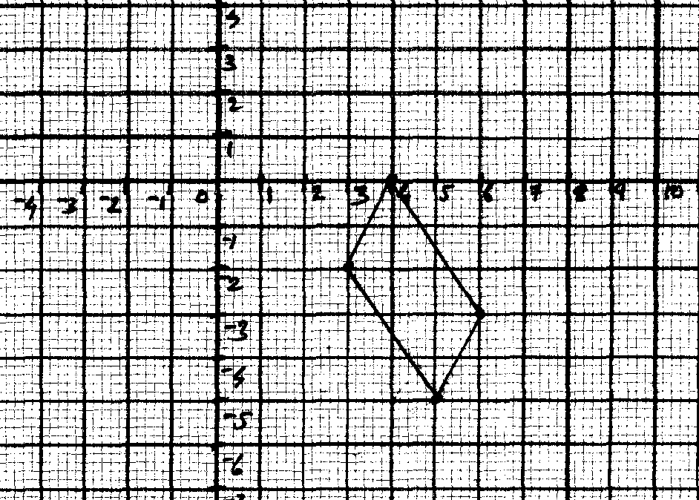

- Find the area of the triangle formed by joining the mid points of the sides of the sides of triangle whose vertices are $(4,−7),(−8,7),(\text{10},\text{13})$
- Draw a triangle ABC with side $\text{BC}=6\text{cm}$ , $∠B={\text{30}}^{0},∠A={\text{120}}^{0}$ then construct a triangle whose sides are $\frac{4}{3}$ times the corresponding sides of $Δ\text{ABC}$
- Prove that the opposite sides of a quadrilateral circumscribing a circle subtend supplementary angles at the centre of the circle
- A regular hexagon is circumscribed by a circle of radius 14 Cm .
Find the area of the shaded region use $\sqrt{3}=1\text{.}7,π=\frac{\text{22}}{7}$
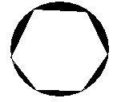

OR

A square ABCD is inscribed in a circle of radius
10 units .Find the area of the circle , not included in the
square (use $π=3\text{.}\text{14}$)
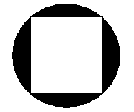

SECTION D

- A train covers a distance of 90 Km at uniform speed .Had the speed been 15 Km /hr more . it would have taken 30 minutes less for the journey find the original speed of the train
OR
A party of tourists booked a room in a hotel for Rs 1200 , three of the members failed to
pay as a result others had to pay Rs 20 more (each) . How many tourists were there in the
party
- The angle of elevation of a jet plane from a point A on the ground is ${\text{60}}^{0}$ .After a flight of 15 seconds , the angle of elevation changes to ${\text{30}}^{0}$ .If the jet plane is flying at a constant height of $\text{1500}\sqrt{3}m$ , find the speed of the jet plane
OR
From a building 60m heigh the angle of depression of the top and bottom of lamp post are ${\text{30}}^{0}$ and ${\text{60}}^{0}$ respectively .Find the distance between lamp post and building ,also find the difference of height between building and lamp post
- Prove that in a right triangle , the square of the hypotenuse is equal to the sum of the squares of the other two sides
Using the above solve the following
L and M are the mid points of AB and BC respectively of $Δ\text{ABC}$, right angled at B prove
that $4{\text{LC}}^{2}={\text{AB}}^{2}+4{\text{BC}}^{2}$
- A building is in the form of a cylinder surmounted by a hemispherical vaulted dome ,the building contains 17.7 m³ of air and its internal diameter is equal to the height of the cylindrical part find the height of the building (use $π=\frac{\text{22}}{7}$)
- Find the median of the following data
Class interval | 110-119 | 120-129 | 130-139 | 140-149 | 150-159 | 160-169 | 170-179
Frequency | 5 | 25 | 40 | 60 | 40 | 25 | 5

