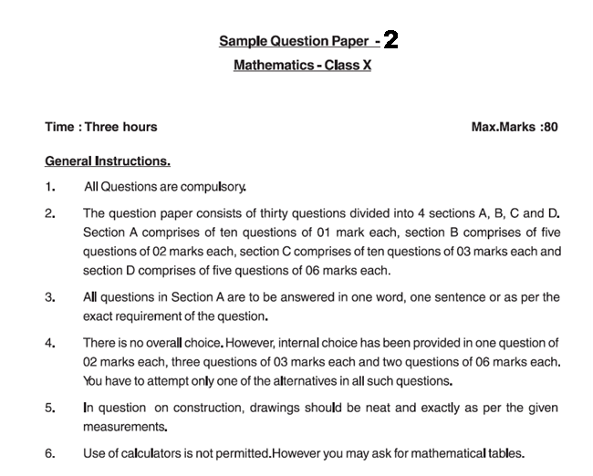
SECTION A
1. Check whether there is any value of n for which 4^{n} ends with the digit zero.
2. If HCF(16, x) = 8 and LCM (16, x) = 48, then the value of x is
3. The graph of y = p(x) are given in Fig below, for some polynomials p(x). Find the number of zeroes of p(x)
4. If 1 is one of the zeros of a polynomial x²—x+k, the value of k is
5. Find the value of k for which the system of linear equations
2x+3y=5 and 4x+ky=10
has infinitely many solution
6. Write the first three terms of the sequence a_{n}= 3n-2
7. If the ratio of area of two similar triangle is 1:49, find the ratio of corresponding sides.
8. D is a point on the side BC of a triangle ABC such that ∠ADC = ∠BAC. Show that CA² = CB.CD.
9. The length of a tangent from a point A at distance 10 cm from the centre of the circle is 8cm. Find the radius of the circle.
10. A student draws a cumulative frequency curve for the marks obtained by 40 students of a class, as shown in figure. Find the median marks obtained by the students of the class
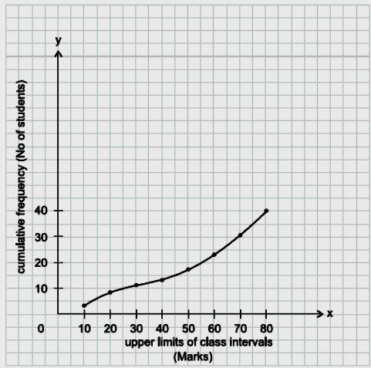

SECTION B
11. Show that any positive odd integer is of the form 6q + 1, or 6q + 3, or 6q + 5, where q is some integer.
12. Divide the polynomial p(x) by the polynomial g(x) and find the quotient and remainder
p(x) = x³ – 3x² + 5x – 3, g(x) = x² – 2
13. Check whether the following equation is quadratic: if so find the roots of the equation. (x – 2)² + 1 = 2x – 3
14. Find the 11th term from the last term (towards the first term) of the AP: 10, 7, 4, . . ., – 62.
15. In Δ OPQ, right-angled at P, OP = 7 cm and OQ – PQ = 1 cm. Determine the values of sin Q and cos Q.
SECTION C
16. There is a circular path around a sports field. Sonia takes 18 minutes to drive one round of the field, while Ravi takes 12 minutes for the same. Suppose they both start at the same point and at the same time, and go in the same direction. After how many minutes will they meet again at the starting point?
17. Find all the zeroes of 2x⁴ – 3x³ – 3x² + 6x – 2, if you know that two of its zeroes are √2 and − √2 .
18. Solve the following system of equation:
$\frac{\text{15}}{u}+\frac{2}{v}=\text{17}$ , $\frac{1}{u}+\frac{1}{v}=\frac{\text{36}}{5}$
19. Solve graphically the system of linear equation 2x+3y=12, 2y-1=x also find the vertices of triangle formed by these lines with y-axis
20. A spiral is made up of successive semicircles, with centres alternately at A and B, starting with centre at A, of radii 0.5 cm, 1.0 cm, 1.5 cm, 2.0 cm, . . . as shown in fig. What is the total length of such a spiral made up of thirteen consecutive semicircles? (Take π = )
21. Solve for x
$\frac{1}{p+q+x}=\frac{1}{p}+\frac{1}{q}+\frac{1}{x}$; $p+q≠0$
22. In Fig., DE || OQ and DF || OR. Show that EF || QR.
23. A ladder is placed against a wall such that its foot is at a distance of 2.5 m from the wall and its top reaches a window 6 m above the ground. Find the length of the ladder.
24. Draw a triangle ABC with side BC = 7 cm, ∠B = 45°, ∠A = 105°. Then, construct a triangle whose sides are times the corresponding sides of Δ ABC.
25. Prove the identity $(1+\text{cot}θ−\text{cos}\text{ec}θ)(1+\text{tan}θ+\text{sec}θ)=2$
Or
Find the trigonometric ratios for angles 30⁰, 45⁰ and 60⁰.
SECTION D
( Qns 26 to 30 carry 6 marks each )
- Prove that if a line is drawn parallel to one side of a triangle, to intersect the other
two sides in distinct points, the other two sides are divided in the same ratio.
Using the above do the following:
In fig. AB//DE and BC//EF . Prove that AC//DF
A D
O B E
C
F
F
- A person standing on the bank of the river observes that the angle of elevation of the top of the tree standing on the opposite bank is 60⁰. When he moves 40m away from the bank, he finds the angle of elevation to be 30⁰. Find the height of the tree and the width of the river.
OR
If the angle of elevation of the cloud from a point h metres above a lake is ‘α’ and the angle of depression of its reflection in the lake is ‘β’ , prove that the
height of the cloud is h ( tan β + tan α )
tan β - tan α

A
- A circle is touching the side BC of ΔABC at P
and is touching AB and AC when produced at
Q and R respectively. Prove that B C
AQ = ½ ( Perimeter of Δ ABC ). Q B P R
Also if AQ = 5cm, find the perimeter of ΔABC.

- A toy is in the form of a cone of radius 3.5cm mounted on a hemisphere of same radius. The total height of the toy is 15.5cm. Find the total surface area of the toy.
OR
A lamp shade made of a special chart paper is in the form of a frustum of a cone open at both the ends. The radii of its ends are 16cm and 24cm and its height is 6cm. Find the cost of the paper used if one square cm of paper costs Rs 0.70.
30. If the median of the distribution below is 28.5, find the values of x and y.
Class interval | Frequency
0 - 10 | 5
10 - 20 | x
20 - 30 | 20
30 - 40 | 15
40 - 50 | y
50 - 60 | 5
Total | 60

