Sample Paper – 2008
Class – XII
Subject – Infromatics Practices

Pre-Board Examination 2008
Code No. 065

• Please check that this question paper contains printed pages.
• Code number given on the right hand side of the question paper should be
written on the title page of the answer-book by the candidate.
• Please check that this question paper contains 7 questions.
• Please write down the serial number of the question before attempting it.

Time allowed: 3 hours Maximum Marks: 70

Note:
(i) All questions are compulsory.
(ii) Section A consists of 30 marks.
(iii) Section B and Section C are of 20 marks each.
(iv) Answer the questions after carefully reading the text.

SECTION A
- Answer the following questions
(a) Differentiate between open source software and free software? 2
(b) What is data ware housing? How it is useful for organization? 2
(c) Draw an entity-relationship diagram to illustrate the case given below:
In a factory, a vendor can supply various items. Each vendor has got a vendor code, vendor name, vendor address and each item also has got an item code, item name, its price per unit. When a vendor supplies an item the transaction is recorded and the information about the transaction stored is date of supply, quantity supplied, order number, item code and vendor code. Map the E/R diagram of corresponding tables. Also identify the key fields. 2
(d) What is DDLC? How it is different from SDLC? 2
(e) Explain the concept of Client Server computing. 2

- Answer the following questions
(a) What is the difference between unloading and hiding of a form? 2
(b) Differentiate between SDI and MDI form in Visual Basic? 2
(c) Differentiate between ADODB project reference and ADODC in a form using suitable example. 2
(d) What is variable life time? What is the lifetime of the following
variables? (i) Local (ii) Global (iii) Module 2
- What is Modules in Visual Basic? Explain any two modules in Visual
Basic. 2

- Answer the following questions.
- Differentiate between Decision control and Looping control structure in context with PL/SQ? 2
- What are Cursor attributes? What do these attributes evaluate to when associated with IMPLICIT cursors? 2
(c) What is the use of a Sub-Query? Which query gets executed first, the
parent query or the sub-query? 2
(d) What is the difference between IN and OUT parameter modes in PL/SOL procedure? 2
(e) What is a transaction in PL/SQL? What commands are available in
PL/SQL for transaction handling? 2

SECTION B

4. Read the following case study and answer the questions that follow:
The Hot & Taste restaurant has computerized its billing. The following the data entry screen used at their outlet. The outlet offers two different types of foods, vegetarian and non-vegetarian. The price of a regular vegetarian THALI meals is Rs. 140/- and that of a non vegetarian THALI meals is Rs.-290/-. The user can choose to have three different types of extra supplements if he wants. Each extra supplement costs Rs. 80/-.

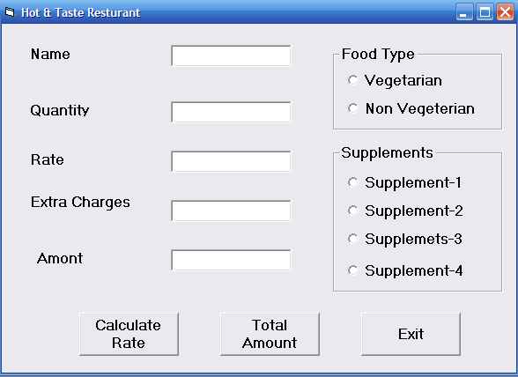

The list for the above form is as follows:
Object type | Object name
Form | Frmrestro
Text box | Txtname  Txtqty  Txtrate  Txtextracharge  Txtamount
Option button | Optveg  Optnonveg
Command button | Cmdcalrate  Cmdcalamount  Cmdexit
Check box | Chksup1  Chksup2  Chksup3

(a) write the commands to disable the textboxes txtrate, txtextracharge, txtamount and cmdamount ,and set the focus on textbox txtname. 2
(b) Write the code for cmdrate to calculate the rate of the food and display it in txtrate depending on the type of food selected by the customer. 2
(c) Enable the cmdamount button. Write the code for cmdamount to calculate the total amount and display it on txtamount. If the quantity is more than 10 give 16% discount on supplement. 3
(d) Write the code for cmdexit to close the application , before closing the application it should display a message “ Do you really want to close the program(yes/no)? ” .if user select yes it should close the program otherwise set the focus on textbox txtname. 3

5. Answer the following questions:
(a) Rewrite the following code segment using select case instead of if else:
Dim sal as integer 2
If sal >=10000 then
Msgbox (“New year bonus is 2000”)
Elseif sal>=12000 and sal <=15000 then
Msgbox (“New year bonus is 5000”)
Elseif sal= 20000 then
Msgbox (“New year bonus is 7000”)
Else
Msgbox (“Bonus not applicable”)
End if
(b) Give the output of the following statements: 2
    - INSTR(LTRIM(“ INFORMATICS”), “ma”)
    - INT(40-20*4/3+5)
    - Lcase (left(mid(“INFORMATICS”, 7,4),3))
    - Format (now , “dddd,mmmm dd, yyyy”)
(c) Find the output of the following code segment : 2
Sum=0
For I = 3 to 7
If (I mod 2 = 0 ) then
Sum = sum +i*17
Else
Sum = (sum + i*5) -13
End if
Next i
Print sum
(d) Write a Visual Basic procedure to print Fibonacci Series. No of elements in the series should be up to the number given as parameter into the procedure.
The Fibonacci series is as follows 0,1 ,1,2,3,5,8, ….. 4
SECTION-C

6. Answer the following questions:
(a) Find the errors in the following PL/SQL code and rewrite the corrected
code underlining the correction made: 2
DECLARE
P NUMBER;
Pr NUMBER := 0;
FOR X IN 3..6 LOOP
IF X MOD 3 := 0 THEN
Pr := Pr * X;
ELSE
Pr := Pr * X;
DBMS_OUTPUT.PUT_LINE (TO_CHAR(PR));
END OF LOOP;
END
(b) What is the usage of %ROWTYPE attribute? Explain with the help of
an example 2
(c) Write the output produced by the following part of code in PL/SQL. 2
DECLARE
Num NUMBER;
V NUMBER :=0;
BEGIN
FOR Num IN 2..5 LOOP
V:= V + Num * Num;
DBMS_OUTPUT.PUT_LINE(V);
END LOOP;
END;
(d) Write a PL/SQL procedure that calculates and displays the volume of a
cuboid. The procedure takes three parameters for length, width and height of the cuboid respectively. The last two parameters are optional having a default value of –1. If the last two parameters are not passed then the volume of a cube having sides equal to the first parameter is to
be calculated. 4
7. Answer the questions based on the tables EMP_MASTER and AIR_SAHARA given below:

Table: EMP_MASTER
Column Name | Data Type | size | Constraint
EMP_NO | Number | 10 | Primary key
FNAME | Varcahar2 | 25 | Not null
LNAME | Varcahar2 | 25 | Not null
DOB_INC | Date
POSITION | Varcahar2 | 25 | Not null
TABLE: AIR_SAHARA
Column Name | Data Type | Size | Constraint
FLIGHT_NO | Number | 10 | Primary key
ORIGIN | Varcahar2 | 25 | Not null
DESTINATION | Varcahar2 | 25 | Not null
SEATS | Number | 4
FLT_DATE | Date |  | Not null
FLT_PRICE | Number | (8,3)
EMP_NO | Number | 10 | Foreign Key EMP_MASTER

(a) Write the SQL command to create the above tables with constraints. 3
(b) Write the SQL command to create a view consisting of fname, lname and position of all the employees whose destination is CHENNAI. 2
(c) Write the SQL command to modify the data type of EMP_MASTER table SEATS - Number to Varchar2. 1
(d) Create a Trigger to change FLT_PRICE to 50,000 every time the FLT_PRICE entered by the user exceeds 30,000. An appropriate message should also be displayed. 4



