Guess Paper – 2008
Class – X
Subject – Mathematics

SECTION A
1. Check whether 6^{n} can end with the digit 0 for any natural number n.
2. Find a quadratic polynomial whose zeros are 5 and - 5.
3. The graph of y = p(x) is given alongside. Find the number of zeros of p(x).
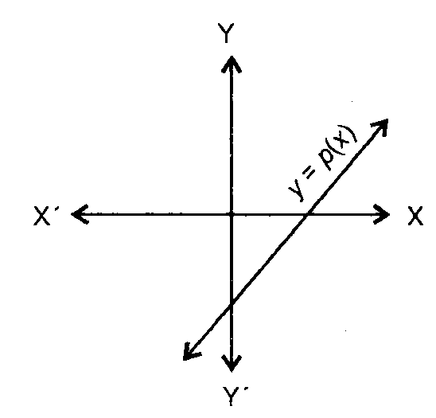

4. Find the nature of the roots of the following quadratic equation:
2x²—3x+5=0
5. Two tangents TP and TQ are drawn to a circle with centre 0 from an external point T. Show that < PTQ = 2< POQ.
6. In the given figure. in ABC. DE 1 BC so that AD = 2.4 cm, AE = 3.2 cm and EC = 4.8 cm. Find AB.
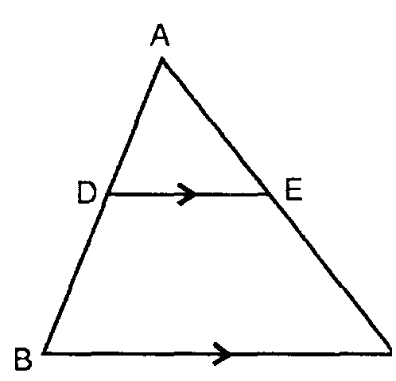
7. Find the length of the tangent drawn to a circle with radius 7 cm from a point 25 cm away from the centre of the circle.
8. Without using trigonometric tables, evaluate cosec 89° sec 10.
9. A tangent PQ at a point P of a circle of radius 5 cm meets a line through the centre 0 at a point Q so that OP = 13 cm. Find the length of PQ.
10. Prove that
Section B
11. Sum of two numbers is 35 and their difference is 13. Find the numbers.
12. Find the values of a and b so that x⁴ + x³ + 8x² + ax + b is divisible by x² + 1.
13. Find the solution of the pair of equations
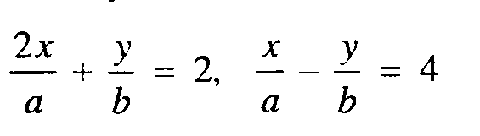
14. Find the value of p for which the points (- 5, 1), (1, p) and (4, - 2) are collinear.
15. Find the zeros of the quadratic polynomial x² + 7x + 12, and verify the relationship between the zeros and its coefficients.
SECTION C
16. A two digit number is obtained by either multiplying the sum of the digits by 8 and adding I or by multiplying the difference of the digits by 13 and adding 2. Find the number.
17. Show that 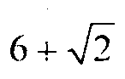 is an irrational number.
18. Find the value of k so that the following quadratic equation has equal roots
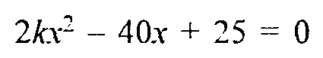
19. Construct a tangent to a circle of radius 4 cm from a point on the concentric circle of radius 6 cm and measure its length. Also, verify the measurement by actual calculation.
20. Prove that 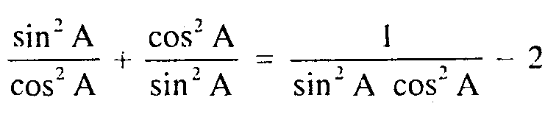
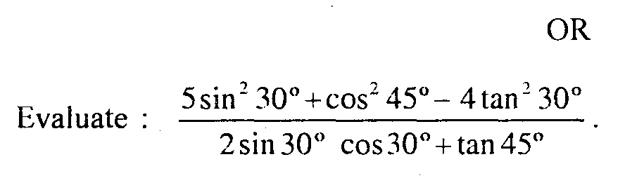
21. In the figure, if 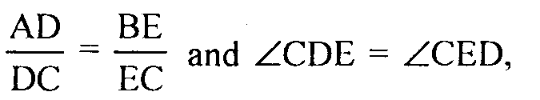 prove that ^CAB is isosceles.
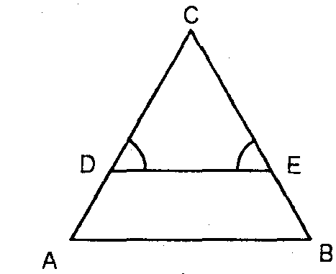
22. If Q (0, 1) is equidistant from P(5, — 3) and R (x. 6), find the value of x. Also find the distances QR and PR.
23. Find the area of the quadrilateral whose vertices taken in order are (- 4, - 2). (- 3. - 5), (3, - 2) and (2, 3).
24. Show that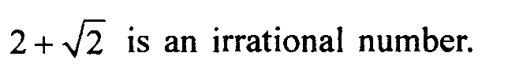
25 On a square handkerchief, nine circular designs each of radius 7 cm are made. Find the area of the remaining portion of the handkerchief.
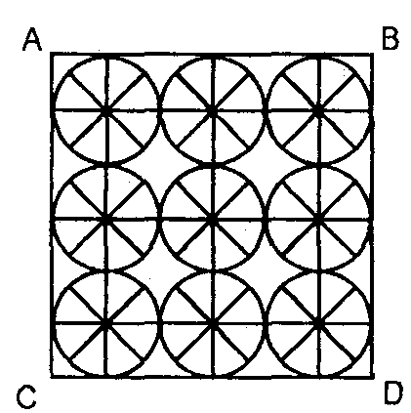
Section D
26 Solve the following system of linear equations graphically
3x + y – 11 = 0, x — y — 1 = 0
Shade the region bounded by these lines and the y-axis. Also, find the area of the region bounded by these lines and the y-axis.
27 The angle of elevation, A of a vertical tower from a point on ground is such that its tangent is 5/12. On walking 192 meters towards the tower in the same straight line, the tangent of the angle of elevation, B is found to be 3/4. Find the height of the tower.
28. State and prove Pythagoras theorem. Use the theorem and calculate area of ^PMR from the given figure.

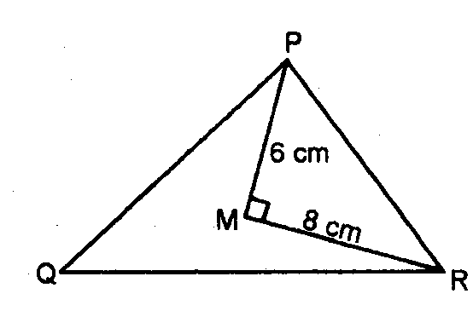
29. A sphere of diameter 12 cm, is dropped in a right circular cylindrical vessel, partly filled with water. If the sphere is completely submerged in water, the water level in the cylindrical vessel rises by 3-cm. Find the diameter of the cylindrical vessel.
30. The heights (in cm) of 60 persons of different age groups are shown in the following table:

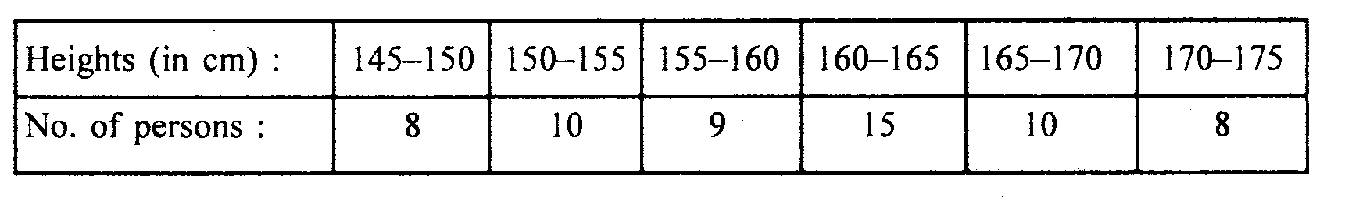
Using the above data draw (i) a less than ogive and (ii) a more than ogive.

