Guess Paper – 2008
Class – X
Subject – Mathematics

BRAIN TEASERS
1. Show that any positive integer is of the form 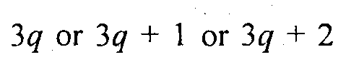for some integer q.
2. Solve for x 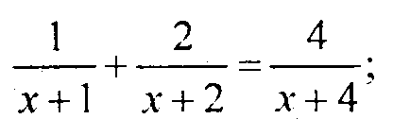
3. The sum of the first 9 terms of an AP is 81 and the sum of its first 20 terms is 400. Find the first term and the common difference of AP.
4. How many three digit numbers are divisible by 7?
5. Find the area of the quadrilateral whose vertices are (1, 1), (7. —3), (12, 2) and (7, 21).
6. A bag contains 6 red, 8 black, and 4 white balls. A ball is drawn at random. What is the probability that the ball drawn is not black?
7. In a right triangle ABC, right angled at B, the ratio of AB to AC 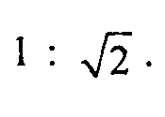. Find the value of 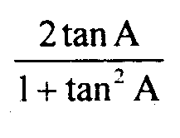
8. If then find the values of A and B.
9. Divide 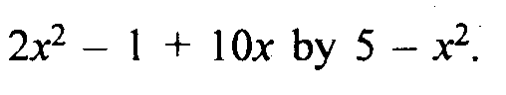
10. Show that the y-axis bisects the line segment joining A (—5, 7) and B(5, 2).
11. Two concentric circles are of radii 5 cm and 3 cm. Find the length of the chord of the larger circle which touches the smaller circle.
12. How many terms of the series 54, 51, 48, ... be taken so that their sum is 513?
13. Find the term of the AP 9, 12, 15, 18, ... which is 39 more than its 36th term.
14. Determine the positive values of k for which the equations x² + kx + 64 = 0 and x² — 8x + k = 0 will both have real roots.
15. Solve the following equations graphically 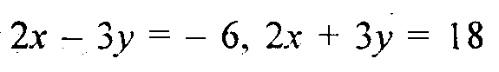 Also, find the area of the region bounded by these lines and the y-axis
16. Prove that 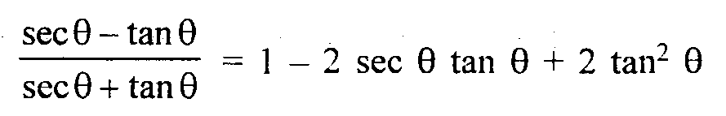
17. PQRS is a diameter of a circle of radius 6 cm. The lengths PQ, QR and RS are equal. Semi-circles are drawn on PQ and QS as diameters as shown in figure. Find the area and the perimeter of the shaded region.

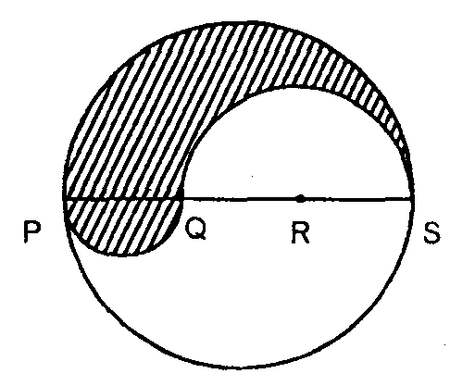

18. A copper wire of diameter 6 mm is evenly wrapped on a cylinder of length 18 cm and diameter 49 cm to cover the whole surface. Find the length and the volume of the wire.
19. Change the following distribution to a more than type distribution and draw its ogive. From the ogive, find the median.

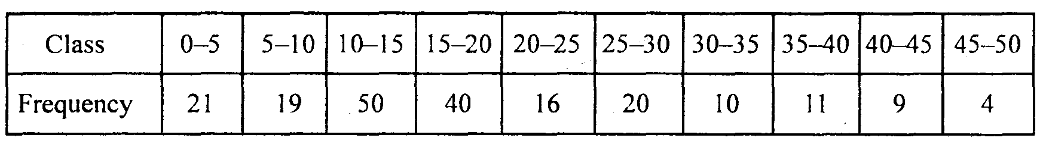
20. Find a 2-digit number such that the product of the digits is 14 and four times the units digit is 6 less than twice the ten’s digit.
21. Some students planned a picnic. The budget for food was Rs 480. But 8 of these failed to go and thus the cost of food for each student increased by Rs 10. How many students attended the picnic?
22. Find the area of the triangle whose vertices are (5, 2), (4, 7) and (7, — 4).
23. In the figure, ABCD is a square of side 14 cm and APD and BPC are semi-circles. Find the area of the shaded region.
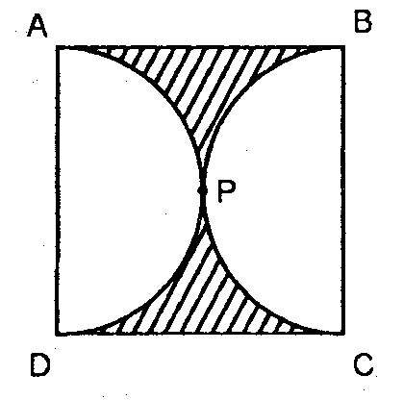
24. Show that any positive odd integer is of the form 4q + 1 or 4q + 3, where q is some integer.
25. Construct a AABC in which BC = 6 cm, ABAC 60° and median through A is 4.5 cm. Construct a AA’BC’ similar to AABC with BC’ = 8 cm.
26. If the roots of the quadratic equation (a — b) x² + (b — c) x + (c — a) 0 are equal, prove that 2a = b + c.
27. An aircraft pilot flies it a distance of 800 km with some average speed. He could have saved 40 minutes by increasing the average speed of the aircraft by 40 km/h. Find the actual speed of the aircraft.
28. A piece of cloth costs Rs 200. If the piece was 5 m longer and each metre of cloth cost Rs 2 less, the cost of the piece would have remained unchanged. How long is the piece and what is the original rate per metre?
29. At the foot of a mountain the elevation of its summit is 45°. After ascending 1000 m towards the mountain up at an inclinaton of 30°, the elevation is found to be 60°. Find the height of the mountain.
30. From the terace of a house 8 m high, the angle of elevation of the top of a tower is 45° and the angle of depression of its bottom is 60°. Find the height of the tower and the distance of the tower from the house.
31. Prove that in a triangle the line drawn parallel to one side to intersect the other two sides in disitinct points divides the two sides in the same ratio.
Using the above, prove that a line drawn parallel to parallel sides of a trapezium divides the non-parallel sides in the same ratio.
32. A right triangle with sides 6 cm and 8 cm is revolved around its hypotenuse. Find the volume and the surface area of the double cone thus generated.
33. Following table gives the cumulative frequency of the age of a group of 199 teachers. Draw the less than ogive and greater than ogive and find the median.
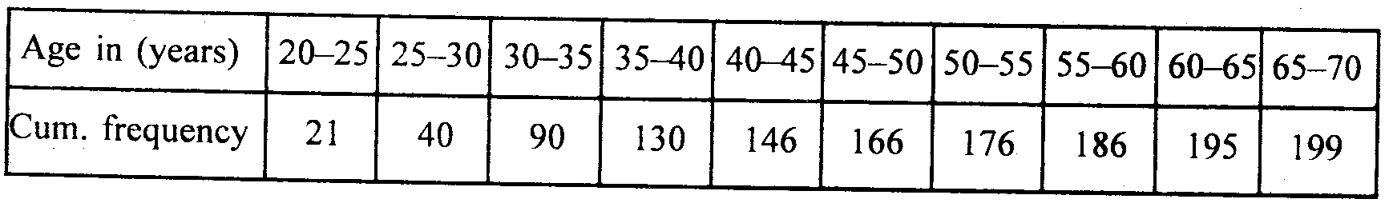
34. Determine graphically the vertices of the triangle, equations of whose sides are given below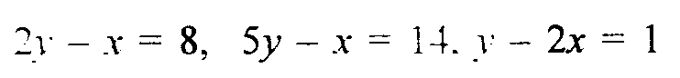
35. Solve the following system of equations : 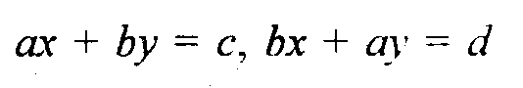
36. Find the sum of odd numbers between 0 and 50.
37. A man arranges to pay a debt of Rs 90,000 in 40 monthly instalments which are in AP. When 30 instalments are paid, he dies, leaving a third of the debt unpaid. Find the values of first three instalments.
38. Prove that sec A (1 — sin A) (sec A + tan A) = 1
39. Find the coordinates of the centre of a circle which passes through the points P(0, 0). Q (—3,3) and R (5, —1).
40. Show that the pointsA(—1, 0), B(0, 3), C(1, 3) and D(0, 0) are the vertices of a parallelogram.
41. In the figure, 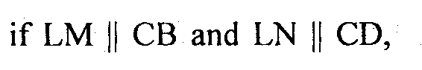then prove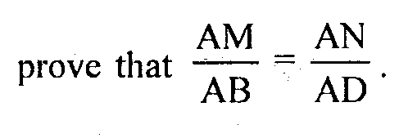

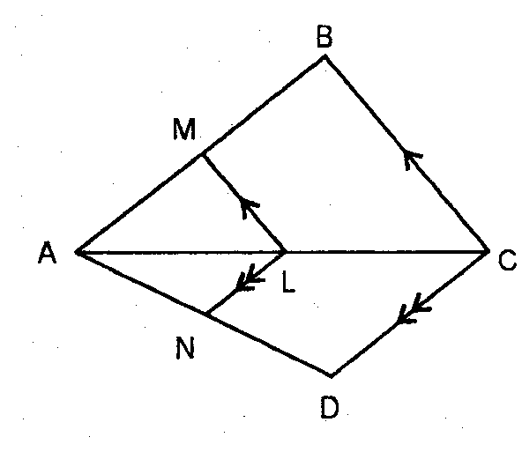
42. A larger wheel of diameter 50 cm is attached to a smaller wheel of diameter 30 cm. Find the number of revolutions made by the smaller wheel when the larger one makes 15 revolutions.

