CBSE Sample Paper
Science Set- A
Class 6
Science - Set A : Answers

Section-A
- Like poles of the two magnets repel each other while their unlike poles attract each other. Hence, both the magnets will repel each other in this case.
- Magnetic materials like iron or cobalt might have been used to make some part of the sharpener due to which, it gets attracted towards the magnet.
- Redworms have gizzard for grinding the food.
- The process of conversion of water into water vapour is called evaporation.
- We get an electric shock because our body is a conductor of electricity.
- The layer of air around the earth is known as atmosphere.
- It is a paste made up of paper, clay and rice husk.
- Yes, this change can be reversed by unfolding the paper aeroplane.
- The birds are very light in weight because of the presence of hollow bones. This is an adaptation which along with feathers and wings helps the birds to fly.
- Ball and socket joint allows movement in all four directions because in this joint around ball like portion of one bone fits into the cavity (socket) of other bone which makes it free to rotate.
- The two magnetic materials are:-
1. Iron.
2. Cobalt.
The two non-magnetic materials are:-
1. Leather.
2. Plastic.
12. Proper disposal of garbage should be a concern of every citizen, and not just of the government. Each and every individual must reduce activities that pollute the environment. A lot of waste is generated from homes, offices, schools, hospitals, etc. It includes food waste, paper, plastic, glass, metal, etc. Therefore, it is required that every individual must reduce the production of wastes and must help in the proper disposal of these wastes.
13. To make the bulb glow, the wires should be joined in this manner as shown in figure below:
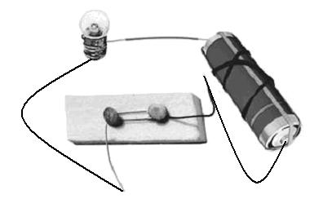
14. Materials through which an electric current cannot flow are called as insulators. For example: rubber
15. The two uses of air are given as follows:-
a. Air is used to inflate the tyres of vehicles.
b. Air is used by plants and animals for respiration.
16. Biotic components include living things such as plants and animals.
Abiotic components includes non-living things such as air, water, soil, rock, heat and light etc.
17. Rats and snakes escape the intense heat of the desert by hiding themselves deep into the burrows in the sand during day. They come out during the night when it is cool outside.
18. Two: Blue and Green.
a. Blue for metals, glass and plastics.
b. Green for cloths, vegetables, fruits and animal waste.
19. Transpiration is the process of evaporation of water from the leaves of plants.
They are tiny droplets of water that remain floating in air and appear to us as cloud.
20. The change that takes place over a long period of time is called a slow change. For example-growth of a plant or rusting of iron.
21. It has long ears to hear the movements of its predators.
ii) Its eyes on the side of its head helps it to look in all directions.
iii) It has high speed of running which helps it to run away from its predators.
22. No, the bulb will not glow in the circuit. The reason behind this is that only positive terminal of an electric cell is connected to one terminal of the bulb using two wires and the negative terminal of the cell is not connected to other terminal of the bulb. Due to this, no current will flow through the filament of the bulb because the circuit does not get completed.
23. Nails and screws are made up of iron which are magnetic materials whereas wooden shavings are non-magnetic materials. So, we can separate them from the scrap by the help of magnet. Wooden shavings will not be attracted towards the magnet while the nails and screws will get attracted to the magnet.
24. The air is considered a mixture because of the following reasons:-
- Air consists of many gases like oxygen, nitrogen, carbon dioxide etc.
- The composition of air varies from place to place.
25. We can conserve water by following ways:
a. Do not waste water and repair all the water leaking taps.
b. Do not use drinking water in garden or in cleaning.
c. Do not throw any waste in ponds or rivers to prevent its pollution.
26. Plastics are used and thrown after use as garbage. Things like ghee, oils, soaps, cereals, snacks, even vegetables are available in smaller packets in which a lot of packaging material is used.
27. Cement bags are converted in to a hard mass due to the chemical reaction with water. A new product is formed, which has entirely different properties. So, this chemical change cannot be reversed.
28. The vertebral column present in human body is commonly called backbone. It is a long tubular structure starting from neck region and runs in the back portion of the human body. It consists of many small bones called vertebrae. These vertebrae are joined end to end. The vertebral column protects the spinal cord and gives support to the whole body.
29. a) The similarity between the shoulder bones and pelvic bones is that they both have ball and socket joint.
(b) Joints are the points where two bones meet or attach with each other. They are necessary for any kind of movements in the body because bones are hard structures and cannot bend.
30. The cells used in calculators are known as button cells, as they resemble with the shape of a button. The plates of these cells are made from compounds of nickel and cadmium. The main advantage of these cells is that they can stay in an active stage for months without any leakage.
31. The poles of the bar magnet are located at its two end points.
Place a magnet on paper and sprinkle some iron fillings on it. It is observed that the iron fillings gets attracted more strongly towards the two ends of the magnet compared to its central portion indicating that the poles are located at these two ends of the magnet. 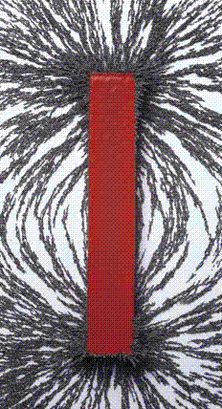
Or,
When the magnet is suspended freely with the thread, it aligns itself in the geographic north-south direction. We use this property of magnet in compass, which is used to give us the direction at a particular place. The diagram of the compass is shown in the figure below:-
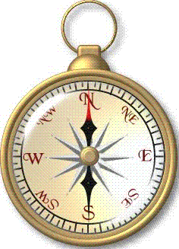
At the central part of the compass, there is a magnetised needle which is placed above a nail. The needle can move freely in all direction. As the needle is magnetic in nature, it aligns itself in the north-south direction due to the property of magnet, showing us the north-south direction. The north pole of the compass is generally painted red so that we may distinguish between the north pole and the south pole.
32. Cockroaches walk and climb as well as fly in the air. They have three pairs of legs which help them in walking. The body is covered with a hard outer skeleton. This outer skeleton is made of different units joined together which permit movement. There are two pairs of wings attached to the thorax. The cockroaches have distinct muscles — those near the legs move the legs for walking. The thoracic muscles move the wings when the cockroach flies.
Or,
Heart – rib cage
b. Brain - skull
c. Spinal cord – vertebral column
d. Lungs – rib cage
e. Urinary bladder - pelvic bones
33. Five activities that are possible due to the presence of air are as follows:-
1. Respiration.
2. Flying of birds and aeroplanes.
3. Dispersal of seeds.
4. Watercycle.
5. Rotation of the windmill.
34. When a candle burns, both physical and chemical changes take place. On burning a candle, the wax melts and is solidified again on cooling. So, melting of wax is a physical change. But the burning of candle also produces light and some gases like carbon dioxide. Hence, the burning of wick of a candle is a chemical change.
Or,
(a) Dissolving sugar in water is a reversible and physical change as sugar can be obtained back by applying a physical method called evaporation.
(b) The rotation of a fan is a periodic change because the change occurs after a fixed interval of time.
(c) The cooking of food is a chemical change as after cooking the food, new product is formed that cannot be reversed into previous food.
(d) The melting of an ice candy is a reversible change because ice candy melts due to increased temperature (room temp.) Melted ice candy can be solidified by freezing it. Hence, this is also a physical change.
(e) Making statues out of plaster of Paris is an irreversible and chemical change because plaster of Paris has a property of setting into a hard mass on getting mixed with water due to the formation of a new compound. The hard mass cannot be converted back into the previous plaster of Paris. Hence, it is an irreversible chemical change.

Section- B:
35. comes to rest in North-South direction.
36. skull
37. domestic waste.
38. earthworm.
39. Fast change
40. electricity
41. air
42. will not glow
43. terrestrial habitat.
44. snow

