**Dedraj Sewali Devi Todi DAV School**

**Biratnagar -13**

**1st Terminal Examination 2080**

**Class: X(CBSE) F.M 100**

**Sub: Math P.M 40**

**Time: 3:00hrs**



**Attempt all the questions:**

**Group-A(1x20=20**)

1. **Choose the best alternative from the following:-**
2. If α and β are the roots of x2 - (k-6)x+(2k-1) find the value of k if α+β=αβ

(i).3 (ii). -3 (iii.) -7 (iv) 7

ii. in the given figure ACB = CDA, AC=8cm , AD=8cm then BD is



(i).22/3 (ii). 26/3 (iii.) 55/3 (iv) 64/3

iii. If A(4,-2) ,B (7, -2) and C(7,9) are the vertices of a ΔABC, then ΔABC is

1. equilateral Δ c) right angled Δ
2. isosceles triangle d) right angled isosceles Δ

iv. Two dice are rolled simultaneously, what is the probability that 5 will come up at least once?

a) b) c) d)

v. If P and Q are two co-prime numbers then LMC (P,Q) is

a) P b) Q c) PQ d) 1

vi. The point which divides the line segment joining A(4, -3) and B(9, 3) in the ratio 3: 2 is

1. (7, 3) b) (4, 2) c) (5, 6) d) (9, 4)

vii. The system of equation x – 4y = 8, 3x – 12y = 24 has

1. infinitely many solution c) no solution
2. may or may not have a solution d) unique solution

viii. The end points of a diametre in a circle is (3, 5) and (7, -3). Find the centre of the circle.

1. (7, 3) b) (4, 2) c) (5, 6) d) (5, 1)

ix. If the difference between 100th term of two AP having the same common difference is 100. find the difference between its 1000th term.

a) 1000 b) 103 c) 10000 d) 100

x. The famous mathematician associated with finding sum of the first hundred natural number is

a) Pythagoras b) Newton c) Gauss d) Euclid

xi. the zeroes of the quadratic polynomial x2+99x+127 are

1. both positive b) both negative c) one positive one negative d) both equal

xii. If in ∆ ABC and ∆ DEF , , then, which two angles are equal for similarity

1. b) c) d)

xiii. D and E are respectively the points on the side AB and AC of a ∆ABC, such that AD = 2cm, BD = 3cm, BC = 7.5cm and DE||BC. the length of DE is

1. 2.5cm b) 3cm c) 5cm d) 6cm

xiv. The forth vertex D of a parallelogram ABCD whose 3 vertices are A(-2, 3), B(6, 7), C(6, 3) is

1. (0, 1) b) (0, -1) c) (-1, 0) d) (1, 0)

xv. If the distant between the point (4, p) and (1, 0) is 5, then the value of p is

1. 4 only b) c) - 4 only d) 0

xvi. The probability of an event is given by

1. b)

c) d) none of these

xvii. The probability of getting a bad egg in a lot of 400 is 0.035. the number of bad eggs in the lot is

1. 7 b) 14 c) 21 d) 28

xviii. What is the probability of Akash celebrating his birthday in 2024AD? Given that he celebrates his birthdays on every Tuesday.

1. b) 0.5 c) d) 1

xix. If two positive integers p = ab2 and q = a2b, a, b being prime numbers, then LCM(p,q) is

1. ab b) a2b2 c) a3b2 d) a3b3

xx. The pair of equation y = 0 and y = -7 has

1. one solution c) no solution
2. two solution d) infinitely many solution

**Group-B [2x5=10]**

2. The H.C.F. (96,404) is 4. Find its L.C.M.

3. Find the zeroes of the quadratic polynomial x2+7x+10, and verify the relationship between the zeroes and the coefficients.

4. Solve:- x + 0.999y =2.999

0.999x + y=2.998

5. In what ratio does the points (-4,6) divide the line segment joining the points A(-6,10) and B(3,-8)?

6. One card is drawn from a well-shuffled deck of 52 cards find the probability of getting.

i) a king of red color ii) a face card

**Group-C [3x6+18]**

7. Prove that is irrational.

8. If and are the roots of quadratic polynomial 5x2+ 5x+1. Find the value of i) 2+ 2

ii)

9. The sum of a two-digit number and the number obtained by reversing the digit is 66. If the digits of the number differ by 2. Find the number. How many such number are there?

10. In the given figure, ABC and AMB are two right angled triangles, right angled at B and M respectively. Prove that

i) ABC AMP C

ii) = M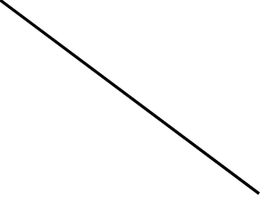

A B P

11. Show that a, a2_____ an are the terms of an A P where an is defined as an = 9-5n. Find the sum of the first 15 terms.

12. If (1,2), (4,4), (x,6) and (3,5) are the verticals of a parallelogram taken in order, find x and y.

**Group-D [4x5=20]**

13. The ratio of the 11th term to 17th term of an AP is 3:4. Find the ratio of 5th term to 21st term of the same A.P. Also find the ratio of the sum of 1st 5 terms to that of 1st 21 terms.

14. If and are zeroes of p(x)= Kx2+4x+4, such that ∝2+ β2 =24, find K.

15. If and are zeroes of the polynomial 6y2-7y+2, find a quadratic polynomial whose zeroes are and .

16. Draw the graph of 2x+y=6 and 2x-y+2=0. Shade the region bounded by this lines and X-axis. Find the area of the shaded region.

17. State and prove the converse of Thales theorem.

18. In the figure, DE II AC and DF II AE. Prove that

= A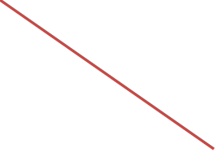

D

B F E C

19. Point A(-1,4) and B(5,7) lie on a circle with center O(2,-3y), Find the value of Y. Hence find radius of the circle.

20. Ashmita has just bought a new i-phone. For its safety she had put a 4 digit passcode. Her phone was stolen by someone which was later recovered by the police. Two policeman A and B reached her in hope to verify the phone. On asking password, She gave different hint to both the police.

Police A’s clue:- When twice the one digit is subtracted from the tens digit the result is 1.

Police B’s clue:- Three more the tens digit is thrice the one digit.

The phone can be opened only when the both clues are solved. Help the police in retrieving the code.

**Group-E [4x3=12]**

1. Manpreet Kaur is the national record holder for women in the shot-put discipline. Her throw of 18. 86th at the Asian grand prix in 2017 is the biggest distance for an Indian female athlete. Keeping her as a role model, Sanjitha is the determined to earn gold in Olympic one day. Initially her throw reached 7.56m only. Being an athlete in school, she regularly practiced both in the morning and in the evening and was able to improve the distance by 9cm every week.

During the special camp for 15 days , she started with 40 throws and everyday kept increasing the number of throws by 12 to achieve this remarkable progress.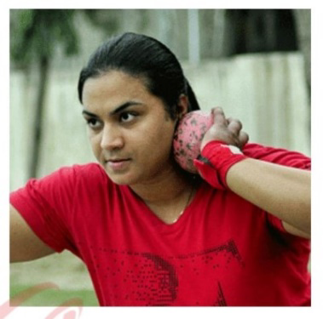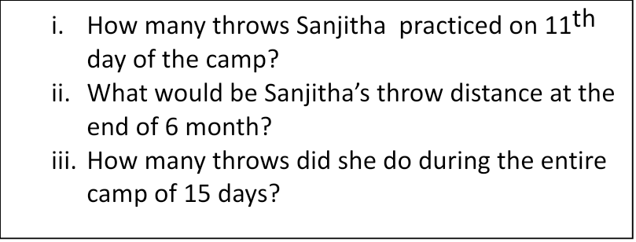

1. Divyansh was thrilled to know that the football tournament is fixed with a monthly time frame from 20th July to 20th August 2013 and for the 1st time in the FIFA women’s world cup history, two nations host in 10 venues. Her father felt that the game can be better understood if the positions of players is represented as points on a coordinate plane.

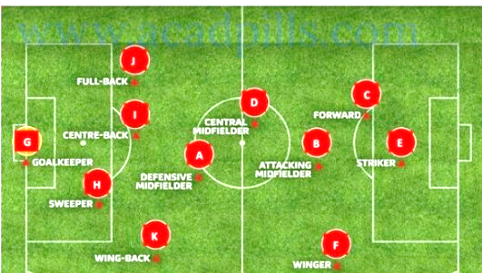

i) At an instance, the midfielders and forward formed a parallelogram. Find the position of the central mid fielders.

If the position of the other players who formed the parallelogram are A(1,2), B(4,3) and C(6,6).

ii) Check if the goal keeper G(-3, 5) , sweeper H(3, 1) and wing-back K(0, 3) falls on a same straight line.

iii) If defensive midfielder A(1,4) attacking midfield (2, -3) and striker E(a, b) lie on the same straight line and B is equidistant from A and E, find the position of E.

3. One day due to heavy storm an electric wire got bent as shown in the figure. It followed tone mathematical of curve. Answer the following questions below.

X

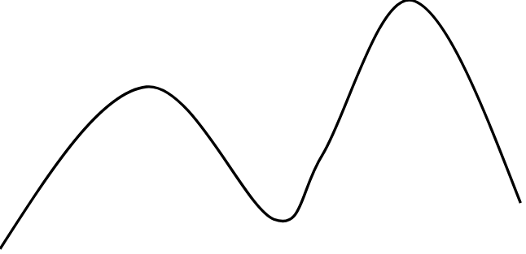

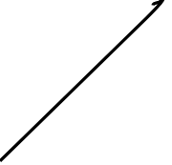



-5 -4 -3 -2 -1 0 1 2

X1 X

Y

1. How many zeroes are there for the polynomial(shape of the wire)
2. 2 b) 3 c) 4 d) 5
3. Find the zeroes of the polynomial.
4. 2,0,-2 b) 2,-2,-5 c) -2,2,-5.5, iv) none of these
5. Find the quadratic polynomial where zeroes are 3 and -4.
6. x2+4x+2 b) x2+ x-12 c) x2-7x-12 d) none of these
7. Name the type of expansion of the polynomial in the given graph?
8. Quadratic b) cubic c) linear d) bi-quadratic
9. If one zero of the polynomial x2-2x-3 is -45 then the other value of x

a)6 b) -6 c) 2 d) -2

4. Rahul is studying in 10th standard. He is making a kite to fly it on a Sunday. Few questions can on his mind while making the kite. Give answer to this question by looking at the figure.

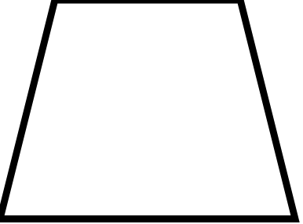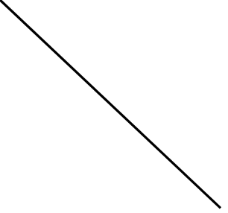

1. Rahul tied the sticks at what angle to each other?
2. 30 ii) 60 iii) 90 iv) 70
3. Which is the correct similarity criteria applicable for smaller triangles at the upper part of this kite?
4. RHS ii) SAS iii) SSA iv) AAS
5. Sites of two similar triangle are in the ratio 4:9 corresponding medians of these triangles are in the ratio.

i) 2:3 ii) 4:9 iii) 81:16 iv) 16:81

d) In a triangle, if square of one side is equal to the sum of square of the other two sides then the angle opposite of 1stside is a right angle. This theorem is called

i) Pythagoras theorem ii) Thales theorem

iii) converse of Thales theorem iv) converse of Pythagoras theorem

5. What is the area of kite, formed by two perpendicular sides of length 6cm and 8cm?

i) 48cm2 ii) 14 cm2 iii) 24 cm2 iv) 96cm2

**Best of Luck!** 