**EXAMINATION 2024-25**

**Class- XII**

**Time : 3 hours Subject- Mathematics (041) M.M: 80**

General Instructions:

1. Section A has 18 MCQ’s and 2 Assertion-Reason based questions of 1 mark each.

2. Section B has 5 Very Short Answer-questions of 2 marks each.

3. Section C has 6 Short Answer - questions of 3 marks each.

4. Section D has 4 Long Answer - questions of 5 marks each.

5. Section E has 3 source based/case based/passage based/integrated units of assessment (4 mark each)

**SECTION – A**

**1**.If the direction cosine of a line are l, m, n

(a) l + m + n = 0 (b) l2 + m2 + n2 =1 (c) l2 + m2 + n2 =0 (d) l - m - n=0

**2**.The value of p for which two vectors are perpendicular

(a) 4 (b) 2 (c) 6 (d) 8

**3**. Evaluate

(a) 1 (b) (c) (d)

**4**. If I =, then I2 is

a) b) c) d)

**5**. If = -x cos x +

a) sin x + C b) cos x + C c) C d) none of these

**6**. IF A= , then A-1 is

a) Identity matrix b) null matrix c)symmetric matrix d) not exists

7. Evaluate

a) +C b) cosx +C c) sin x+ C d) 2 sin + C

8. ABC is a triangle then is

1. 2 b) c) null vector d) none of these

9. Evaluate

a) + C b) + C c) 2 + C d) + 1

10. The integral factor of diff. eq. (cos x).y1+ y sin x = 1 is

a) cos x b) sin x c) tanx d) sec x

11. If is an acute angle and the vector (sin

a) b) c) d)-1/3

12. If a line has direction ratio 2, -1, -2, then the direction cosines are

a) 2/3, -1/3, -2/3 b) 2/3, -1/3, 2/3 c) 2, 1, 2 d) 1,2,1

13. If sin -1 (x2 +y2 ) = a , then dy/dx is

1. – y/x b) – x/y c) x2/y2 d) none of these

14. The number of possible matrices of order 2 with each entry 1, 2 or 3 is

a) 81 b) 80 c) d) none of these

15. For maximize Z = 3x+ 2y with constraints x+2y 3x+y

Which of the following is not a corner point of feasible region?

a) (0,5) b) (4,5) c) (5,0) d) (0,0)

16. If then

a) x b) x = y c) x=10 d) y = 2

17. A problem in Science is given to three students whose chances of solving it are 1/2, 1/3and 1/4 respectively.

If the event of their solving the problem are independent the probability that the problem will be solved is

1. 1/4 b)1/3 c) d) 3/4

**18**. The lines are

(a) perpendicular b) parallel c) skew d) None of these

In the following questions (Q19, Q20) , a statement of assertions (A) is followed by a statement of reason (R).

Choose the correct answer out of the following choices:

1. Both A and R are true and R is the correct explanation of A
2. Both A and R are true and R is not the correct explanation of A
3. A is true but R is false
4. A is false but R is true

**19**. Assertion A: Two coins are tossed simultaneously. The probability of getting two heads,

If it is known that at least one head comes up, is 1/3

Reason R: Let E and F be two events with a random variable then

**20**. Assertion A:

Reason R:

**SECTION -B**

21.Show that the relation R in set Z of integers given by R = {(a,b): 2 divides a – b} is an equivalence relation.

OR

22.Show that are orthogonal.

OR

Find the sine of angle between vectors and

23. If

24.Find the vector equation of a line that passes through the point A(1, 2, -1) and parallel to the line

25. Evaluate

**SECTION-C**

26. Evaluate

27. Solve the following Linear Programming Problem graphically

Maximise Z = x + 2y, Subject to 2x + y ,

28. If

OR

If y = sin (sin x), prove that

29. Solve diff. eq. OR Solve diff. eq. y

30.

31. If x = a sin3

**SECTION -D**

32. Make a rough sketch of the region bounded by the curve and find its area

by using integration.

33. Find the short distance between the lines and

OR

Find the perpendicular distance of the point (1, 0, 0) from the line .

34. Prove that the relation R on Z, defined by R={(a, b):(a – b) is divisible by 5} is an equivalence relation.

OR

Show that the function f:R – {0} 🡪R – {0} defined by f(x) = is one-one and onto function

35.Find the inverse of matrix A = . Using A-1 , solve the equations

,

**SECTION- E**

Three case study based questions are compulsory.

36. Read the following passage and answer the question given below:

During examinations a candidate has to reach examination centre and he has three options, going by

bus, by scooter or by car. The probability of his going by bus or scooter or by car are 3/10, 1/10,

3/5 respectively. The probability that he will be late is ¼ and 1/3 if he travels by bus or scooter

respectively but he travels by car he is not late.

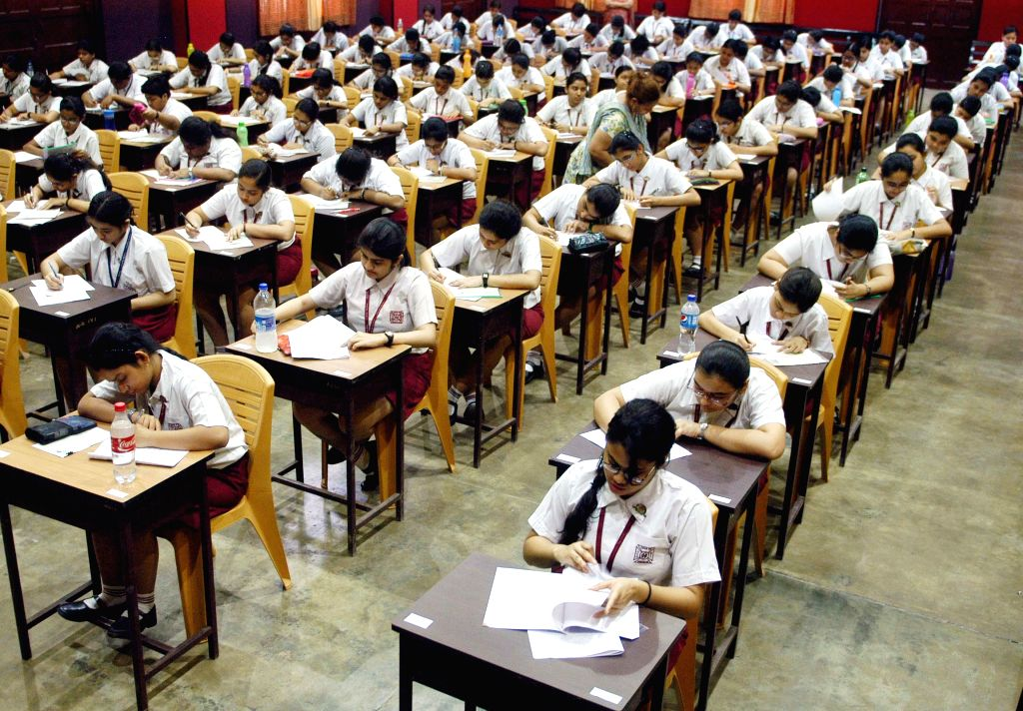

Based on the above information, solve the following questions:

1. What is the probability that candidate reaches late?

(ii) What is the probability of reaching late if he travels by car?

37.A man has an square shaped piece of golden board of size 24 cm by 24 cm is to be made into a box

without top by cutting from each corner and folding the flaps to form a box.

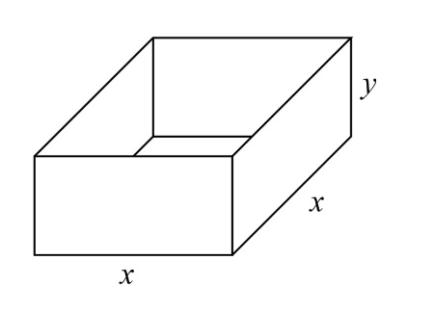

box

By the above information, answer the following questions.

a)What is the volume V of open box formed by folding up the flap?

b) What should be the side of the square piece to be cut from each corner of the board

to be hold he maximum volume?

c)What should be the maximum volume of open box?

OR

d)Find the volume of the box if by folding up the flap length of side of the square becomes 12 cm?

38. Employee in an office are following social distance and during lunch they are sitting at

places marked by points A, B and C. Each one representing position as A(

and C(

A * * B

* C

By the above information, answer the following questions:

a) Find the distance between B and C.

b) Find the area of the triangle ABC.

c) Find the magnitude of vector AC.

OR

d) Find the angle ABC.

----------------- ALL THE BEST------------