Class – X

Guess Paper

Mathematics

Time allowed: 3 hours M.M: 80

**General Instructions:**

(i) All questions are **compulsory**.

(ii) The question paper consists of **30** questions divided into four **sections A, B, C** and **D**. **Section-A** comprises of **6** questions of **1 mark** each, **Section-B** comprises of questions of **2 marks** each, **Section-C** comprises of **10** questions of **3 marks** each and **Section-D** comprises of **8** questions of **4 marks** each.

(iii) There is no overall choice.

(iv) Use of calculator is not permitted.

(v) Do not write anything on the question paper except roll number.

**SECTION-A**

1 If both the zeroes of the polynomial ax2 + bx +c are equal and opposite in sign, then find the values of b.

2 Write the largest natural number that divides the product of any three consecutive natural numbers.

3 Find the value of k for which 2k, k + 10 and 3k + 2 are in A P.

4 In Δ PRQ, ST||RQ and PS = 5 cm and PQ = 10 cm. If ST = 3 cm, then find QR.

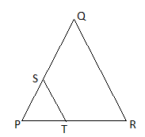

5 Find the value of ‘a’ if  is the mid-point of the line segment joining the points Q(-6, 5) and R(-2, 3).



6 If cos9 = sin and 9 < 90o,then find the value of tan5.

**SECTION-B**

7 Show that the square of an odd positive integer can be of the form 6q+1 or 6q+3 for some integer q..

8 Find the value of p and q so that the system of equations 2x + 3y = 7 and 2px + py = 28 – qy have infinitely many solutions.

9 Find the sum of all the 11 terms of an AP whose middle most term is 30.

10 A line intersects the y-axis and x-axis at the points P and Q, respectively. If (2, -5) is the mid-point of PQ, then find the coordinates of P and Q.

11 The sum of two digits of a two digit number is 11. Find the probability that the number is

(i) A prime number

(ii) Either divisible by 2 or 3.

12 A jar contains blue and green marbles. The number of green marbles is 5 more than twice the number of blue. If the probability of drawing a blue one is 2/7, then find how many blue and green marbles are there in the jar?



**SECTION-C**

13 Prove that √5 is an irrational number.

14 If  and β are the zeroes of the polynomial 2x2 – 5x + 7, find the quadratic polynomial whose zeroes are 2 + 3β and 3 + 2β .

15 The age of father is twice the sum of the ages of his two children. After twenty years his age will be equal to the sum of ages of his children. Find the age of father.

16 Find the coordinates of the point Q on the x-axis which lies on the perpendicular bisector of the line segment joining the points A(-5, -2) and B(4, -2). Name the type of triangle formed by the points Q, A and B.

**OR**

Find the values of k if the points A(k+1, 2k), B(3k, 2k+3) and C(5k-1, 5k) are collinear.

17 D, E and F are respectively mid points of the sides AB, BC and CA of ∆ABC. Find ratio of the area of ∆DEF and ∆ABC.

**OR**

In ∆PQR, PD ┴ QR such that D lies on QR. If PQ = a, PR = b and QD = c, DR = d, then prove that (a + b)(a – b) = (c + d)(c – d)

18 If a, b, c are the sides of a right triangle where c is the hypotenuse, prove that the radius r of the circle which touches the sides of the triangle is given by  .

19 Evaluate



**OR**

If sinθ + cos θ =√3, prove that tanθ + cotθ =1

20 A circle is inscribed in an equilateral triangle of side 12 cm, find the area of remaining portion.

**OR**

Find the area of the shades region.

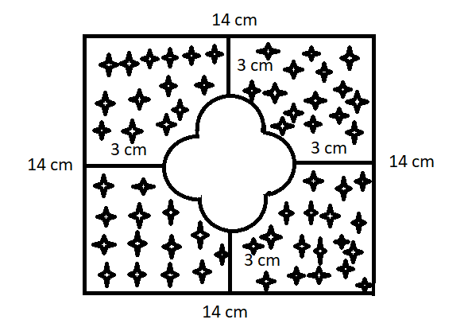

21 The rain water collected on the roof of a building of dimension 22m x 20m is drained into a cylindrical vessel having base diameter 2m and height 3.5m. If the vessel is full upto the brim, find the rain fall in cm.

22 Find the mean and mode of the following distribution:

|  |  |  |  |  |  |  |
| --- | --- | --- | --- | --- | --- | --- |
| Age (in years) | 5 – 15 | 15 – 25 | 25 – 35 | 35 – 45 | 45 – 55 | 55 – 65 |
| No. of students | 6 | 11 | 21 | 23 | 14 | 5 |

**SECTION-D**

23 The hotel bill for a number of people for overnight stay is Rs. 4,800. If for the same amount there were 4 more people, the bill each person had to pay would have reduced by Rs. 200. Find the number of people staying overnight.

**OR**

Solve:  

24 In given figure, if PQRS is a parallelogram and AB || PS, then prove that OC || SR.

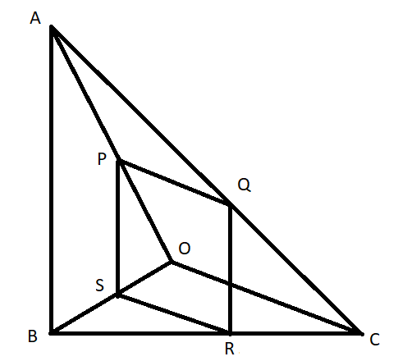

**OR**

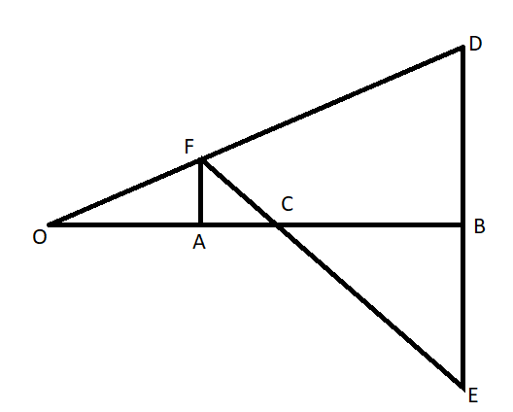In given figure, OB is the perpendicular bisector of the line segment DE, FA ┴ OB and FE intersects OB at the point C. Prove that .

25 Find the sum of integers between 100 and 200 that are

(i) divisible by 9

(ii) not divisible by 9

26 Given a rhombus ABCD in which AB = 4 cm and . Divide it into two triangles say ABC and ADC. Construct the triangle AB’C’ similar to Δ ABC with scale factor . Draw a line segment C’D’ parallel to CD where D’ lies on AD. Is AB’C’D’ a rhombus? Give reason.

27 The lower window of a house is 2 m above the ground and its upper window is 4 m vertically above the lower window. At certain instant, the angle of elevation of a balloon from these windows are observed to be 600 and 300 respectively. Find the height of the balloon above the ground.

28 If cosec θ + cot θ = p, then prove that 

29 The difference between outside and inside surface area of cylindrical metallic pipe 14cm long is 44cm2. If pipe is made up of 99cm3 of metal, then find outer and inner radii of the pipe.

30 Draw more than and less than ogive and hence find the median.

|  |  |  |  |  |  |  |  |
| --- | --- | --- | --- | --- | --- | --- | --- |
| Group | 0 – 10 | 10 – 20 | 20 – 30 | 30 – 40 | 40 – 50 | 50 – 60 | 60 – 70 |
| Frequency | 4 | 4 | 7 | 10 | 12 | 8 | 5 |

**OR**

If the median is 28.5. Find the values of x and y.

|  |  |  |  |  |  |  |  |
| --- | --- | --- | --- | --- | --- | --- | --- |
| C.I | 0 – 10 | 10 – 20 | 20 – 30 | 30 – 40 | 40 – 50 | 50 – 60 | Total |
| frequency | 5 | x | 20 | 15 | y | 5 | 60 |

Submitted by:

Deepak Dutta

PGT (Math)

9816055445

